**Knowledge Engineering:** all technologies behind leveraging knowledge-based systems to solve domain-specific issues; an important branch of AI.

**Knowledge Graph**: the representative knowledge engineering technique under the background of the continuous development of World Wide Web

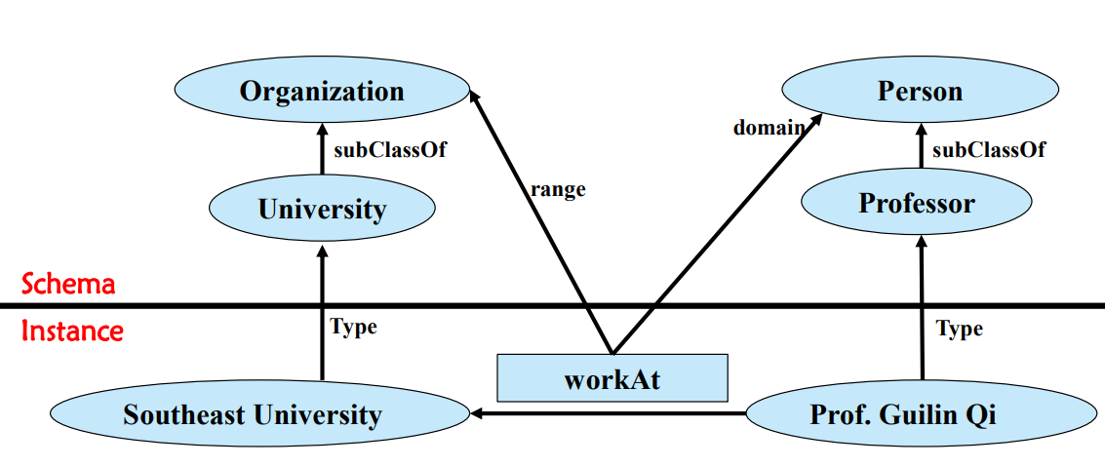

**Knowledge Graph Projects:** DBpedia, YAGO, Wikidata, BabelNet, Zhishi.me…

**Knowledge Graph Techniques:** knowledge representation, knowledge reasoning, knowledge extraction, knowledge fusion, knowledge storage and querying, knowledge-based question answering…

**Knowledge Graph Applications:** Finance, Digital Library, Law, Publisher…

**Knowledge Representation**：

**Knowledge representation** is to use the representation that computer can deal with to express human knowledge.

mathematical logic, - production rules, - semantic network, - frames

**Mathematical logic:** also called form logic, symbolic logic,… - Symbolic representations are important KR methods

**Example：**

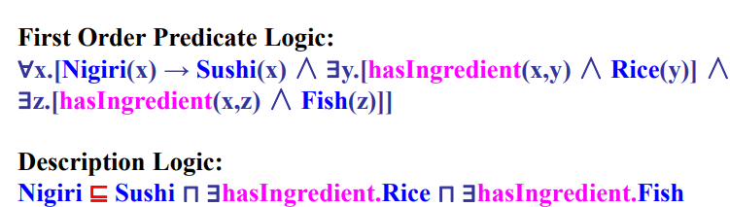

**Production Rules:** If A Then B(CF = [0, 1]), A→B; - A: Premise, B: Conclusion; - CF (Certainty Factor), i.e., rule confidence; - Production rules can model uncertain knowledge with CF;

**Semantic Network:** - a knowledge representation scheme involving nodes and links (arcs or arrows) between nodes, a directed graph;

- nodes: objects or concepts, links(directed): relations between nodes;

- use human language to label nodes and links.

- does have widely accepted formal representation.

**Frame:** - Each piece of information about a particular frame is held in a slot;

- The information can contain: ∙ Facts or Data ∙ Values (called facets) ∙ Procedures (also called procedural attachments) ∙ IF-NEEDED : deferred evaluation ∙ IF-ADDED : updates linked information ∙ Default Values ∙ For Data ∙ For Procedures ∙ Other Frames or Subframes

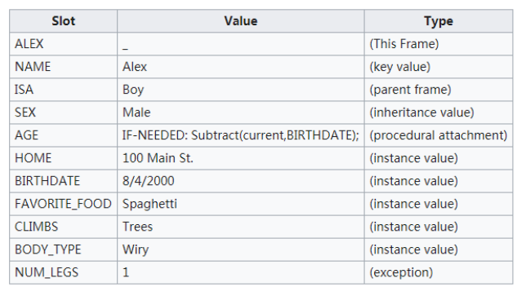

**Knowledge representation** is to use the representation that computer can deal with to express human knowledge.

**Knowledge graph representation** is to use the representation that computer can deal with to express the knowledge in knowledge graph.

**Knowledge graph representation**

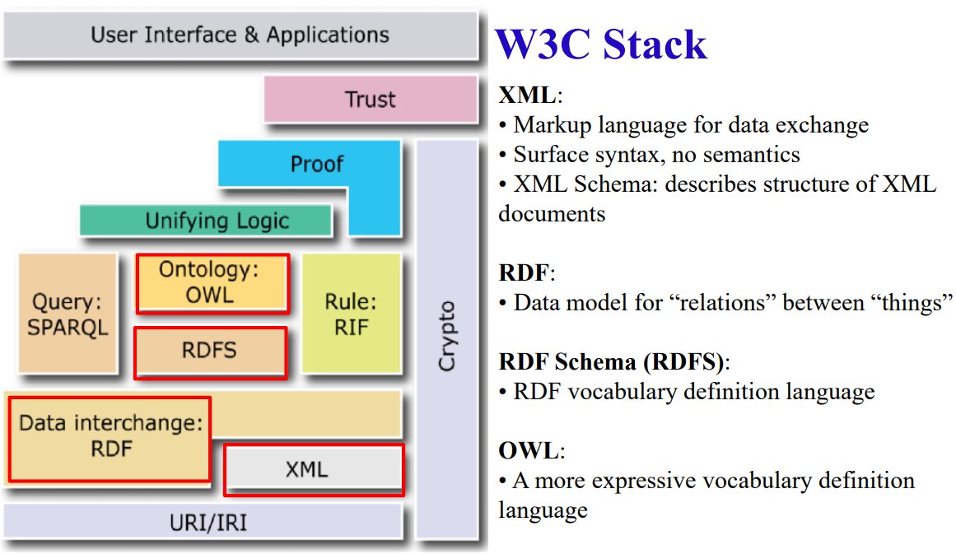

**XML**： eXtensible Markup Language (XML) 1.0 (Fifth Edition)

**HTML** (HyperText Markup Language): for documents designed to be displayed in a web browser.

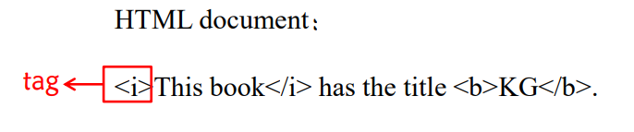

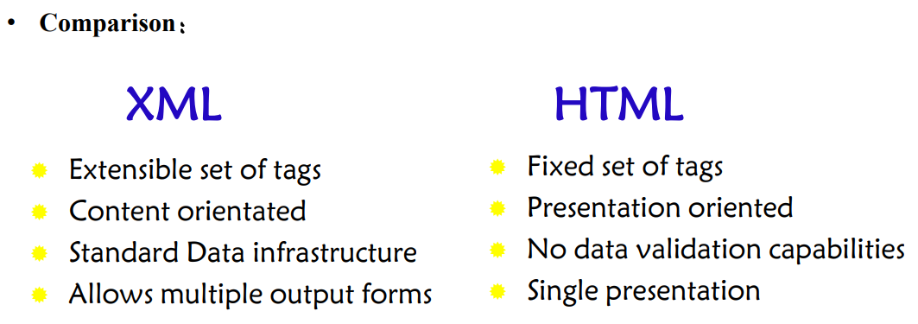

XML is designed for data exchange.

**XML Syntax**

Each XML document is a text document;

Each XML document begins with a **declaration containing**

- the version number of the used standard

- and optionally, the character encoding (default: Unicode)

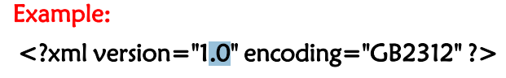

**XML Elements:**

- describe objects which are enclosed in matching tag-pairs, tags are case-sensitive:

- can contain text and/or further XML elements, arbitrarily nested;

- empty elements can be abbreviated:<book></book> e.g. can be written as <book />

- the outermost element is called root element (there is only one)

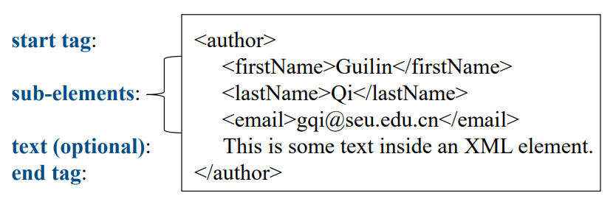

**XML Attributes:** - an attribute is a name-value pair separated by an equal sign (=), example: 

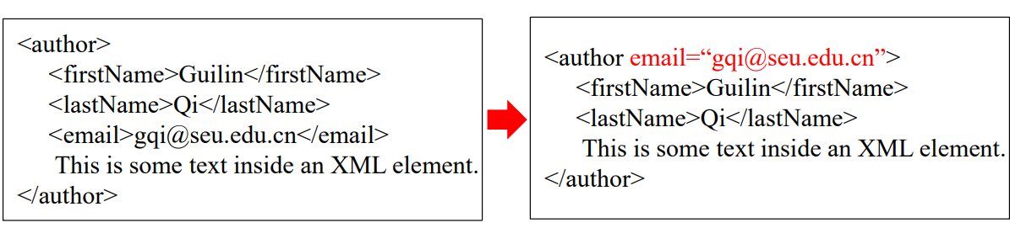

Example: an XML document → tree structure

**EX:**

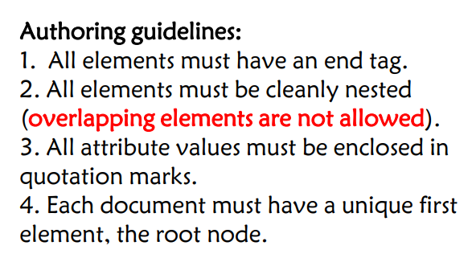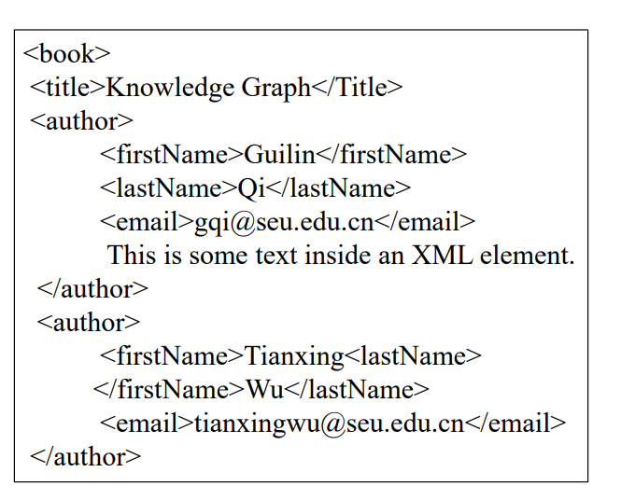

**XML Comment:** <!-- comments -->. problem: not user-friendly Solution

**XML Namespaces** provide a method to avoid element name conflicts.

Solution : Adding prefixes XML Namespaces provide a method to avoid element name conflicts. Defining a namespace for each prefix: use an xmlns attribute. -XML Namespaces provide a method to avoid element name conflicts. -The namespace can be defined by an xmlns attribute in the start tag of an element.

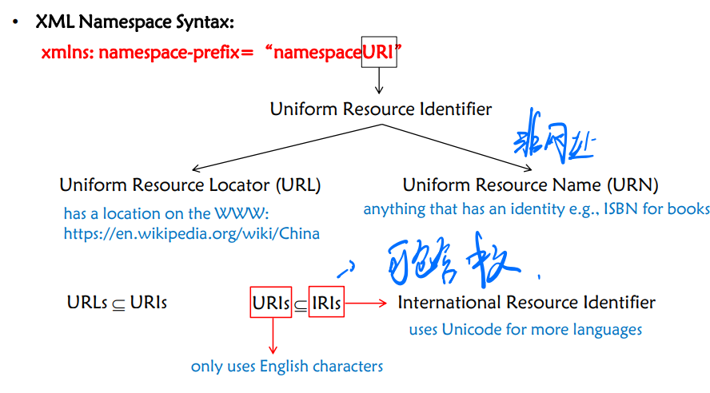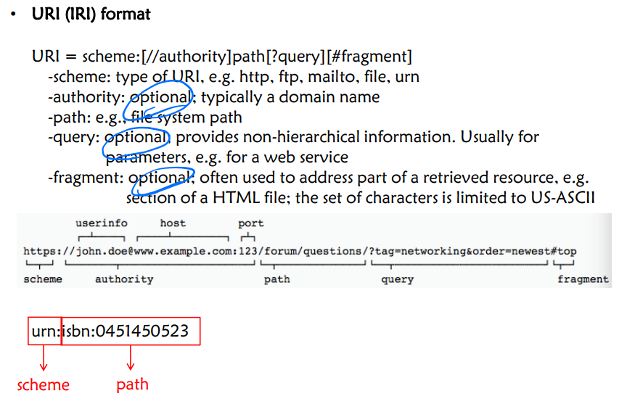

Why do we need XML Schema?

-These degrees of freedom get in the way when exchanging XML documents between applications!

- It is necessary to come up with agreements about the structure of the information, including the names of tags and attributes, and whether certain sub-elements are required or not.

- XML Schema is a W3C standard which provides for this.

- XML schemas are themselves written in XML.

- An XML document validated against an XML Schema is "Well Formed" and "Valid".

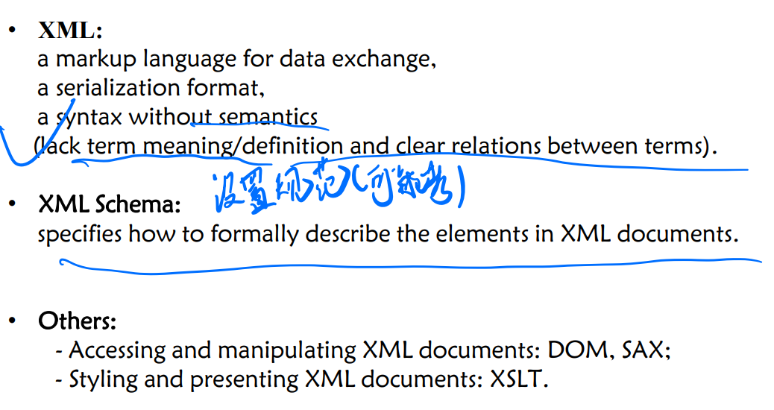

**RDF**

**RDF**: - the data model of Semantic Technologies and of the Semantic Web;

- structures metadata about Web sites, pages, etc.: 1. Page author, creator, publisher, editor, … 2. Data about them: email, phone, job, …

- can be used for machine-readable data exchange ;

- is introduced in W3C Recommendation of 1999 (Version 1.0);

- uses XML as main syntax for serialization

**RDF**: a data model about triples: ( subject , predicate , object )

**A RDF knowledge base:** a directed labeled graph, i.e., Knowledge Grap

**RDF Graph:** Directed Labeled Graph Problem: names are ambiguous.

**QName:** used in RDF as shorthand for long URIs (IRIs)

**RDF Triple (Statement)**

**Subjects**: Resource or blank node  **Predicates**: Resource

**Object**: Resource, literal or blank node **Resources**: IRIs

**Literal**s: - data values; - encoded as strings; - interpreted by datatypes; - treated the same as strings without datatypes, called plain literal; ∙ A plain literal may have a language tag; ∙ Datatypes are not defined by RDF, but usually from XML Schema

**EX:** Does the datatype “德国” equals to “德国” @ zh ?

**Blank node:** **unnamed resource or complex node (later)**

- The set of blank nodes, the set of all IRIs (named resources) and the set of all literals are pairwise disjoint;

- Representation of blank nodes is syntax-dependent: underline+colon+ID (Turtle syntax): _:xyz, _:bn;

- The scope of the ID of a blank node is only the document to which it belongs.

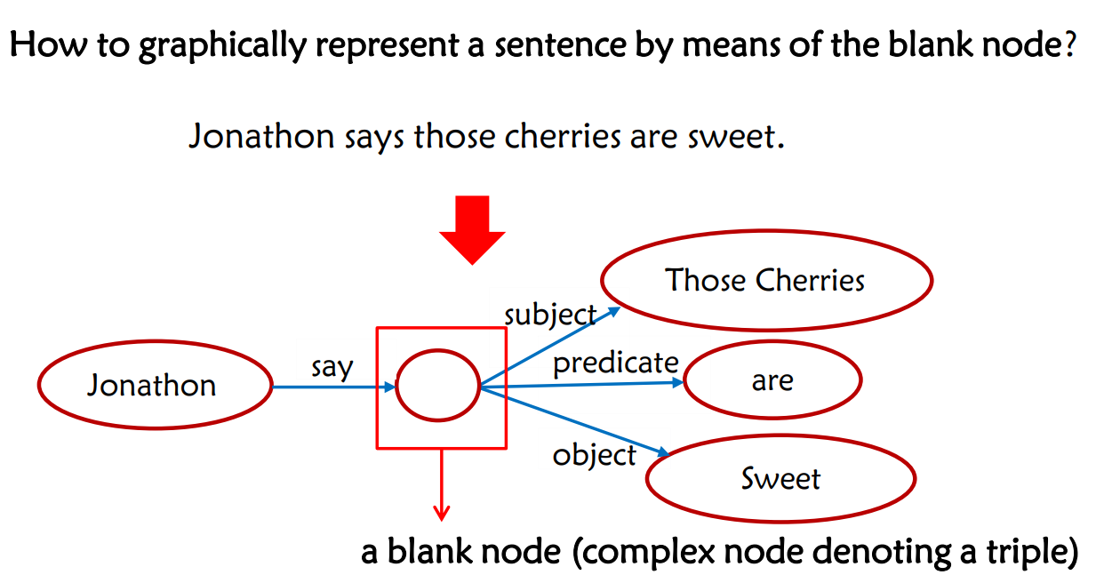

**Turtle** (Terse RDF Triple Language): - list as S P O triples (easy to read) - IRIs are in <angle brackets>

- triples end with a full-stop . - whitespaces are ignored

**RDF/XML:** - RDF is originally designed on basis of XML (data exchange format on the Web) - a lot of tools and libraries support XML - Namespaces are used for disambiguating tags; - Tags belonging to the RDF language come with a fixed namespace, usually abbreviated “rdf”. - Untyped literals can be left as free text; - A subject can contain several property elements; - Object-descriptions can be used as subject-descriptions for further triples.

**N-ary relationa:**• Not all relations are binary.

• All N-ary relations can be “encoded” as a set of binary relations using auxiliary nodes, and this process is called reification.(物化)

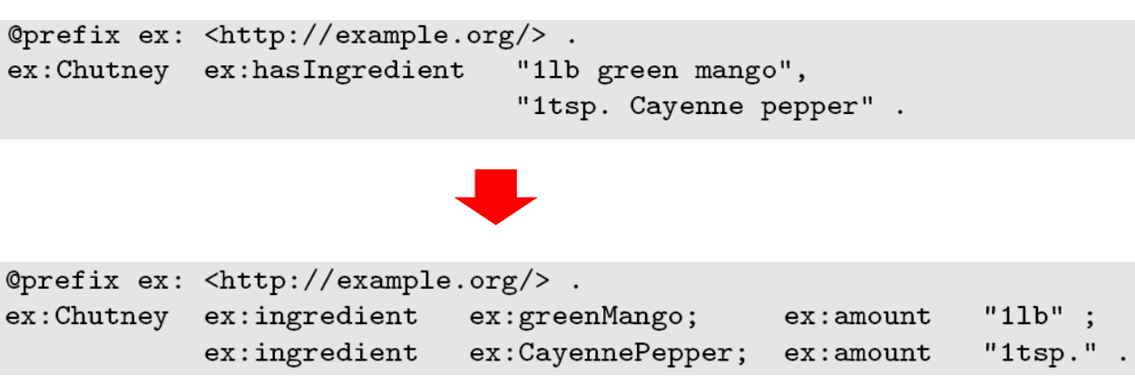 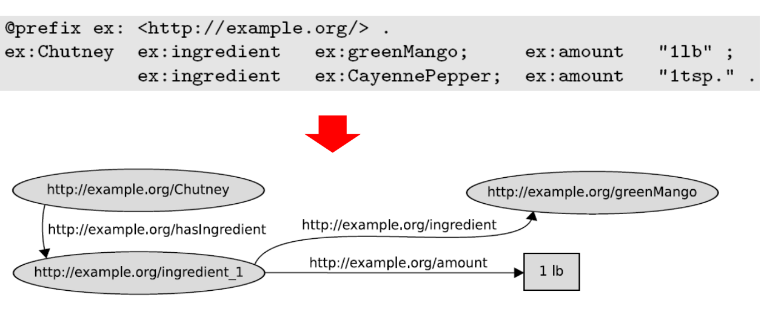

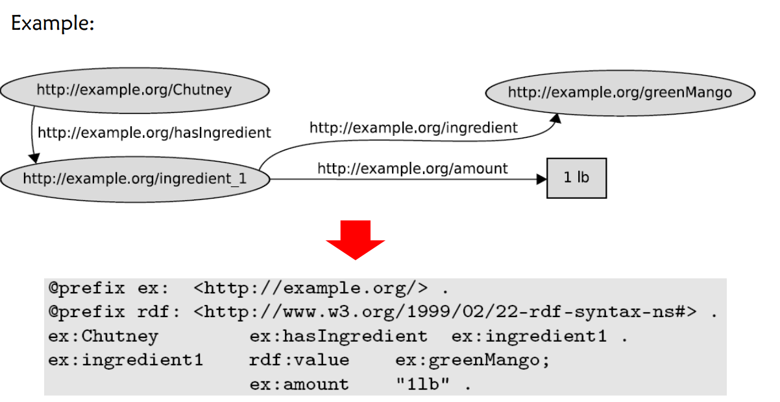 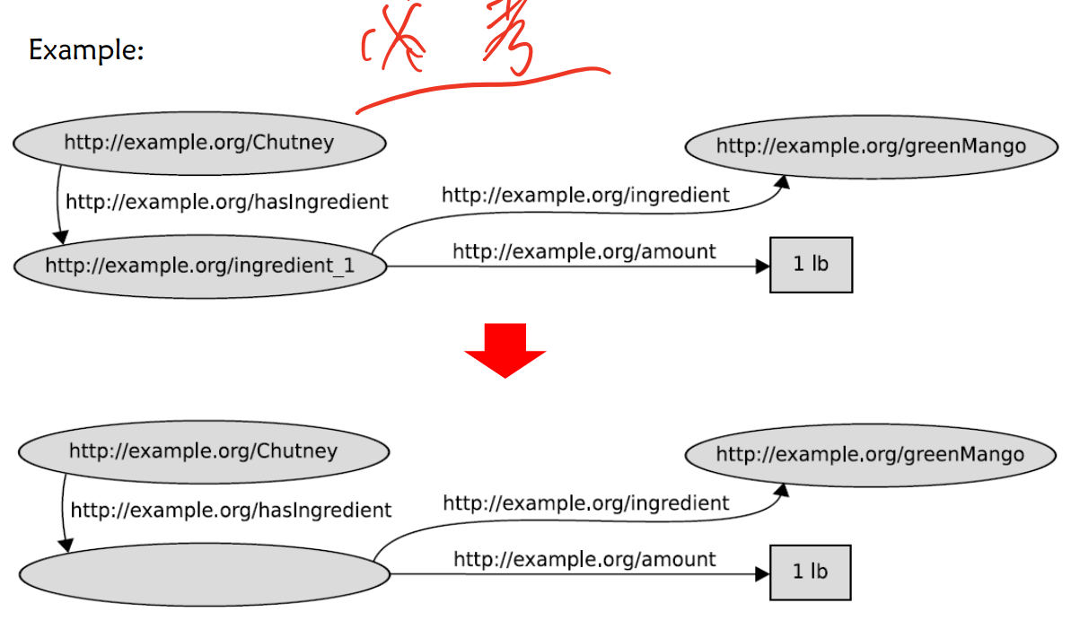

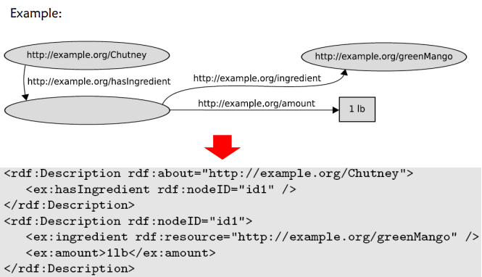

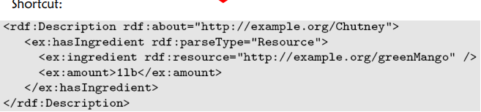

**RDFS**

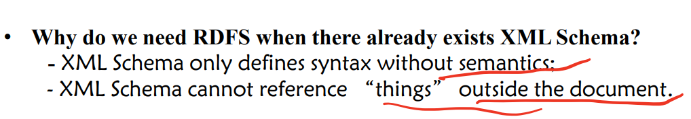

rdf:type ：用于指定个体的类；rdf:value: rdf:Property的实例 ，可以用于描述结构化的值。

rdf:subject, rdf:predicate, rdf:object：主谓宾

rdfs:Class. 用于定义类。 rdf:Property: class of all relationships (properties)

(= those resources, that are referenced via predicate URIs)

rdfs:subClassOf：用于指定类的父类；

rdfs:subPropertyOf：用于指定属性的父属性；

rdfs:domain：用于指定属性的定义域；rdfs:range：用于指定属性的值域。可用于类型推理。

rdfs:Resource : All things described by RDF are called resources, and are instances of the class rdfs:Resource

rdf:List, rdf:Seq, rdf:Bag, rdf:Alt, rdfs:Container: diverse kinds of lists

rdfs:ContainerMembershipProperty : class of all relationships that represent a containedness relationship

rdf:XMLLiteral : class of all values of the predefined datatype XMLLiteral

rdfs:Literal: class of all literal values (every datatype is a subclass of this class)

rdfs:Datatype :class of all datatypes(therefore it is a class of classes, similar to rdfs:Class)

rdf:Statement : class of all reified propositions (triples)

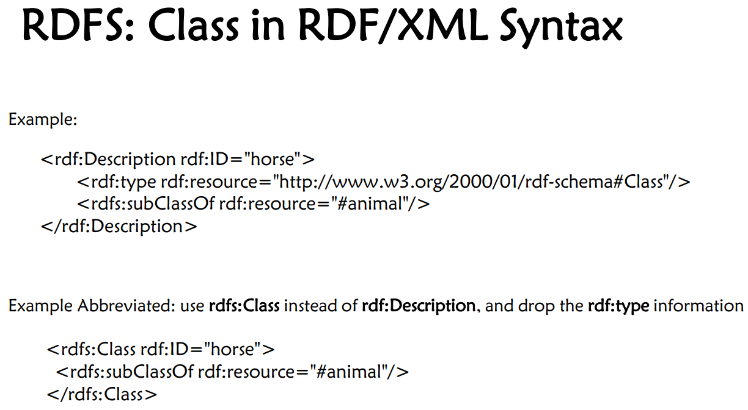

**!!! rdf:type 连接schema 层与instance 层**

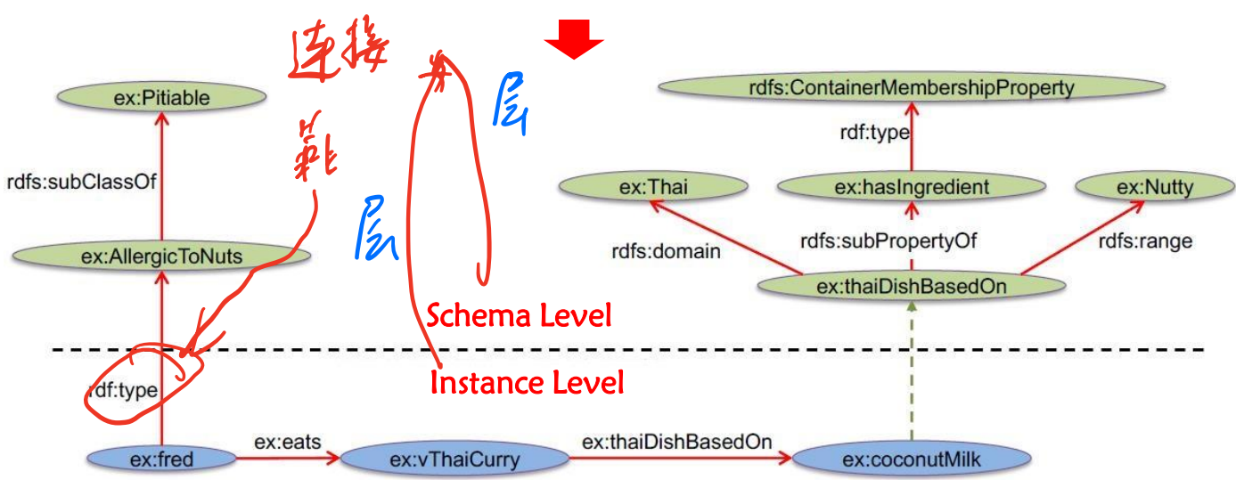

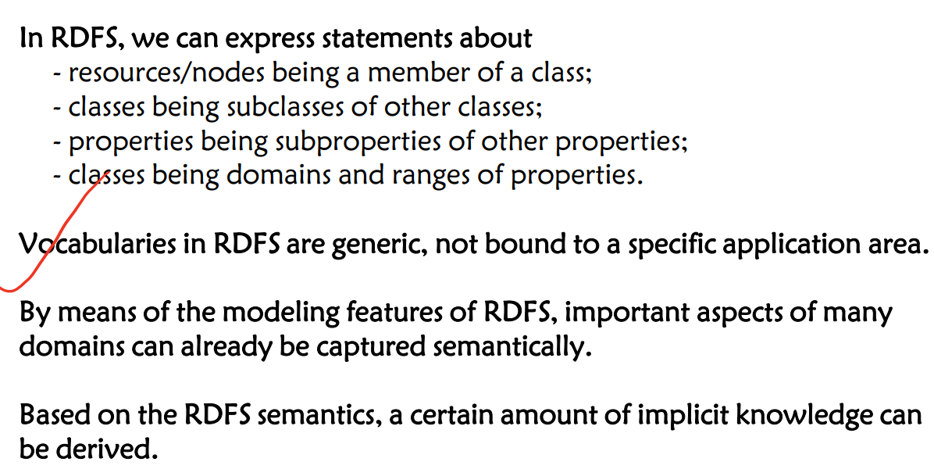

**Owl**

Problems in RDFS: The ability to describe resources is not so strong. In complex scenarios, the semantic expressive ability of RDFS is weak, since RDFS lacks many features:

1) RDFS does not have constraints on property domain and range: For “Human”, the range of “hasChild” should be “Human”; For “Elephant”, the range of “hasChild” should be “Elephant”.

2) RDFS does not have cardinality constraints: The number of “Father” for one person should be one; One person has at most two parent. (property: “hasParent”)

3) RDFS does not have descriptions on property characteristics: transitivity, symmetry, functionality, relations to other properties (inverse, equivalence)…

4) RDFS lacks definitions on equivalence: equivalence on individuals, classes, and propert

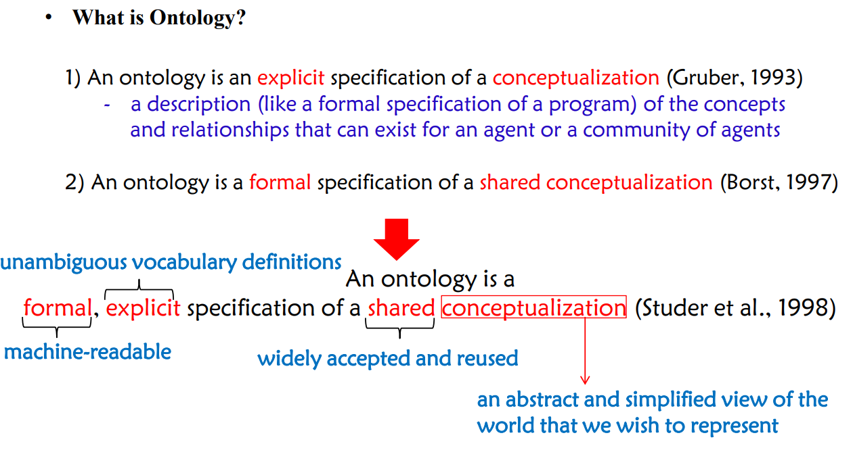 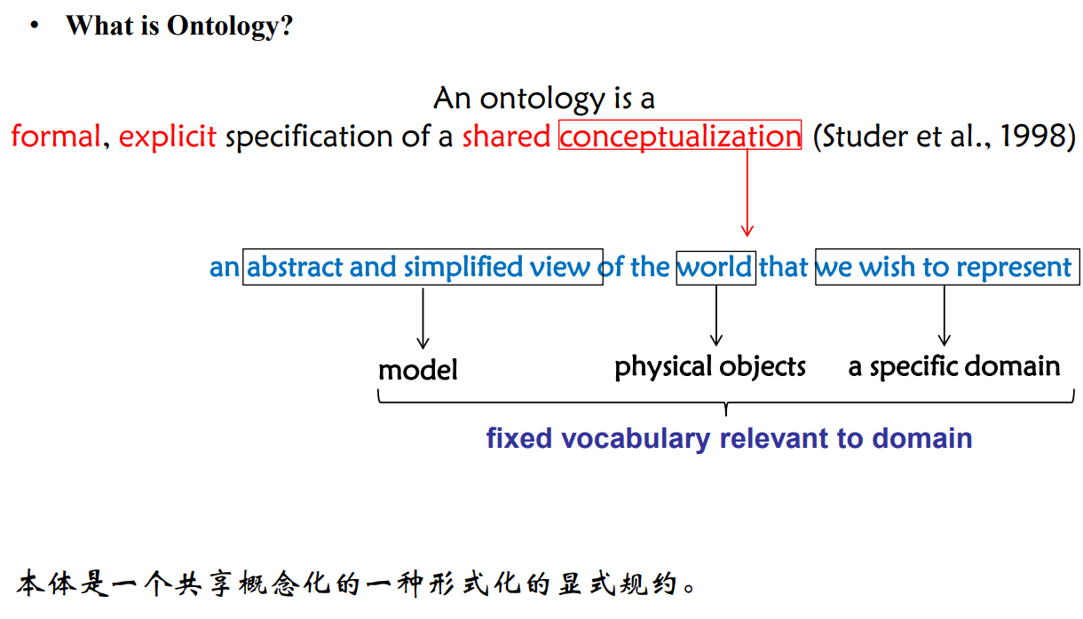

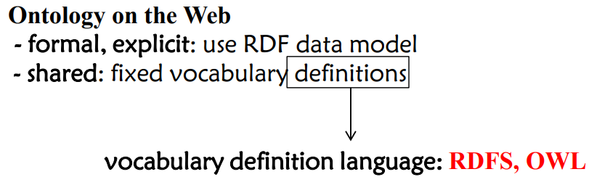 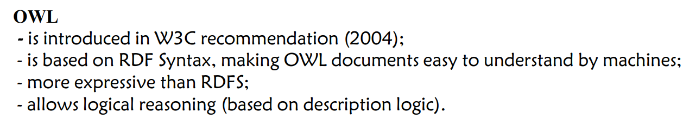

owl:equivalentClass 类

owl:equivalentProperty 属性

owl:sameAs 实例



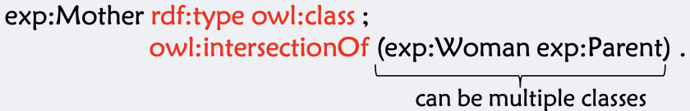

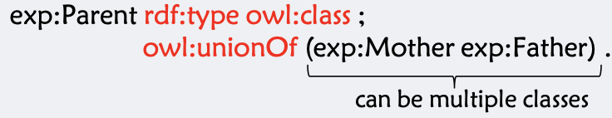

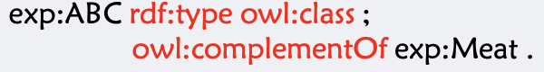

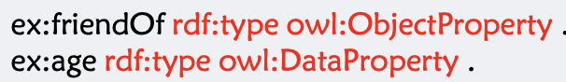



Everyone has only one mother. (宾语只有一个)



Each post-graduate student has only one supervisor.（主语只有一个）





exp:ancestor owl:inverseOf exp:descendant 关系之间的上下位

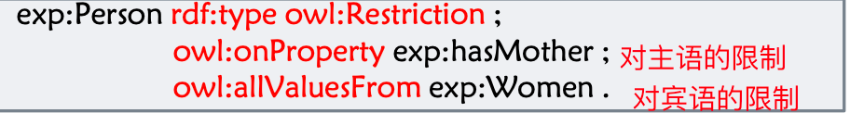

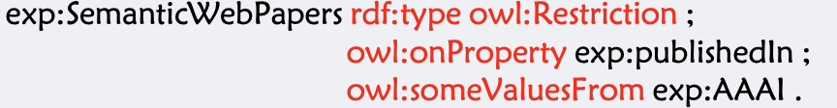

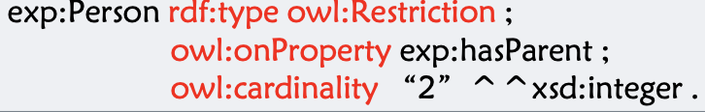

1) Giraffe is a kind of animal which eats leaves.

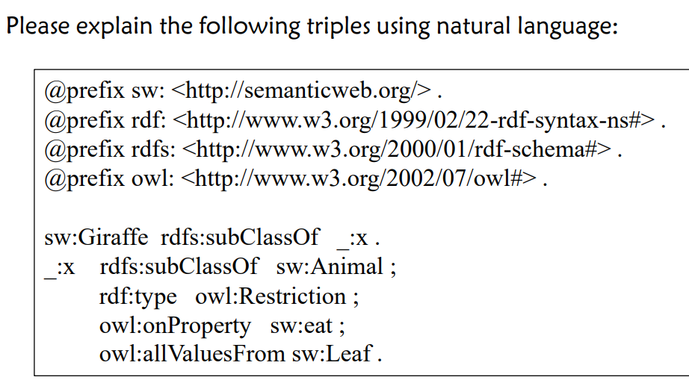

2) ChildlessPersons are the persons who are not parents.

@prefix sw <http://semanticweb.org/>

@prefix rdf: <http://www.w3.org/1999/02/22-rdf-syntax-ns#>

@prefix owl: <http://www.w3.org/2002/07/owl#>

_:x0 rdf:type owl:class ;

owl:complement sw:Parent .

sw:ChildlessPerson rdf:type owl:class ;

ow:intersectionOf (sw:Person _:x0) .

3) Every segment can only have two end points;

4) The set of integers is divided into the set of positive integers and the set of negative integers.

sw:Integers rdf:type owl:class ;

owl:unionOf (sw:PositiveInteger sw:NegativeInteger) .

5) Explain the following OWL triples in natural language

ex:LuxuryBathroomApartment rdf:type owl:class ;

rdfs;subClassOf _:x .

_:x rdf:type owl:Restriction ;

owl:onProperty ex:hasbathroom ;

owl:allValuesFrom ex:LuxunryBathroam ;

owl:equivalentClass ex:Apartment.

Luxury Bathroom Apartments are apartments that only have luxury bathrooms.

**Description Logic**

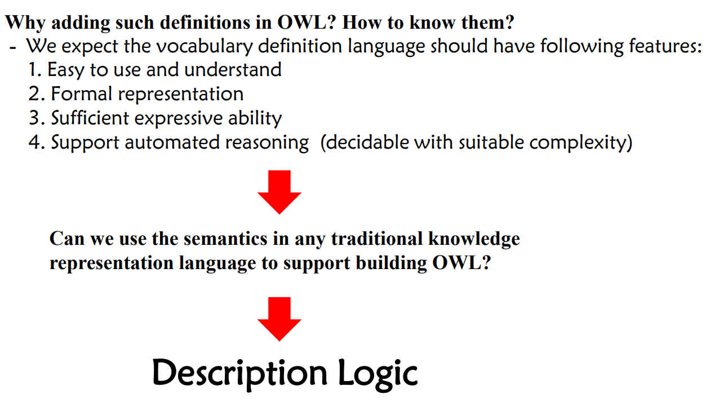

**Propositional Logic:** deals with propositions (which can be true or false) and relations between propositions, including the construction of arguments based on them. Negation (not): ¬ , • Conjunction (and): ∧ , • Disjunction (or): ∨, • Material implication (if...then): → , • Biconditional (if and only if): ↔ .

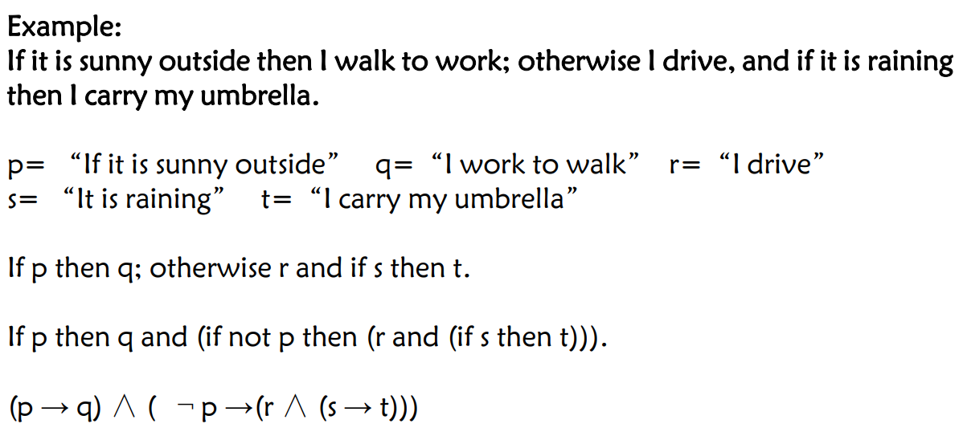

**Problems:** - Hard to identify “individuals” (e.g., Mary, 3) - Can’t directly talk about properties of individuals or relations between individuals (e.g., “Bill is tall”) - Generalizations, patterns, regularities can’t easily be represented (e.g., “all triangles have 3 sides”)

**First Order (Predicate) Logic**: - is a formal language in which propositions are expressed in terms of predicates (relations), variables and quantifiers.

- contains different kinds of symbols:

• **Constant symbols**, which represent individuals in the world – Mary – 3 – Green

• **Function symbols,** which map individuals to individuals – fatherOf(Mary) = John – colorOf(Sky) = Blue

• **Predicate symbols**, which map individuals to truth values – greater(5,3) – green(Grass) – color(Grass, Green)

• **Variable symbols** – E.g., x, y,

• **Connectives** – Same as in Propositional Logic

• **Quantifiers** – Universal ∀ – Existential ∃

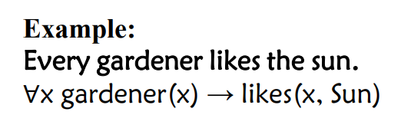 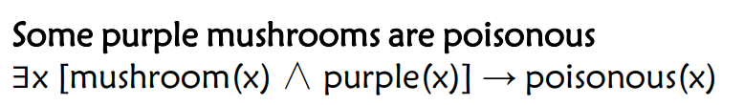 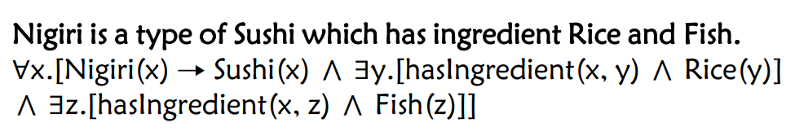

**Description Logic:** - Fragments of **first order logic (FOL)** - Desirable computational properties: decidable and lower complexity than FOL - Succinct and variable free syntax

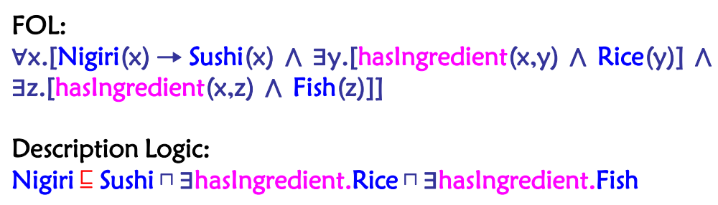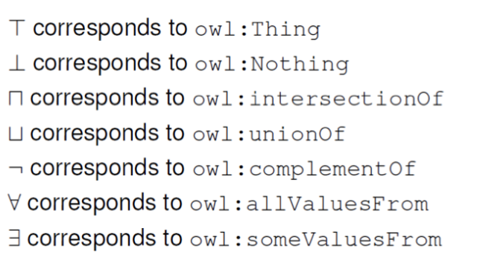

TBox是描述的公理，描述概念之间的关系，如C等于D，C是D的子集 ; ABox的描述的断言，描述个体与个体，个体与概念的关系，如r(a,b),C(a)

Ontology (aka **Tbox,** Terminological Box) axioms define terminology (schema).

Ground facts (aka **Abox**, Assertion Box) use the terminology (data)

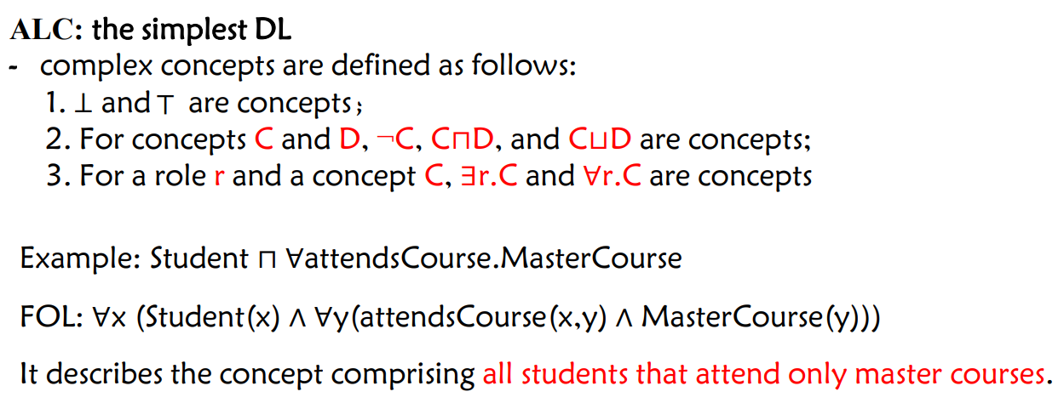

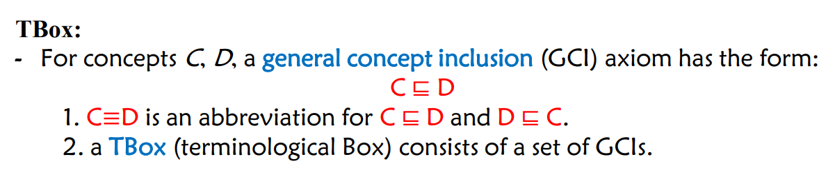 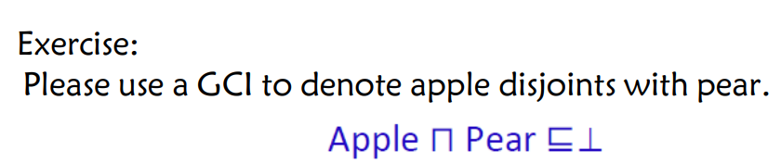

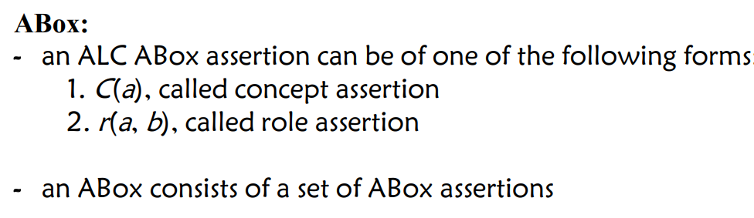

1) Any student must attend at least one lecture: Student ⊑ ∃Attend.Lecture

2) John is a brother of Mary: Brother(John,Mary)

3) Parents are exactly those who are mothers or fathers: Parent ≡ Mother ⊔ Father

4) Every teacher must teach someone: Teacher ⊑ ∃Teach.Person

5) Every finger is a bodypart and is a part of hand:

Finger ⊑ BodyPart⊔ ∃PartOf.Hand

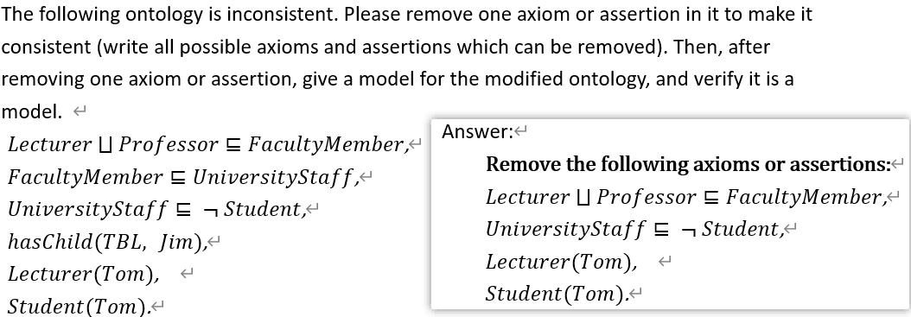

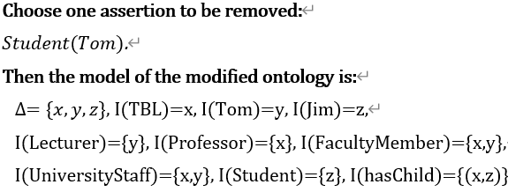

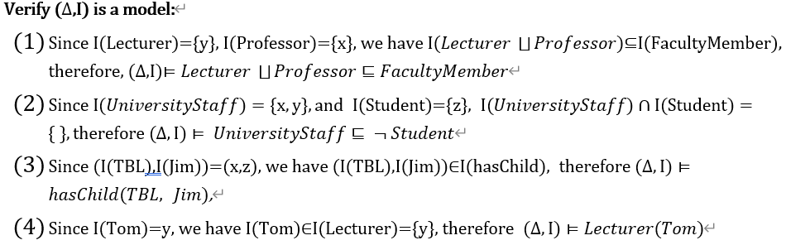

**Incoherent ontology:** ontology with at least one unsatisfiable concept.

**Inconsistent ontology:** ontology without a model.

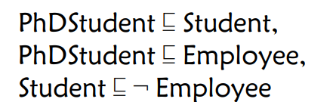 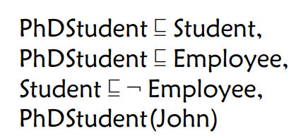

**Knowledge Graph Reasoning**

**KG Reasoning** is to infer new knowledge from the given KG.

**Classification: - Logical reasoning - Statistical reasoning**

**Logical Reasoning** include: - **Deductive Reasoning(演绎推理)** 用规则和前提来推导出结论:determines whether the truth of a conclusion can be determined for that rule, based solely on the truth of the premises.

- **Inductive Reasoning(归纳推理）**由大量的前提和结论所组成的例子来学习规则**:** attempts to support a determination of the rule.

- **Abductive reasoning(溯因推理)** 从事实推理到最佳解释的过程: selects a cogent set of preconditions. 学习规则 寻找前提

**Deductive Reasoning •** Classification: **- Forward reasoning - Backward reasoning**

**Forward Reasoning** (forward chaining) starts with the available data and uses inference rules to extract more data until a goal is reached. - An inference engine using forward chaining searches the inference rules until it finds one where the antecedent (If clause) is known to be true. - When such a rule is found, the engine can conclude, or infer, the consequent (Then clause), resulting in the addition of new information to its data. - The forward chaining approach is often employed by expert systems

**Materialization** is to compute all implicit statements by applying rules on assertions.

**Classification** is to compute all implicit subclass relations by applying rules on a TBox

**Backward reasoning** (Backward chaining) is an inference method described colloquially as working backward from the goal. - It is often used in entailment checking or query answering in KG. - It uses the rules to rewrite the query in several ways and the initial query is entailed if a rewritten query maps to the initial facts.

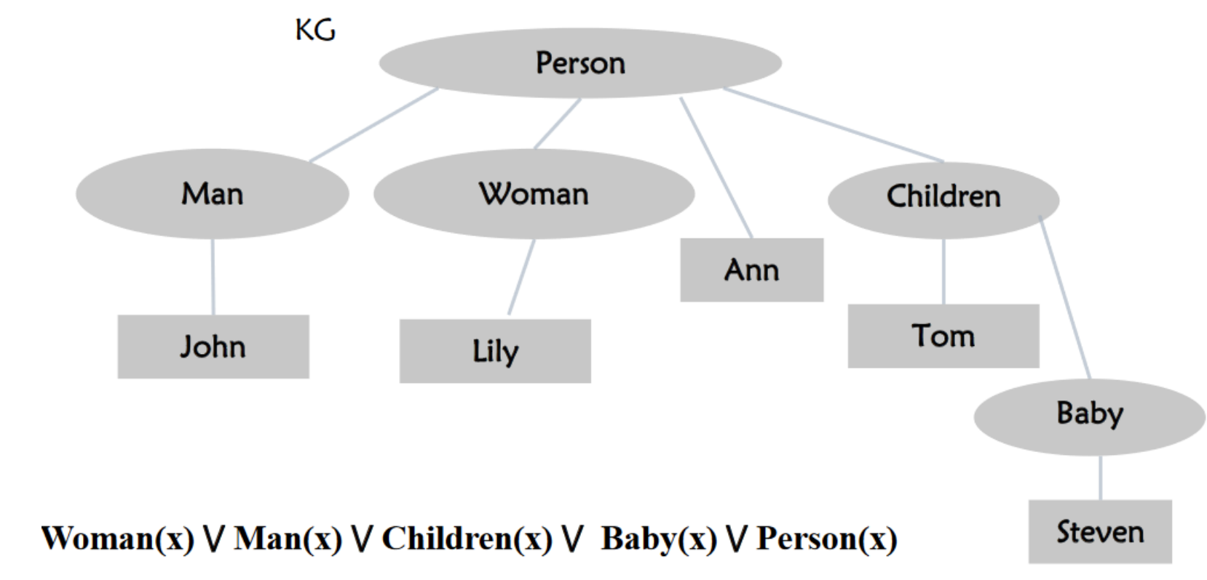

In logical reasoning, we mainly focus on deductive reasoning, i.e., leveraging rules and preconditions to infer new knowledge. • Deductive reasoning including forward reasoning and backward reasoning. • **Forward reasoning** actually gets as much knowledge as possible before application. • **Backward reasoning** starts from the target/ application and can quickly get the result

**Datalog** is a declarative logic programming language, which is designed for knowledge base and database. • Datalog has similar expressive ability with OWL. • Datalog supports recursion, and rule editing (more freely) for reasoning.

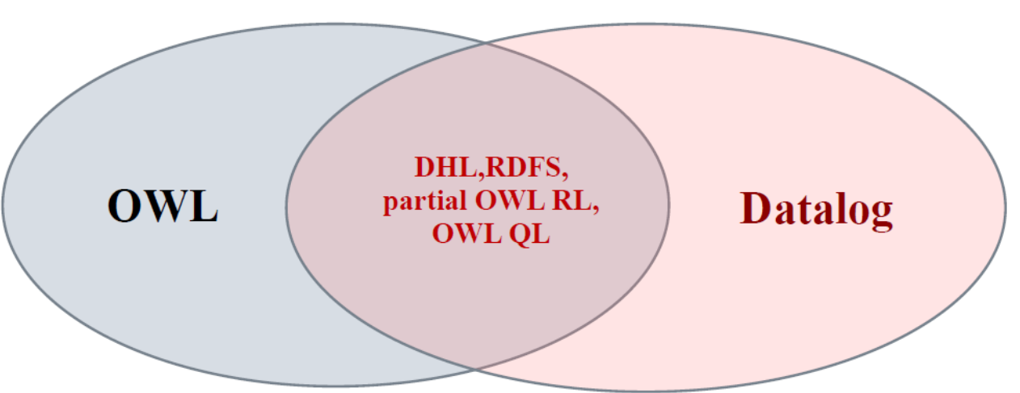 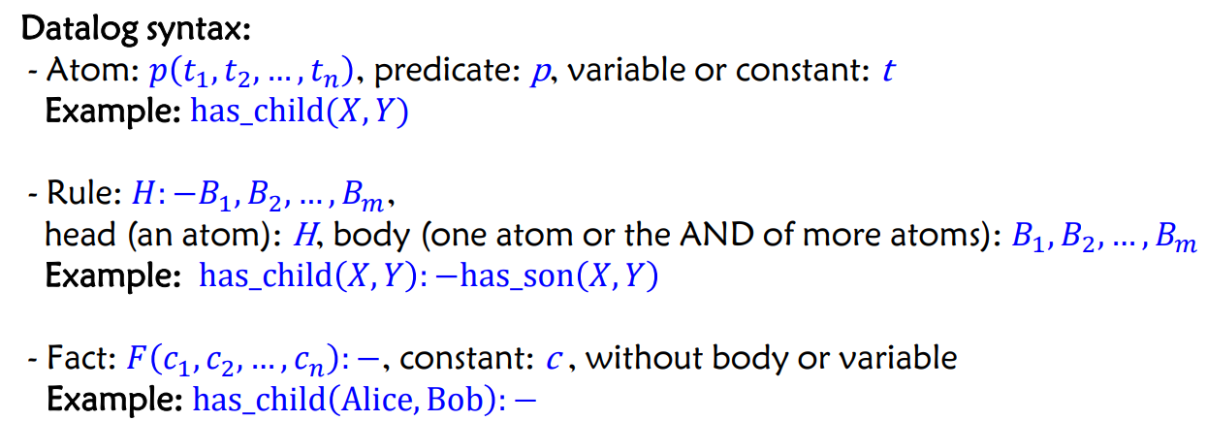

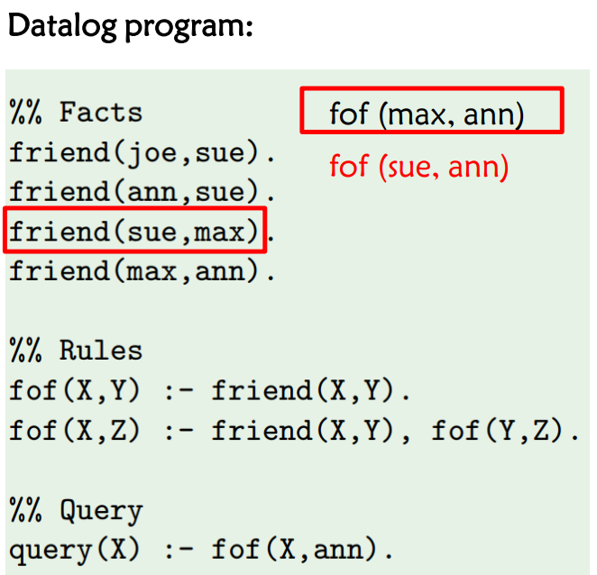 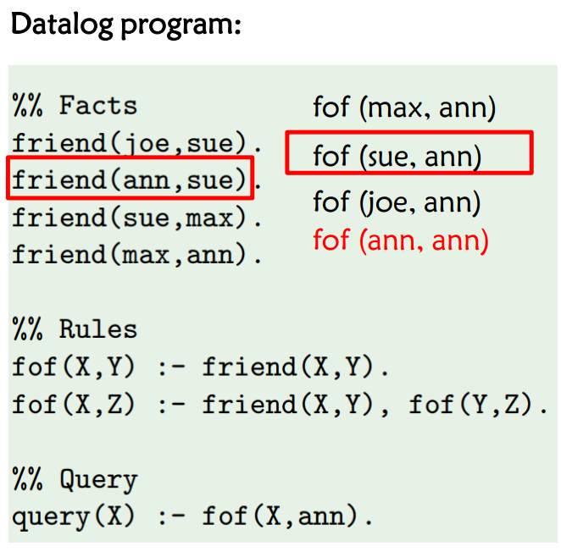

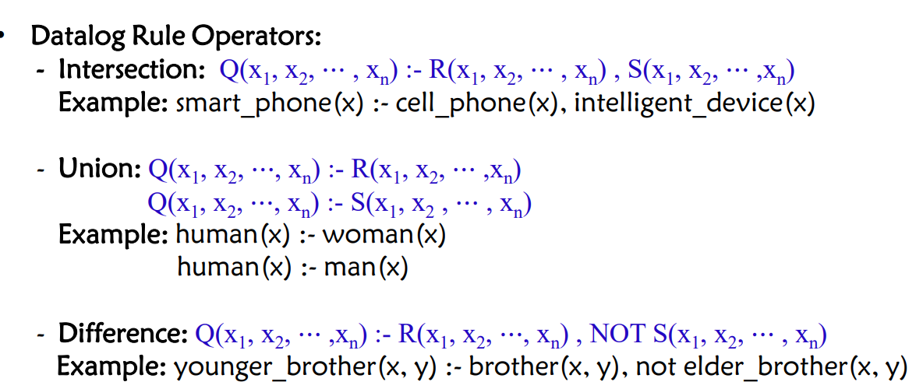

**Statistical Reasoning** tries to find suitable statistical models to fit the samples and predicts the expected probabilities of the inferred knowledge. - knowledge graph embedding based reasoning - inductive rule learning based reasoning - multi-hop reasoning.

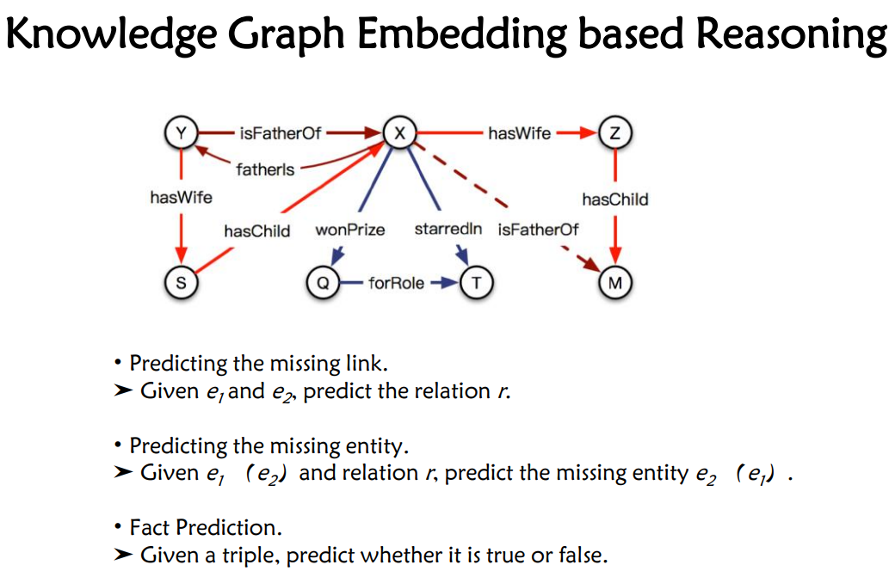



**One-hot representation:** - Foundation of Bag-of-words Model

**Distributional Representation** When a word w appears in text, its context is the set of words that appear nearby (within a fixed-size window)： Use many contexts of w to build up a representation of w

**Word Vectors** We will build a dense vector for each word, chosen so that it is similar to vectors of words that appear in similar contexts.

Note: **word vectors** are sometimes called word embeddings. They are a **distributed representation.**

**Advantage of Distributed Representation** 1. Deal with data sparsity problem in NLP 2. Realize knowledge transfer across domains and across objects 3. Provide a unified representation for multi-task learning

What is the **representation learning**? Objects are represented as dense, real-value and low-dimensional vector

**Different ways of KG Representation**

**Based on discrete symbols**  **Based on continuous vectors**

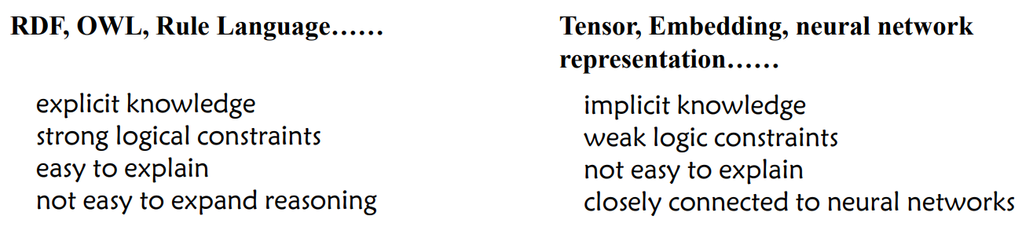

Knowledge Graph Embedding: **Application**

**Entity Prediction, Relation Prediction, Recommendation System**

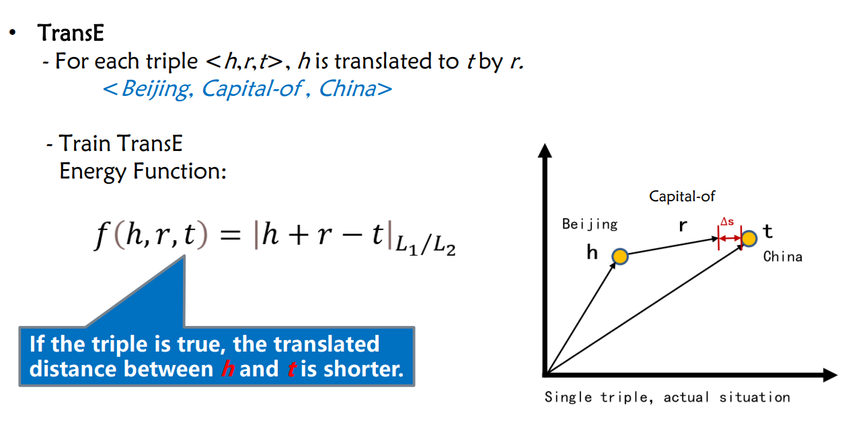

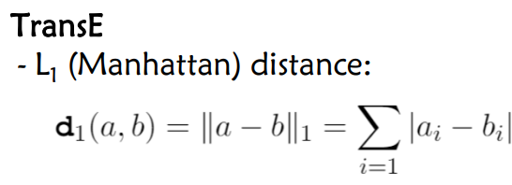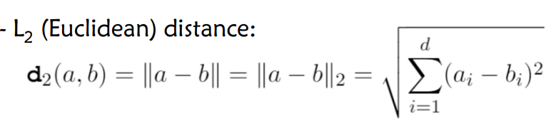

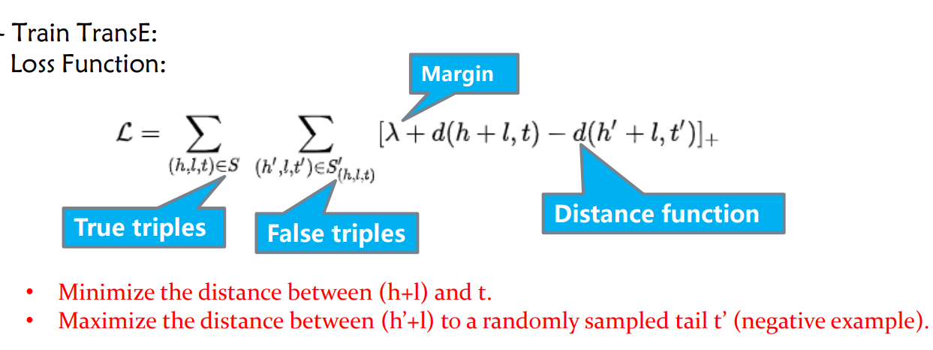

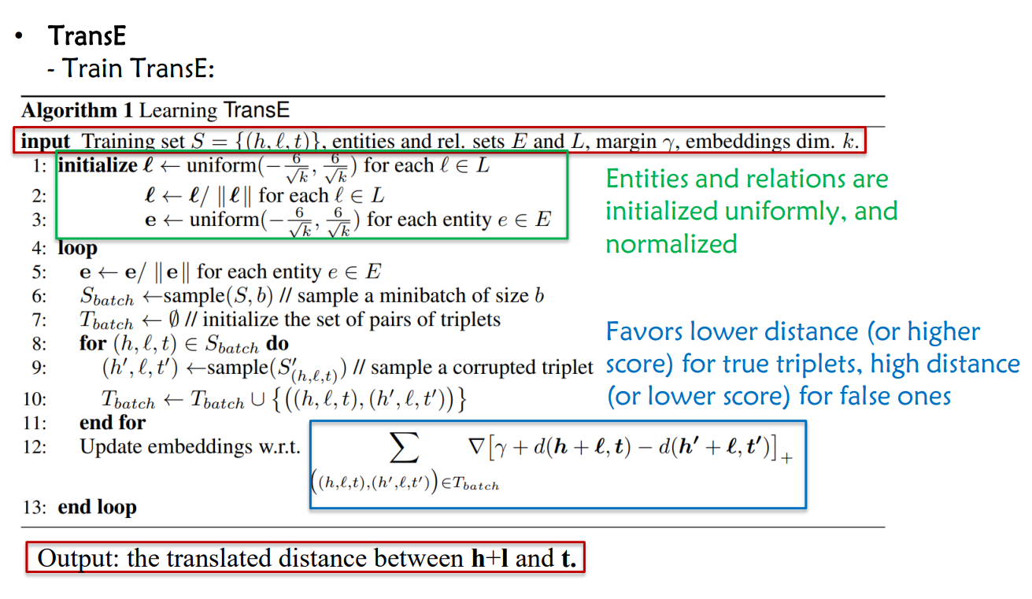

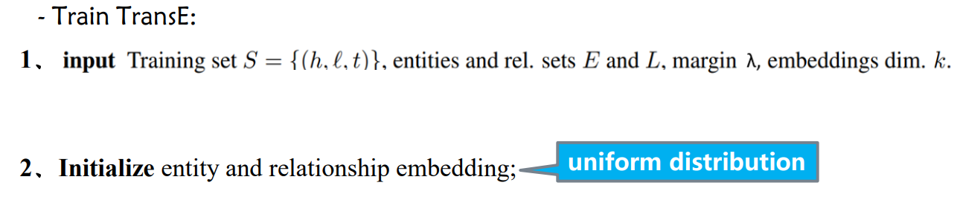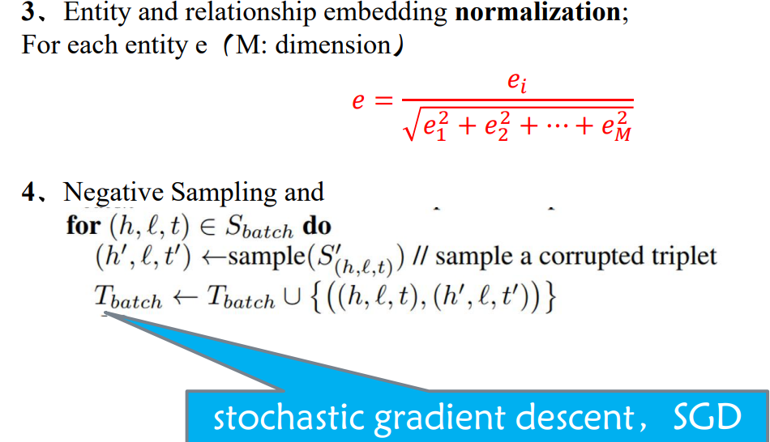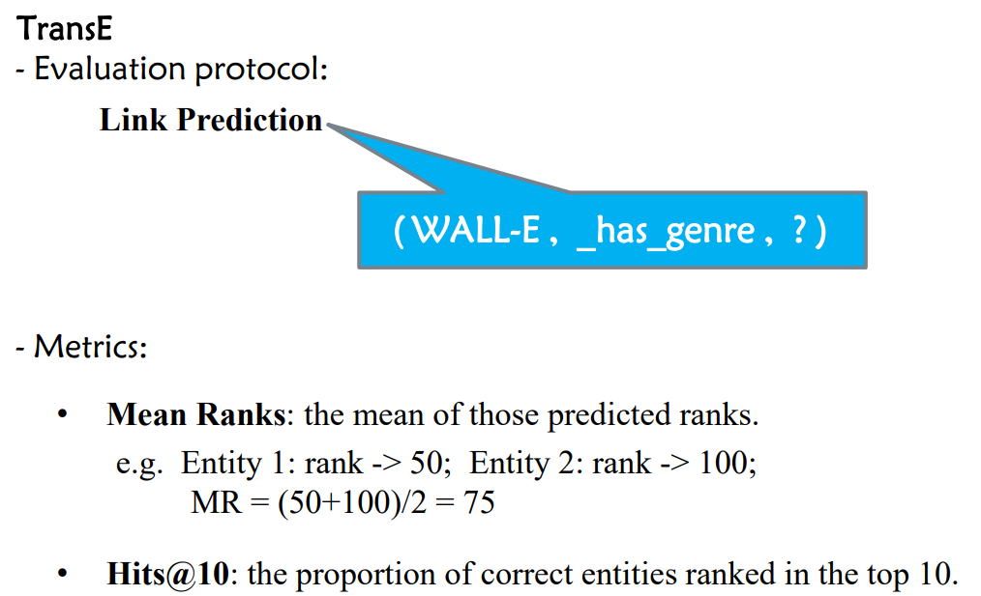

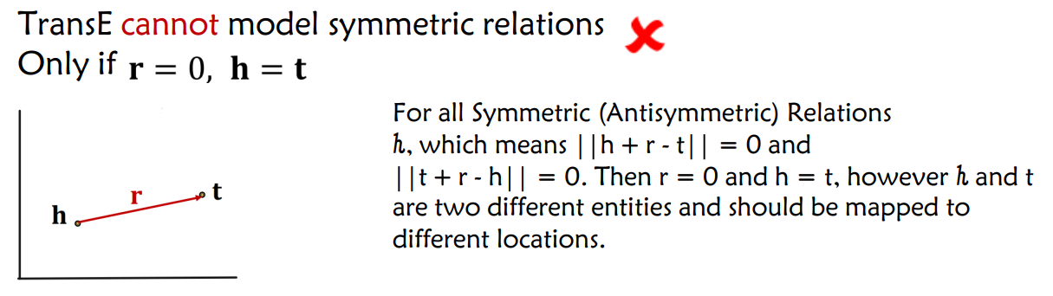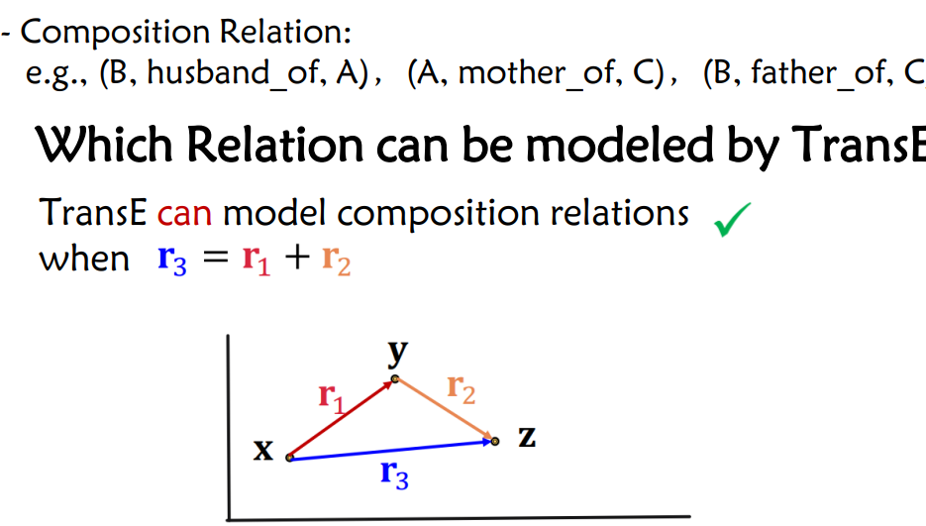

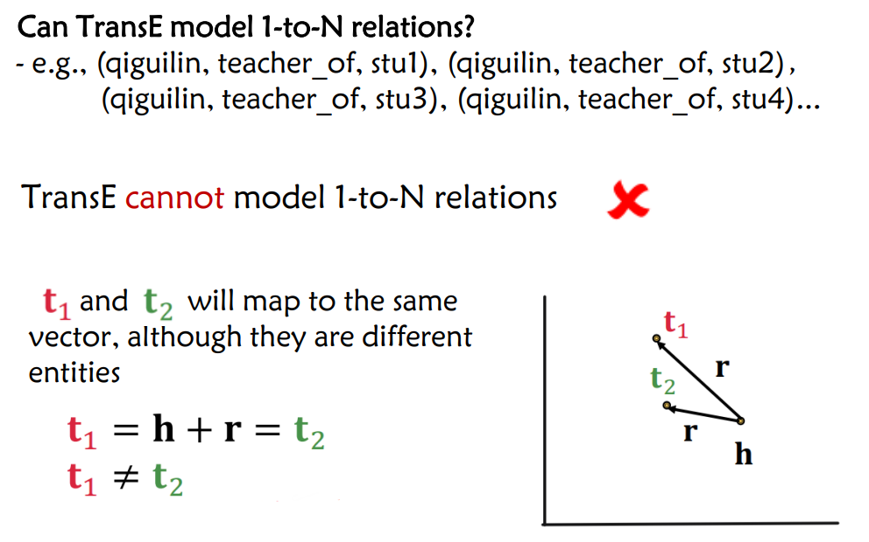

**Issue of TransE** TransE cannot handle symmetric relations and 1 to n, n to 1, n to m relations.

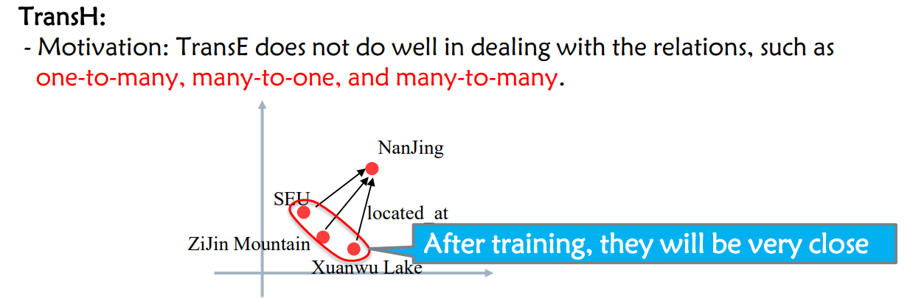

**TransH proposes:** modeling a relation as a hyperplane together with a translation operation on it.

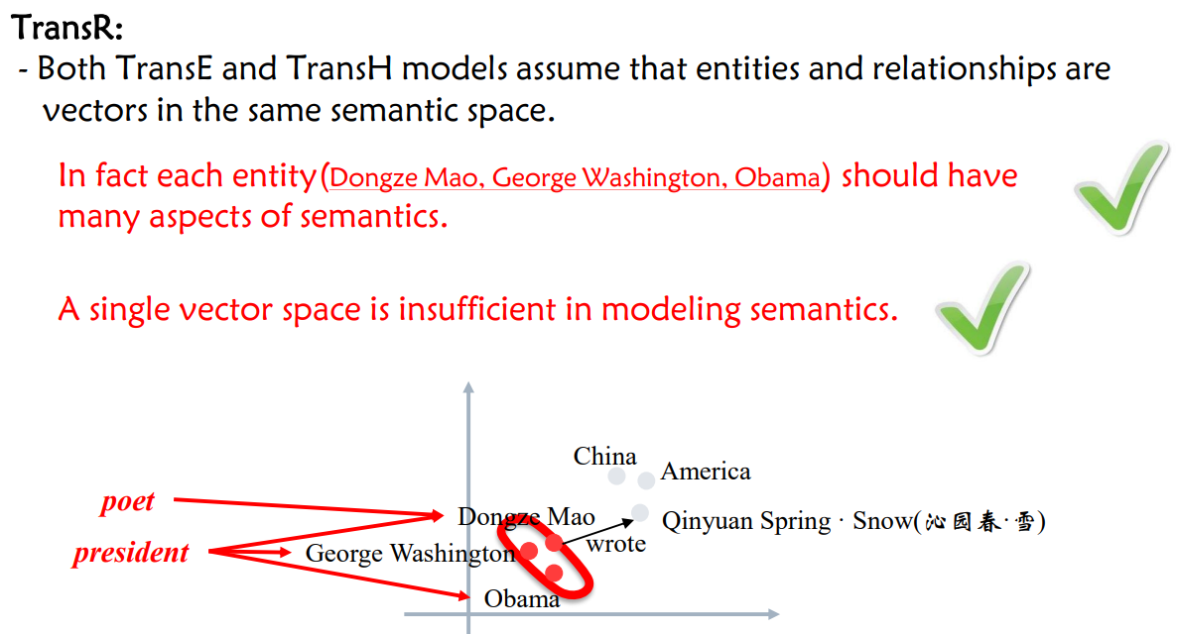

**TransR proposes**: • Build entity and relation embeddings in the separate entity space and relation spaces;

• Then projecting entities from entity space to the corresponding relation space and building translations between projected entities.

EX: In training the knowledge graph embedding model TransE, we need to perform negative sampling for each triple in the training set. Given one triple (China, hasCity, Beijing) in the training set, and all entities {Nanjing, Shanghai, New York, Paris, Rome, Italy, Athens} in the knowledge graph, please write a negative sample, and analyze if all possible negative samples are real false. If not, can you analyze the reason and give your own solution?

针对三元组(China, hasCity, Beijing)，随机将头实体或尾实体替换为其他实体，得到一个三元组即为一个negative sample。随机替换的结果并不一定得到真的负例，即会得到false negative的三元组，例如 (China, hasCity, Nanjing/ Shanghai)，原因是hasCity是一个1对多关系，随机替换尾实体得到的三元组也可能是正确的三元组，解决方案是针对1对多关系，尽可能去替换头实体，针对多对1关系，尽可能去替换尾实体。

**Relational Database**

**Knowledge Graph Construction**: Extracting knowledge from heterogeneous data sources to form a knowledge graph

**Principles of designing database terms**: • Think of all the facts that will be collected • plenty of fields • consult widely • small facts, “atomic” • difficult to add later

**Joins between tables: Primary Key** • Each table needs a primary key • Choose (at least) one field that only contains unique values Commonly an auto-incrementing whole (integer) number

**Joins between tables**: relate two tables by **primary keys and foreign keys**

**Database design: workflow**

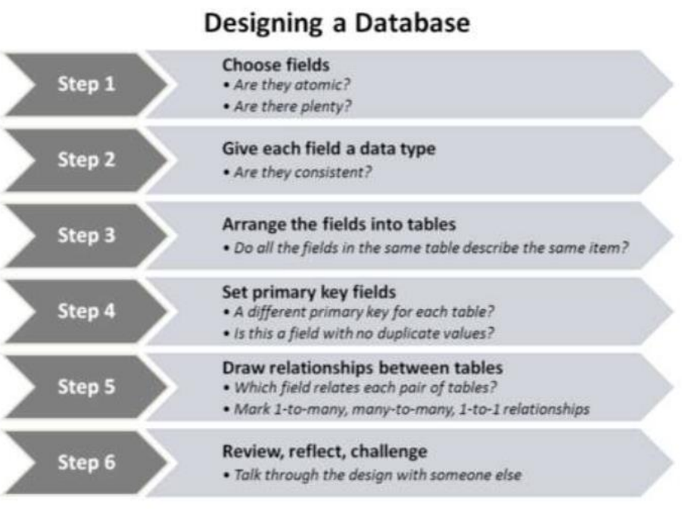

**When to use a relational database** Your data can be organized in tabular form • e.g., information about things that share common properties (organized in one column/ field) You are interested in multiple types of entity • And the relationships between them • Entities may be concrete or more abstract You want to identify instances of things that meet certain criteria (query) You want to be able to present one dataset in multiple different ways • Query results can be exported and used elsewhere

**Benefits of relational databases** More accurate representation of complex data • And helps avoid duplication of information Permits flexible querying • Wider range of questions possible than with a spreadsheet (multiple tables) • Useful if you are unsure which questions you will want to ask Suitable for collaborative use • Multiple people can access and use the same database • Can encourage (or enforce) consistency in data entry Technology has been around for several decades • Widely supported and well understood

**RDB2RDF: Direct Mapping & R2RML**

**RDB2RDF** is to map the content of Relational Databases to RDF.

Two **W3C RDB2RDF Standards**: - **Direct Mapping - R2RML**

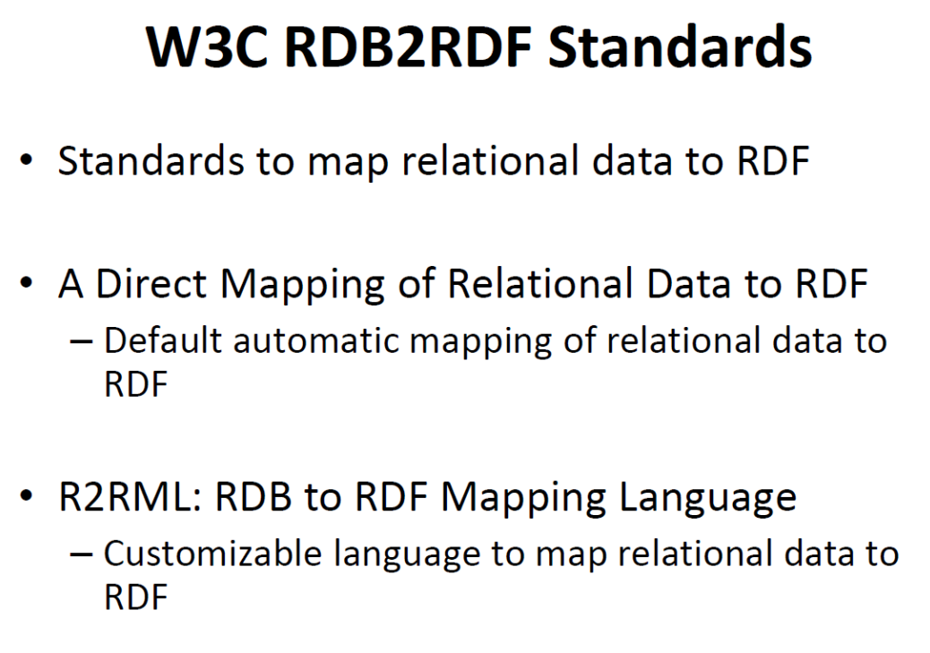

**Direct Mapping Idea:** Convert relational data into RDF, by making explicit the semantics encoded in the **relational schema**. Create **URIs** following some **simple rules**: Map • table to class • column to property • row to resource • cell to literal value • in addition cell to IRI - if there is a foreign key constraint

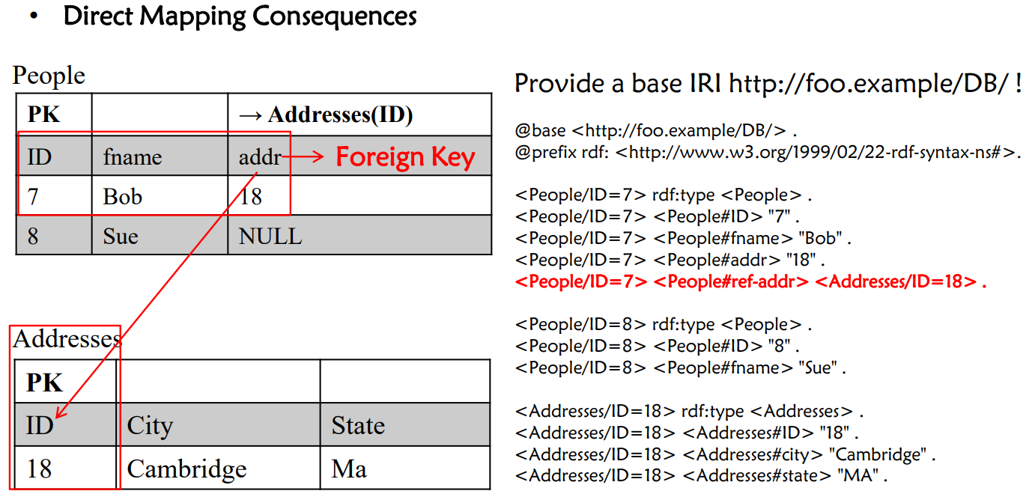

**R2RML** is a language for specifying mappings from relational to RDF data.

A mapping takes as input a **logical table,** i.e., a database table, a database view **(a virtual table collecting data from relational tables**), or an SQL query.

A logical table is mapped to a set of triples by a rule called **triples map.**

**A triples map has three parts:** - the input **logical table** - a **subject map** - several **predicate-object maps** (combining predicate and object maps).

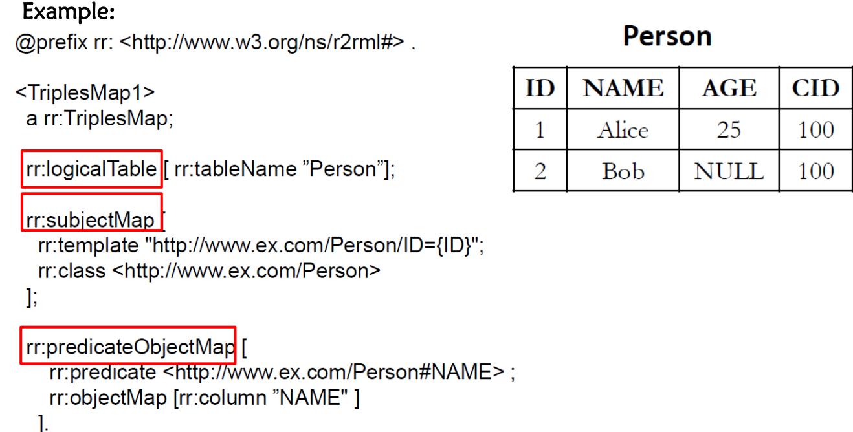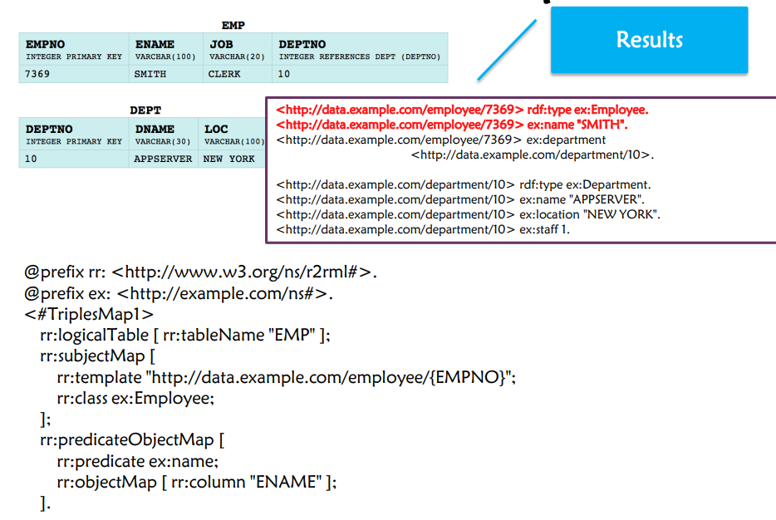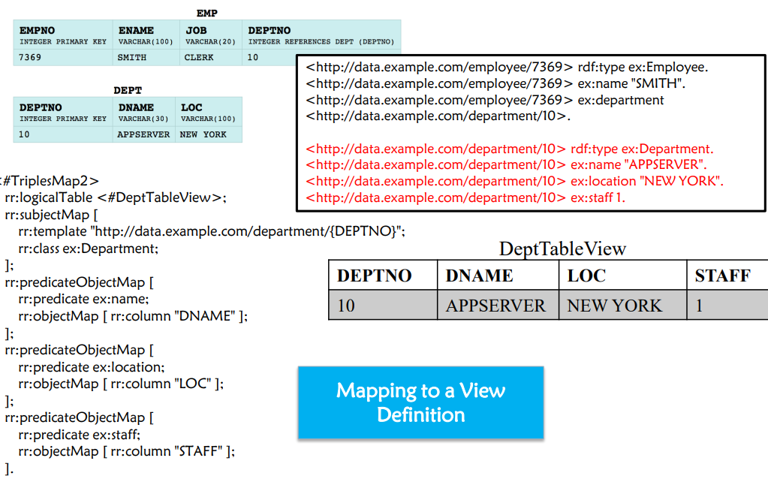

为了生成谓词ex:department的三元组，需要将EMP和DEPT进行连接：

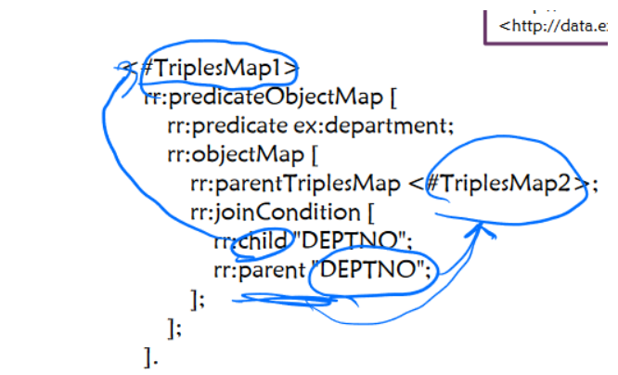

**Triple Extraction from Relational Web Tables**

**Steps of Triple Extraction** • **Entity Linking:** Mention to Entity • **Column Typing:** Column to Class (i.e., Type) • **Relation Extraction**: Semantic Association between Columns to Relation

**What is Entity Linking (EL) in Web Tables?** △ Mapping the string mentions in table cells to their referent entities in a given knowledge base (KB).

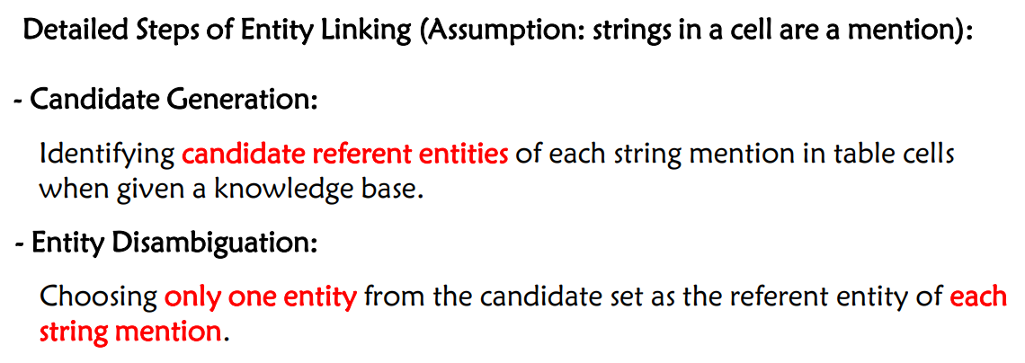

**Dictionary-based method** - collecting all (string, entity) pairs from anchor texts, redirect pages, and disambiguation pages in Wikipedia; - ranking based on co-occurrence frequency.

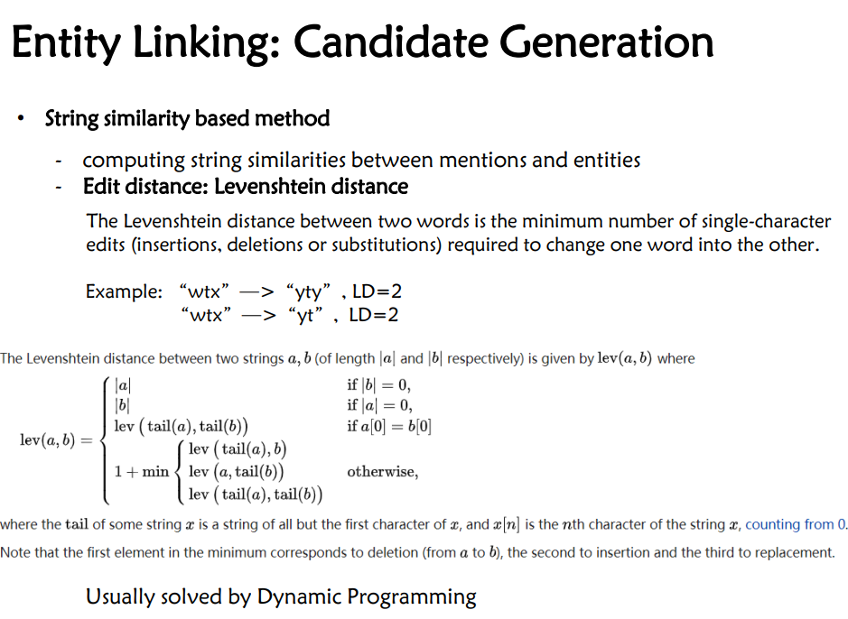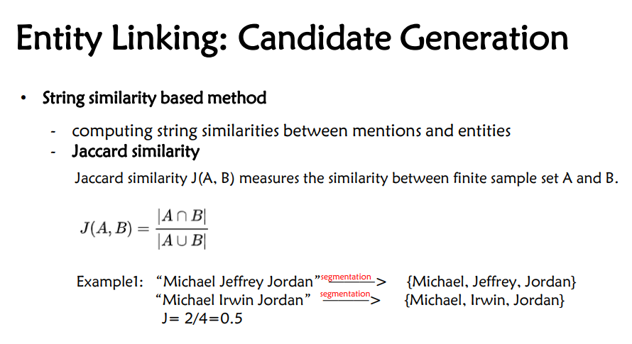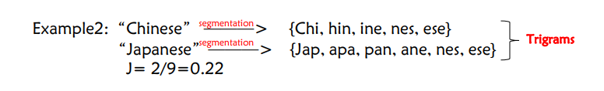

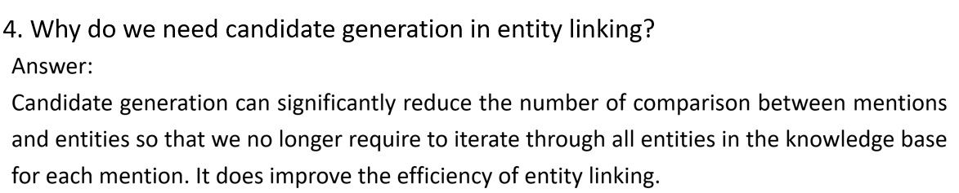

**Synonym-based method** - combine with the dictionary-based method or string similarity based method - use a knowledge graph containing rich synonym information, e.g., BabelNet, WordNet

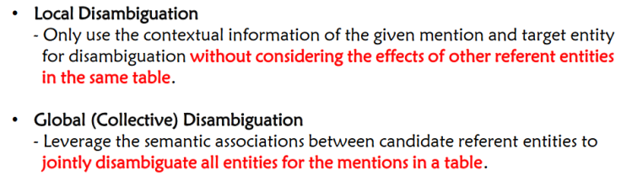

**Local Disambiguation**

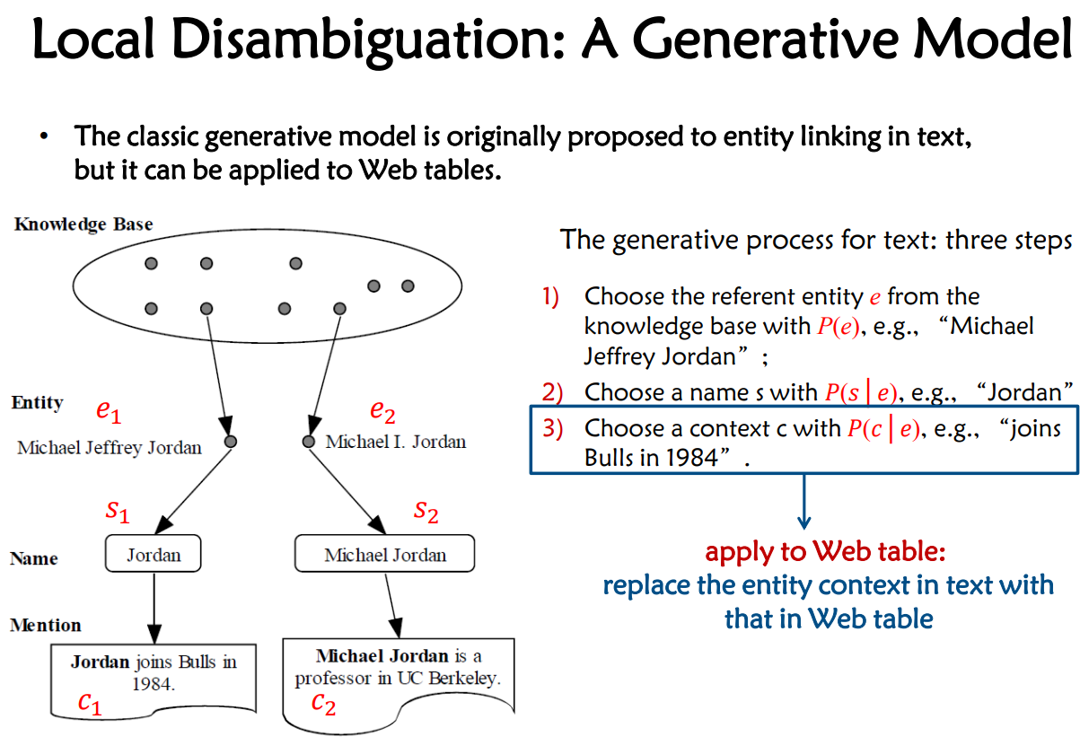

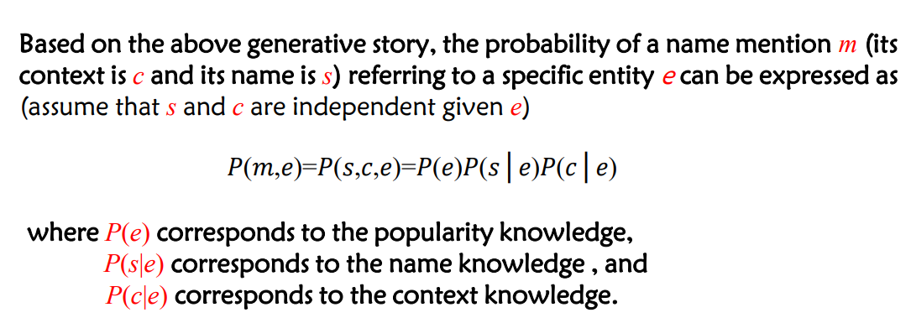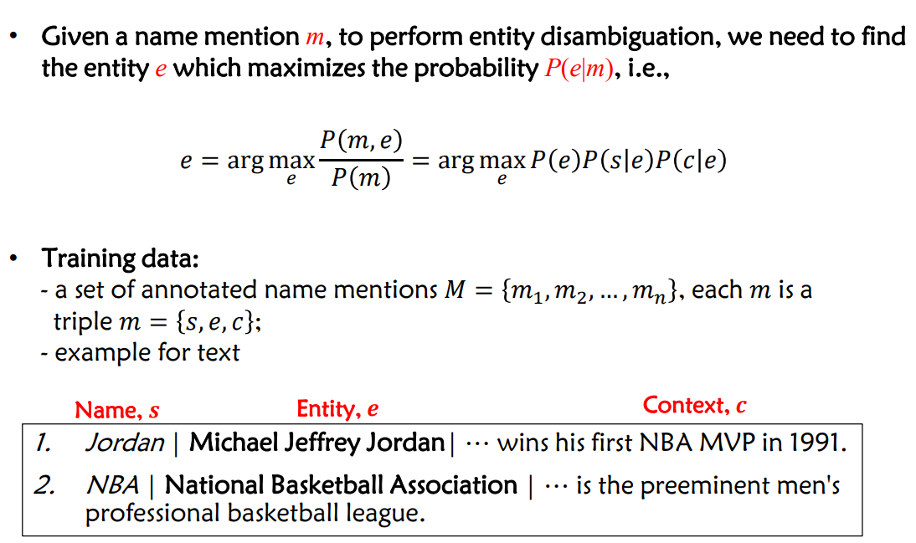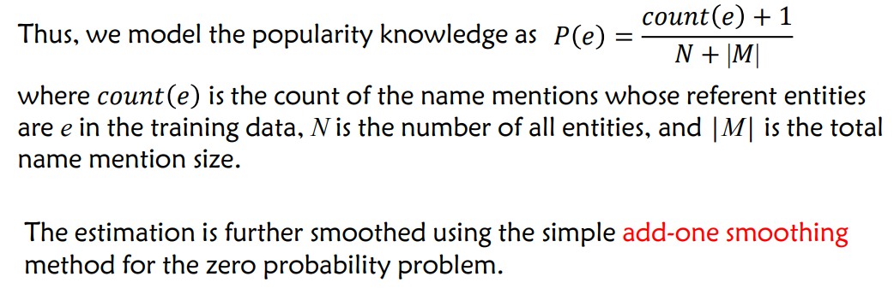

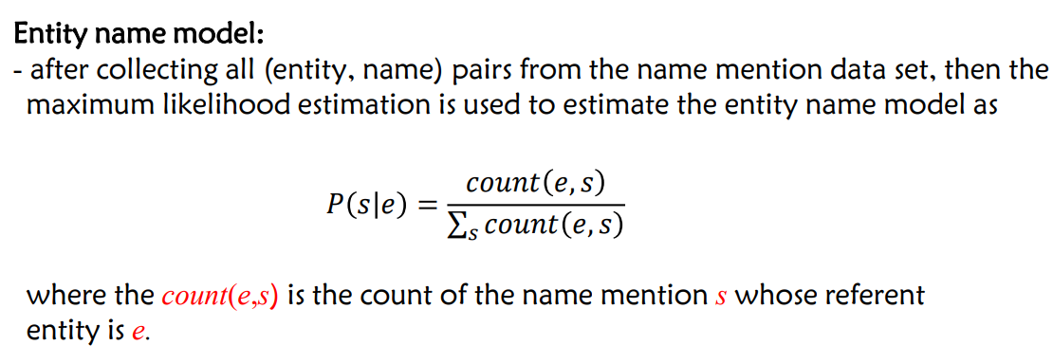

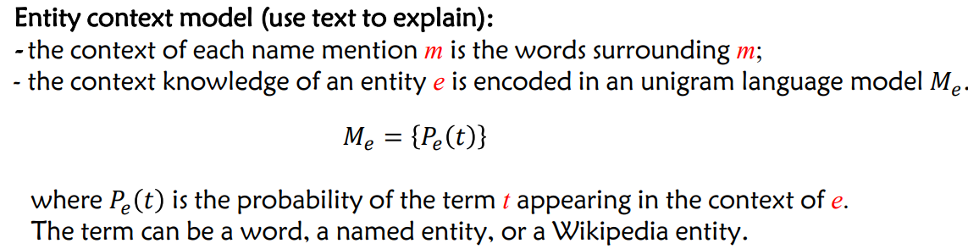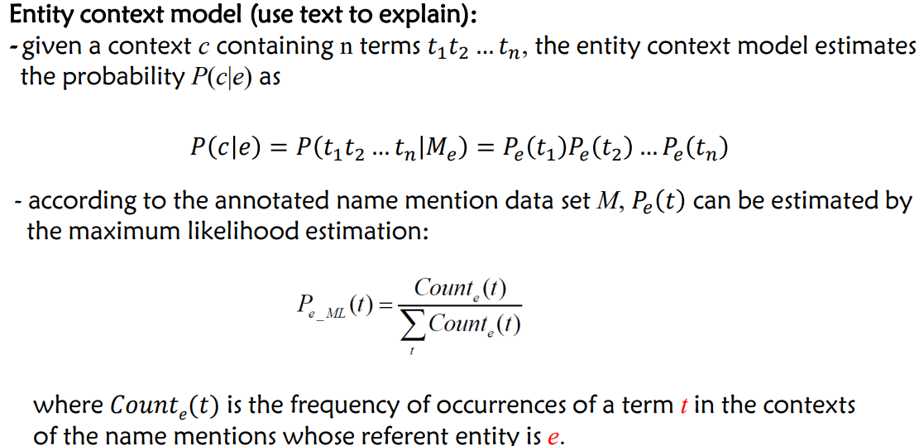

**Global Disambiguation**

Building an Entity Disambiguation Graph for each given table. Each graph **consists** of: **Mention Nodes**, **Entity Nodes， Mention-Entity Edges:** undirected edges between mentions and its candidate referent entities, **Entity-Entity Edges**: undirected edges between entities.

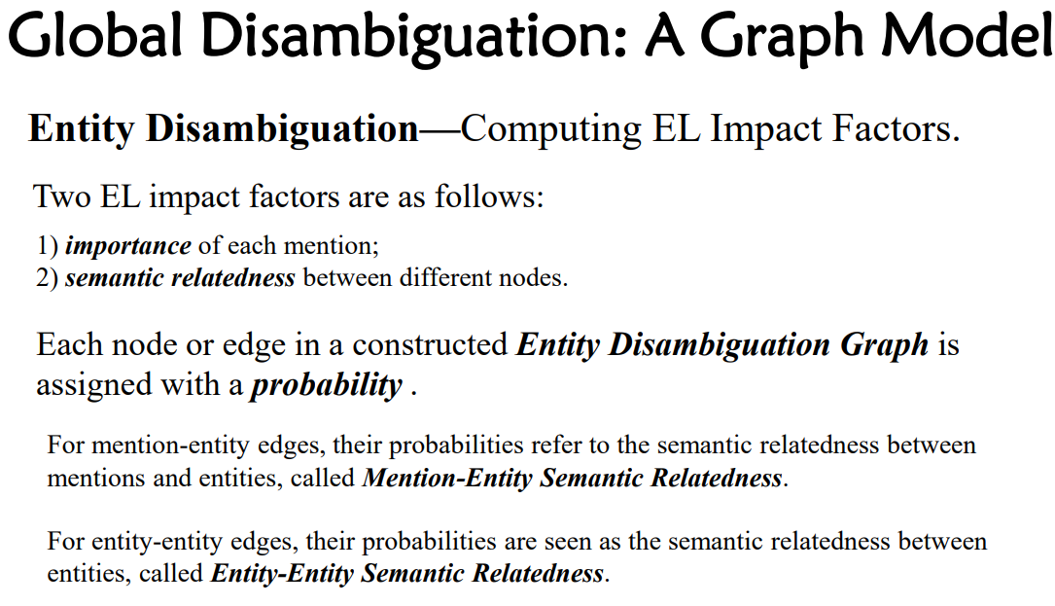

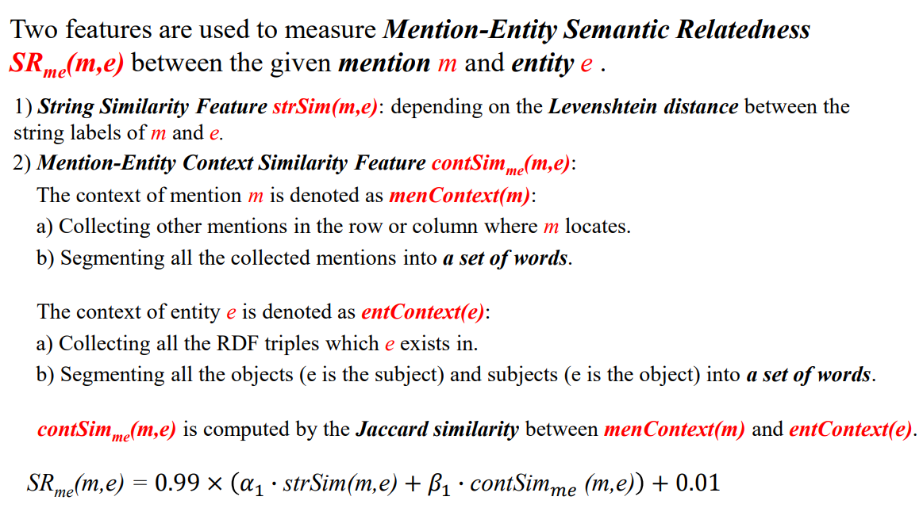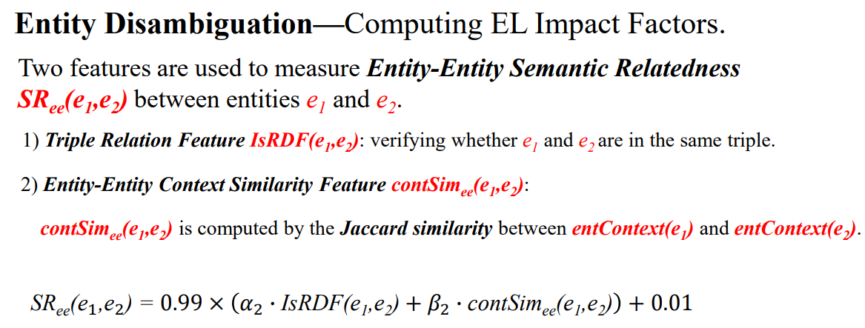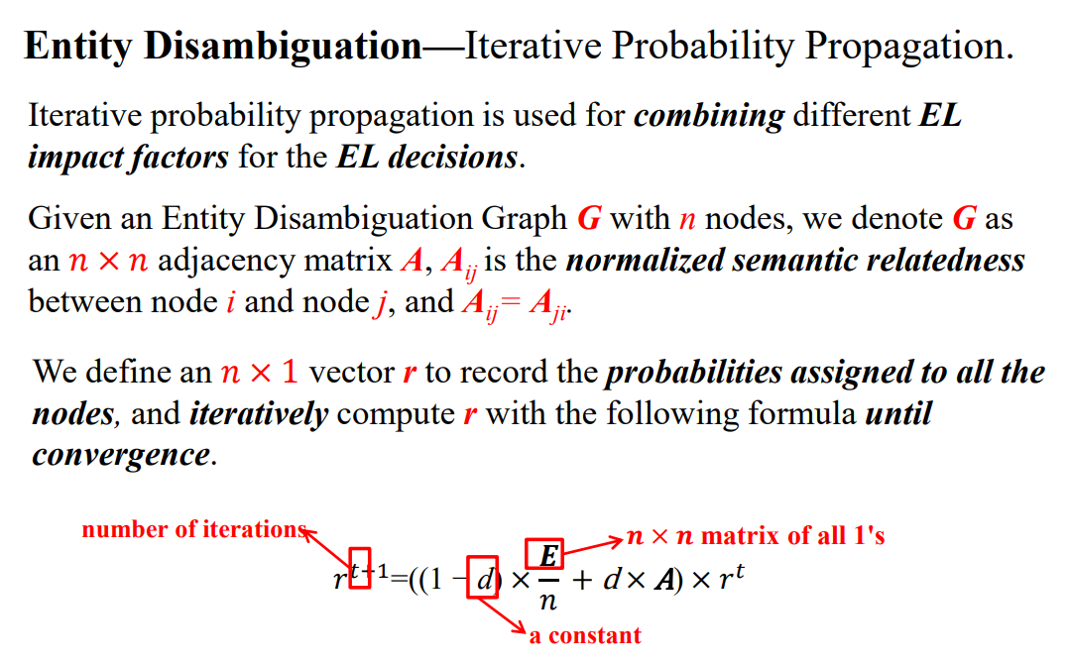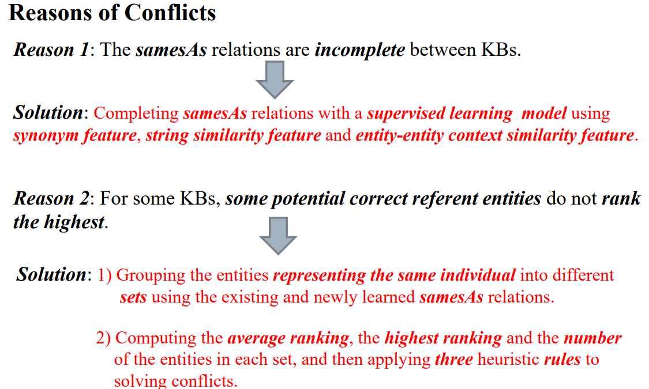

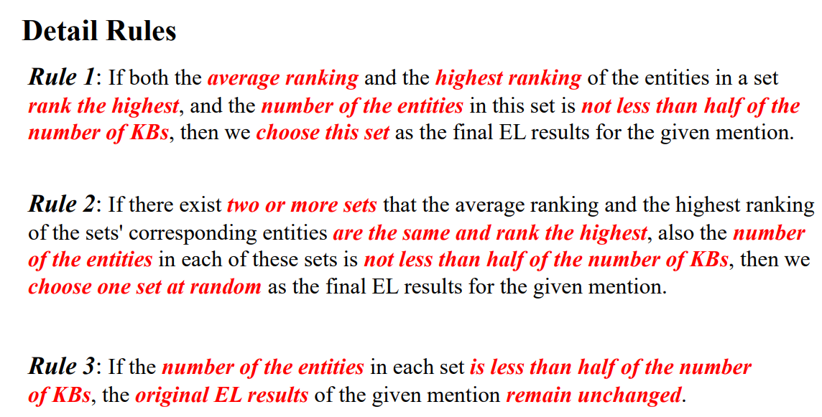

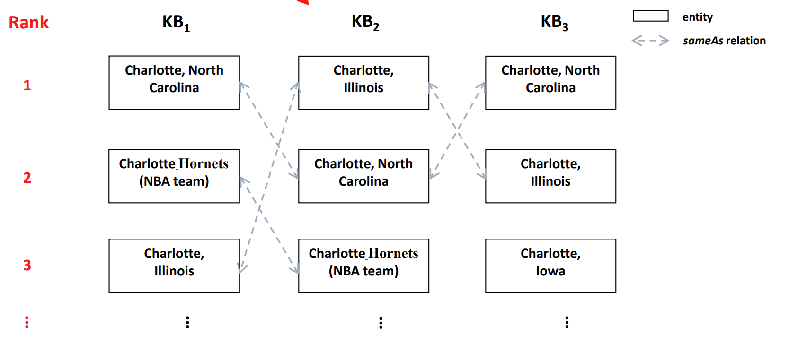

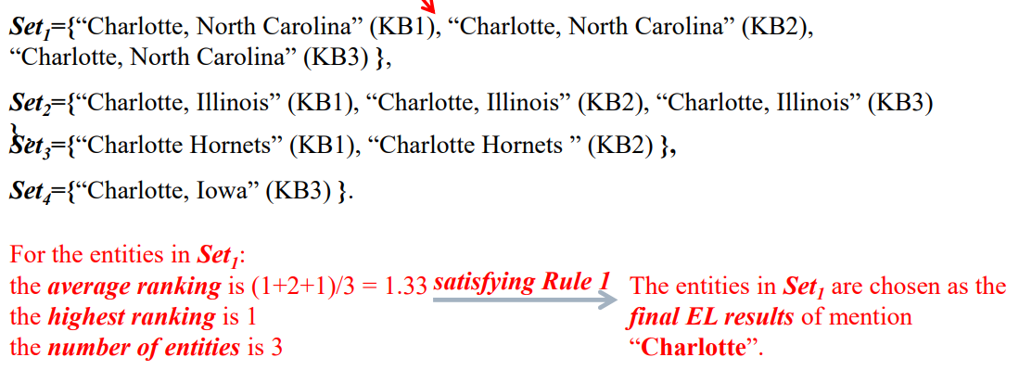

**Knowledge Graph Construction from Semi-Structured Data**

**What is semi-structured data? Semi-structured data** is a form of structured data that does not obey the tabular structure of data models associated with relational databases or other forms of data tables, but nonetheless contains tags or other markers to separate semantic elements and enforce hierarchies of records and fields within the data

**Modules of Knowledge Graph Construction** from Online Encyclopedias

**Fact Extraction • Type Inference • Taxonomy Induction**

**Fact Extraction**：Facts are factual knowledge represented as triples, each of which is in the form of **<subject,predict,object>** **subject**: an entity (an individual entity or a conceptual entity (i.e., concept)) **predicate:** property/ relation **object:** an entity or a literal value

**Fact Extraction from Infoboxes**

**Generic Infobox Extraction**: do not map synonymous properties, e.g., birthdate and dateOfBirth

**Mapping-based Infobox Extraction**: map synonymous properties

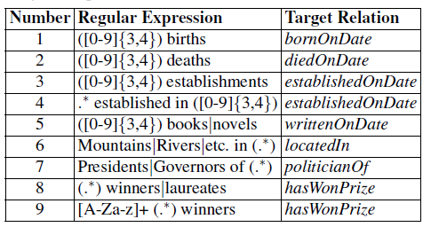

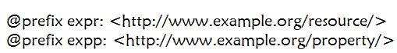

Answer:

expr:Tim_Berners-Lee expp:bornOnDate “1955” ;

expp:hasWonPrize expr:Turing_Award ;

expp:hasWonPrize expr:Royal_Medal ;

expp:hasWonPrize expr:Medal;

expp:hasWonPrize expr:Webby_Award ;

expp:hasWonPrize expr:Award .

后续验证步骤：1) 检查expr:Tim_Berners-Lee是否在expp:bornOnDate的定义域中，“1955”是否在expp:bornOnDate的值域中；

2) 检查expr:Tim_Berners-Lee是否在expp:hasWonPrize的定义域中，expr:Turing_Award，expr:Royal_Medal，expr:Medal，expr:Webby_Award，expr:Award是否在expp:hasWonPrize的值域中。

**Type Inference from Infoboxes**

1. Names of infobox templates are extracted as entity types (DBpedia).

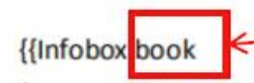

1. Property-value pairs in infoboxes are mapped to concept-instance pairs (Zhishi.me).

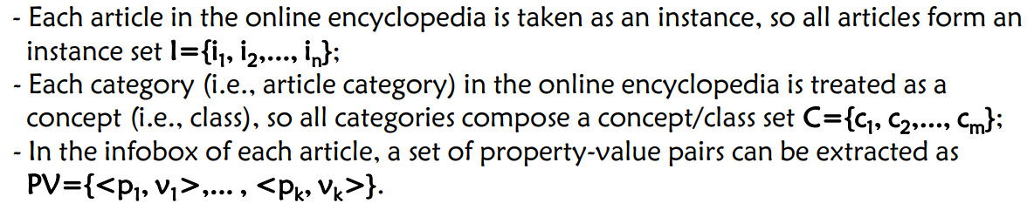

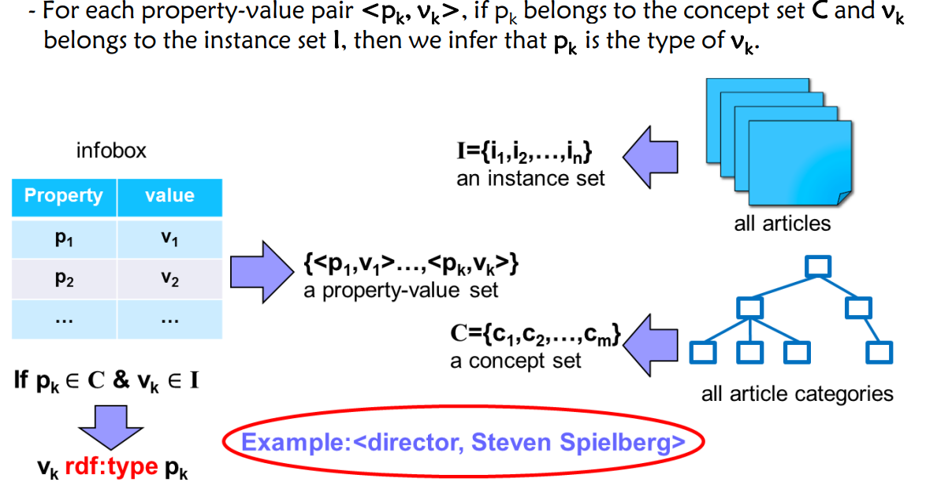

**Type Inference from Categories**

• Each article is usually assigned to several categories in online encyclopedias, so these categories can be taken as important candidate types for entities/ instances.

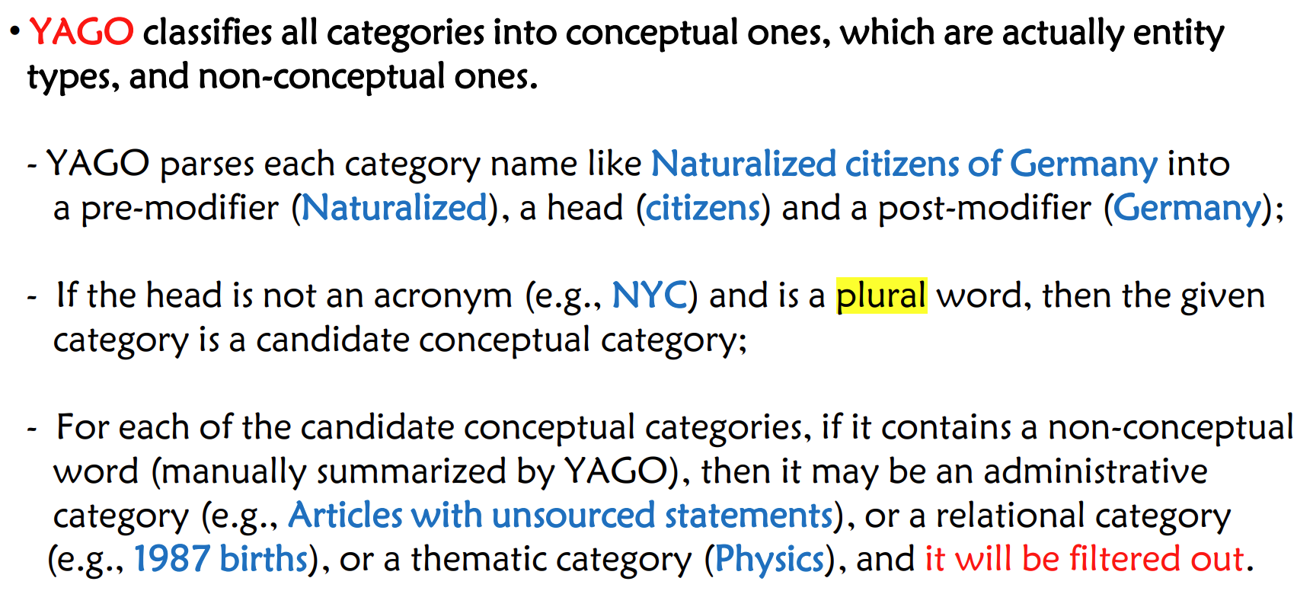**• Problems:** - The heuristics cannot be applied in some languages (e.g. Chinese and Japanese), in which nouns have no explicit singular or plural forms. - The heuristics cannot catch the semantic associations between instances and classes (i.e., categories), which may lead to mistakes in the process of type inference

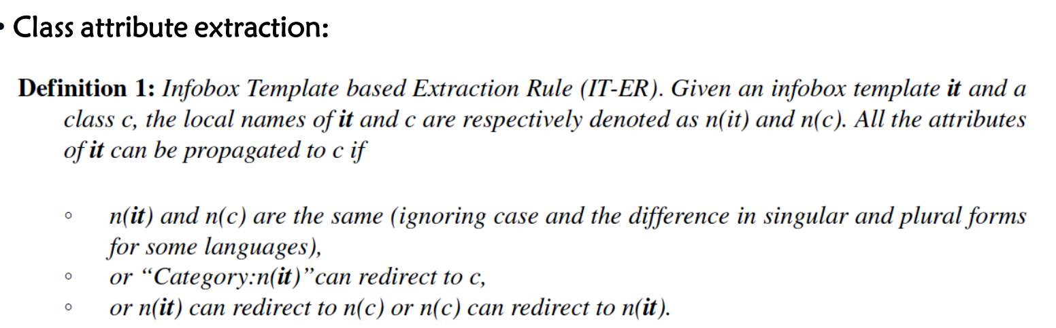 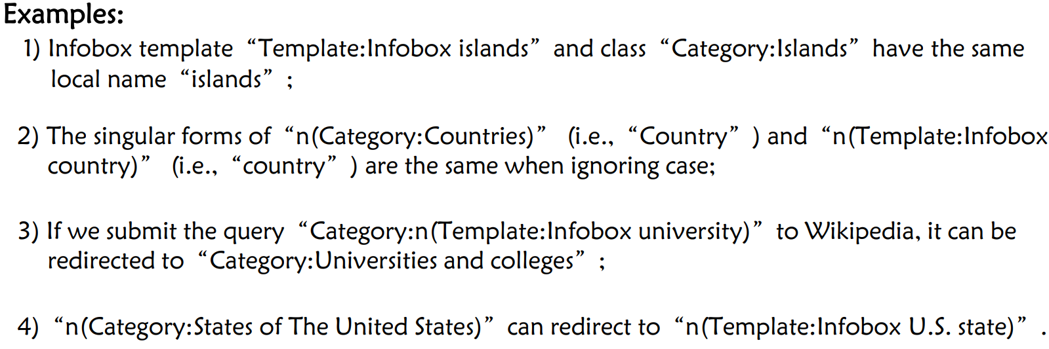 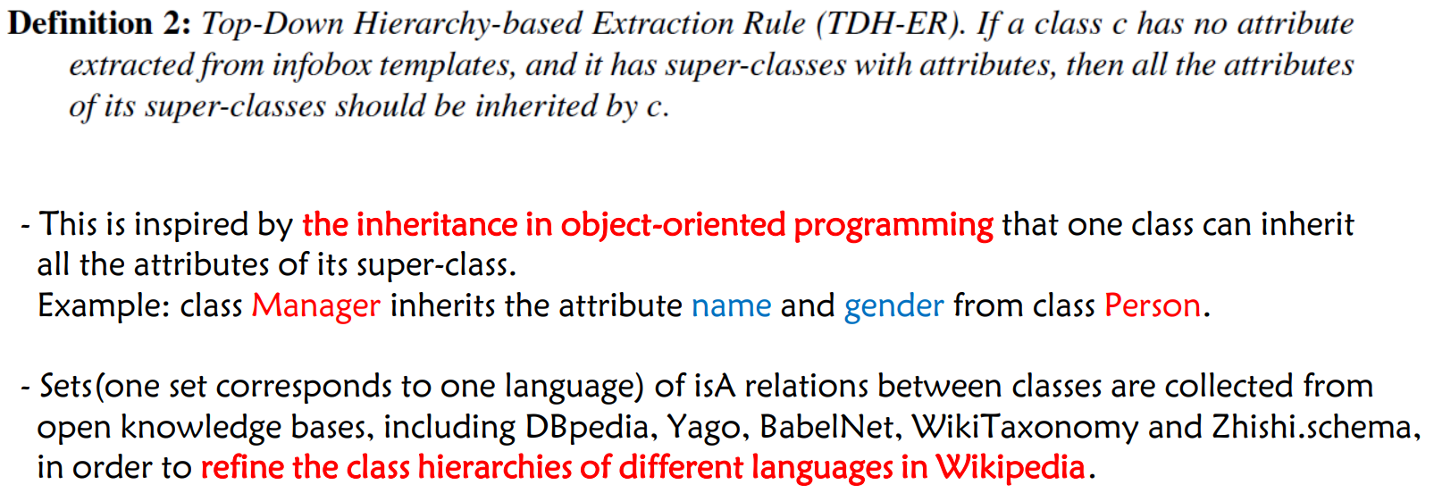 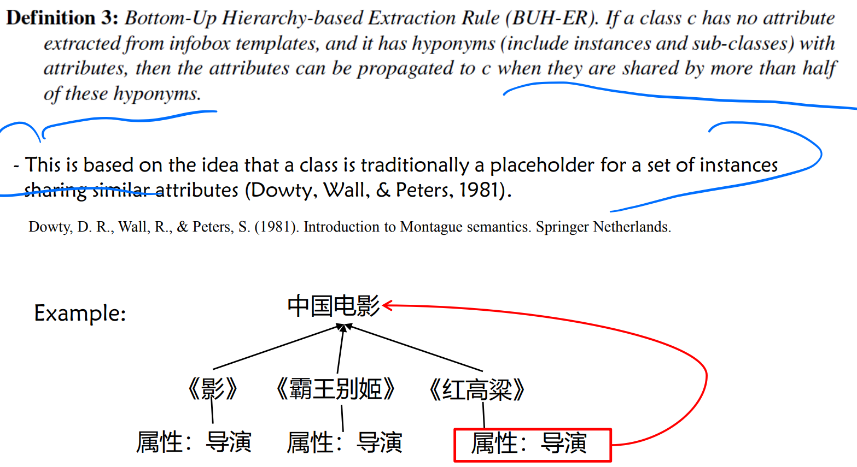 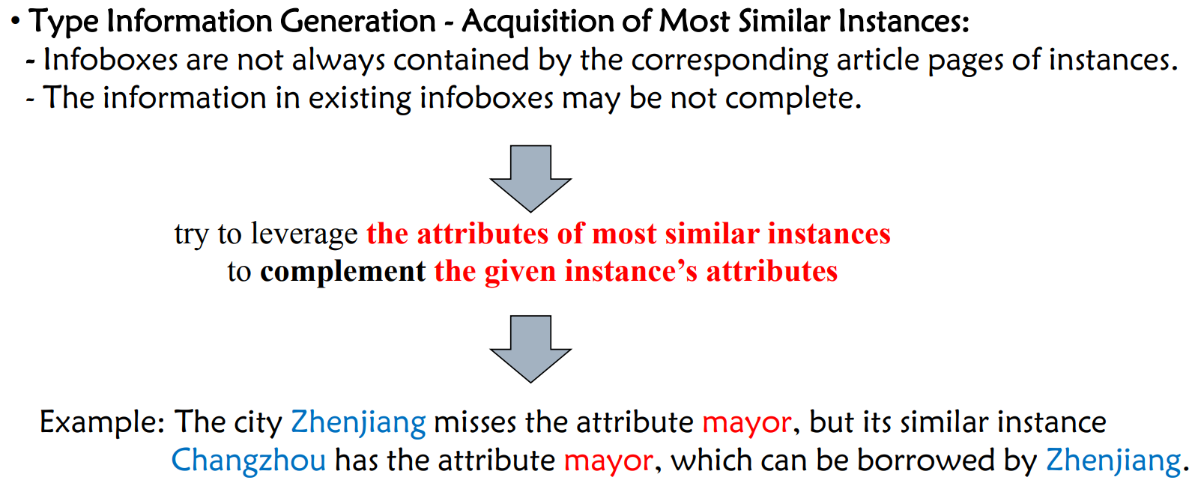 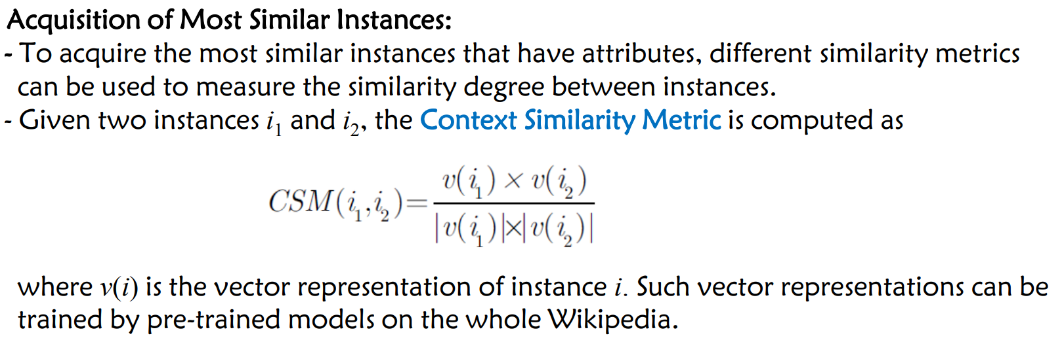 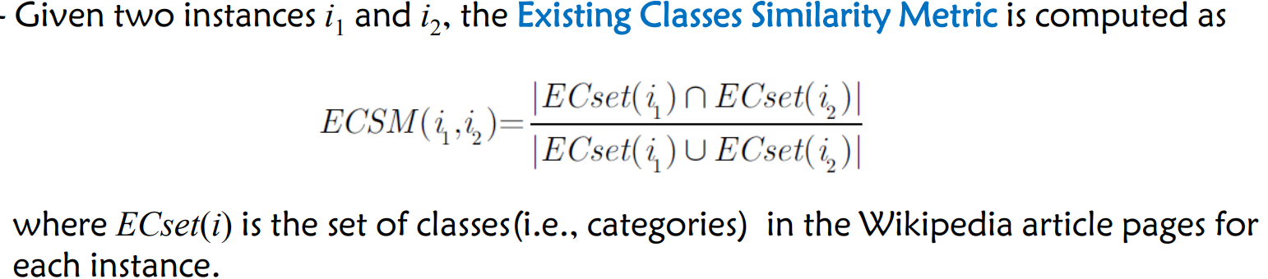 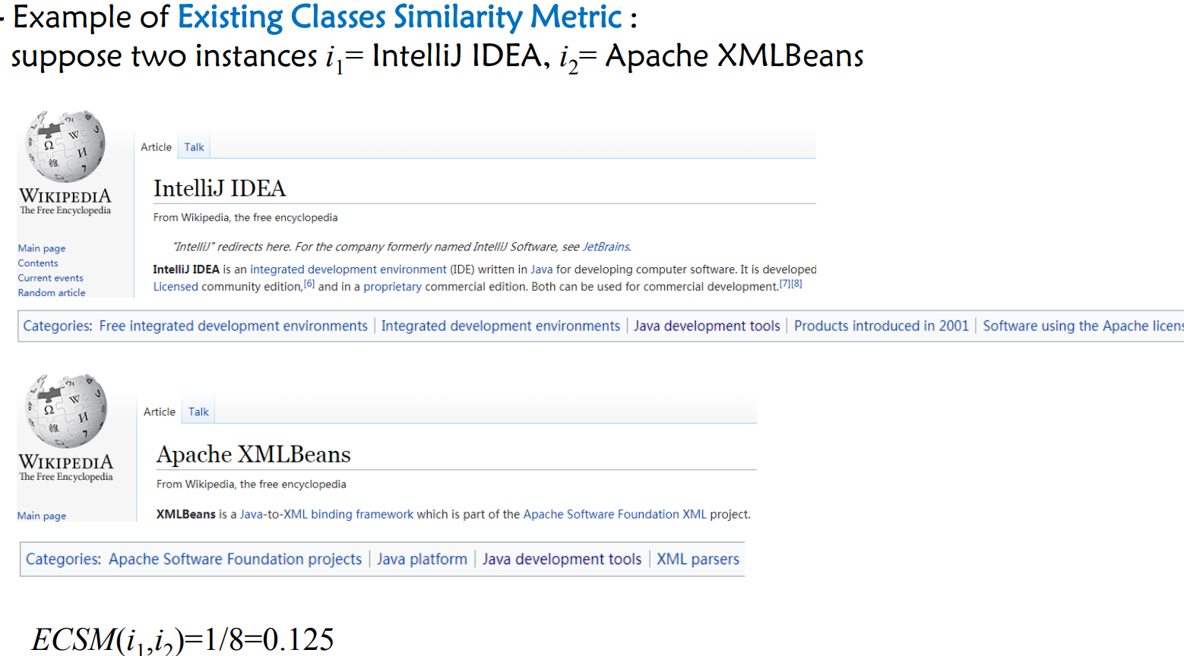 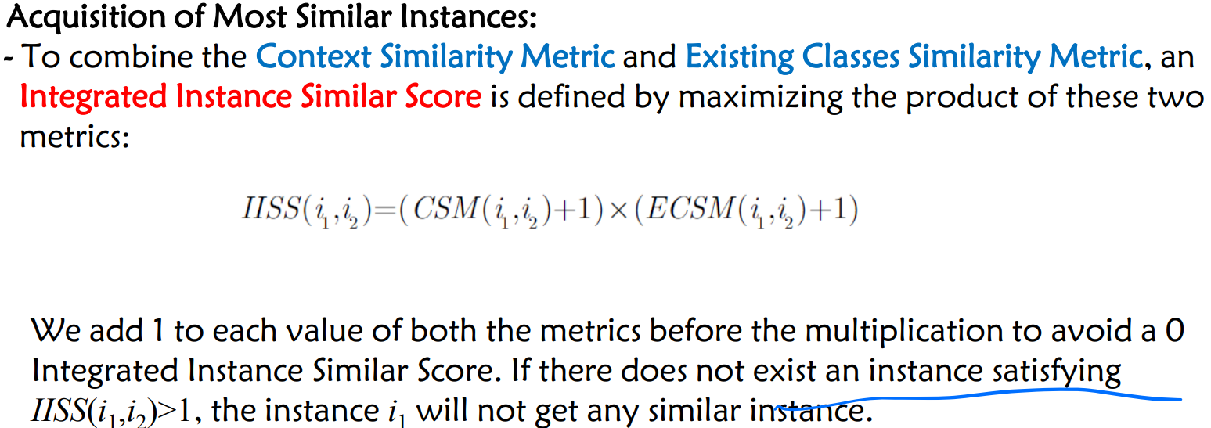

**• Type Information Generation** – Type Inference with Random Graph Walk: - After extracting attributes of instances and classes, each instance, its attributes and the classes in its corresponding Wikipedia article page naturally form a graph, in which the given instance and its classes are linked by shared attributes. - To compute the probability of the class being the type of the given instance leveraging the graph structure, a random graph walk model is used to infer the types of each given instance. - the attribute-driven type inference assumption: In Wikipedia, if an instance contains representative attributes of one of its classes (i.e., categories), there may exist a rdf:type relation from the instance to the category with a high probability. - To model the above assumption in the random graph walk model, it is supposed that if some class can be reached by more of its representative attributes on the built graph of an instance, then the probability of the class being the type of the given instance is higher.

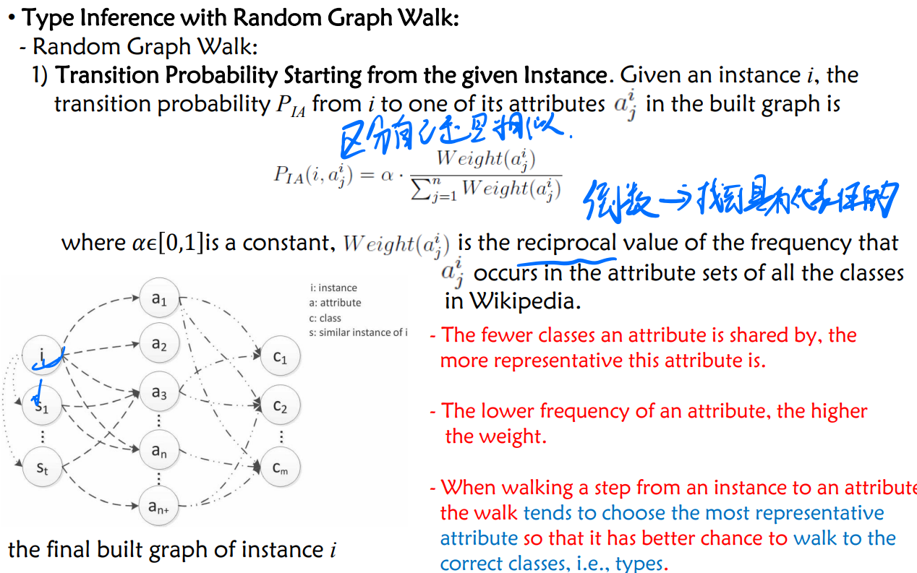

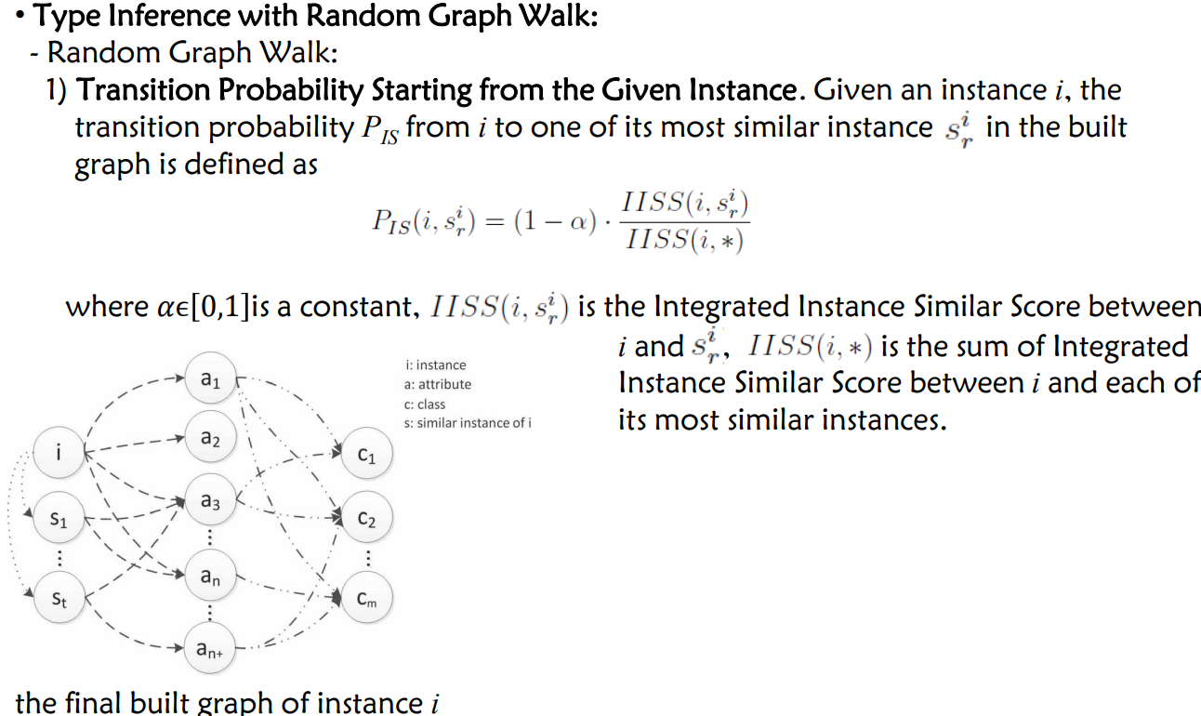 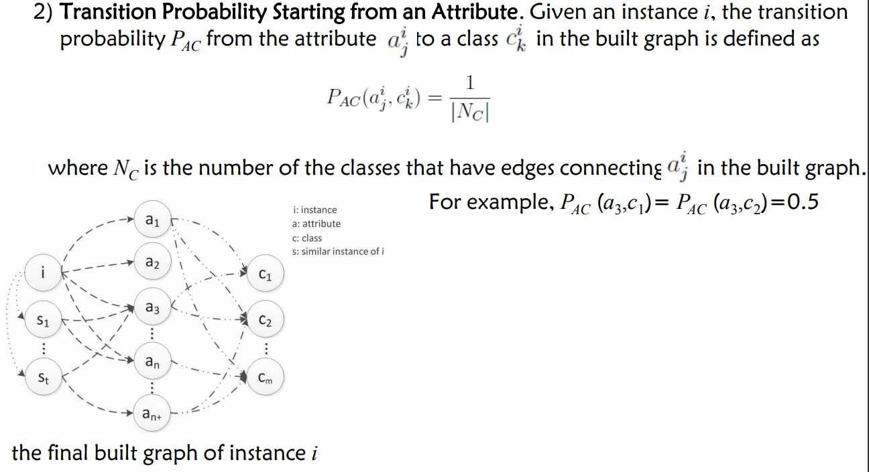 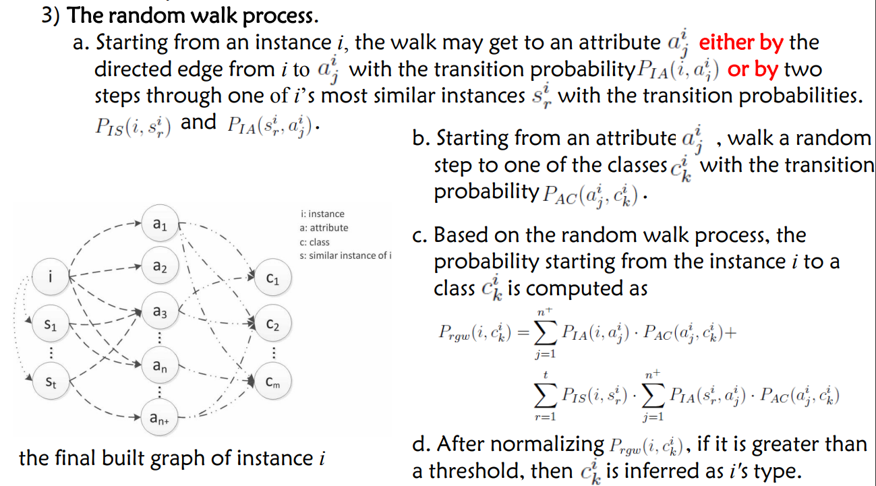

• **Two steps on type inference from text**: 1) **Type extraction**, which extracts the types of each entity from the first sentence of its corresponding article. - The first sentence in each article gives a textual definition of each entity, and it usually provides important type information. 2) **Type disambiguation,** which links extracted types to correct Wikipedia entities. - Since the types extracted in the first step are just plain strings, the second step aims to assign real senses to these types.

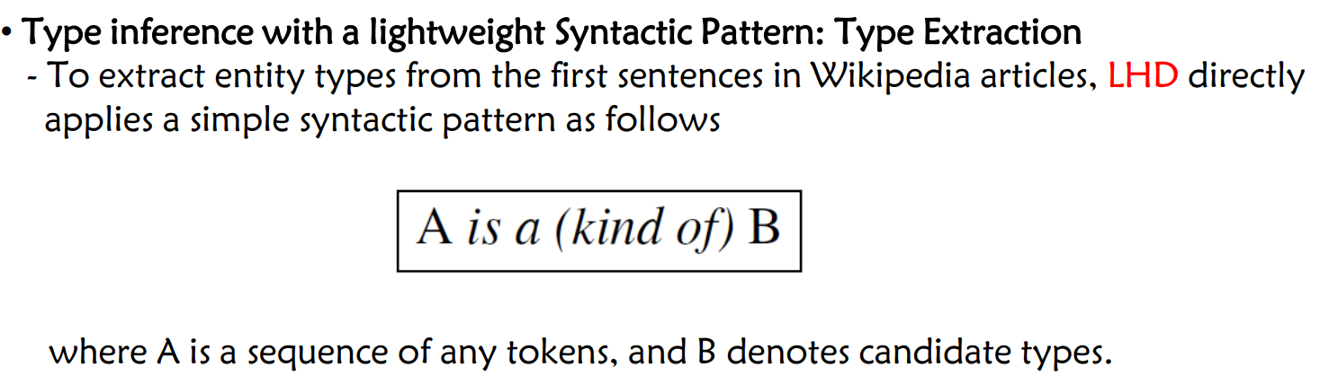 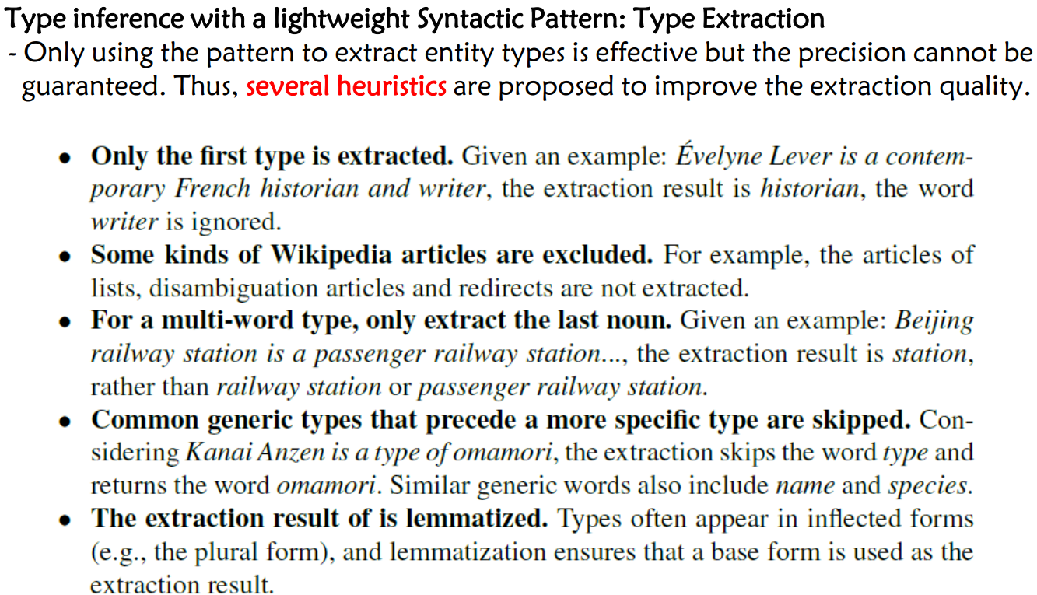

**Taxonomy Induction**

A taxonomy is a directed acyclic graph consisting of is-a relations between entities, including conceptual entities and individual entities.

**Taxonomy induction from Wikipedia** is to refine the Wikipedia category system by removing not-is-a relations. (WikiTaxonomy)

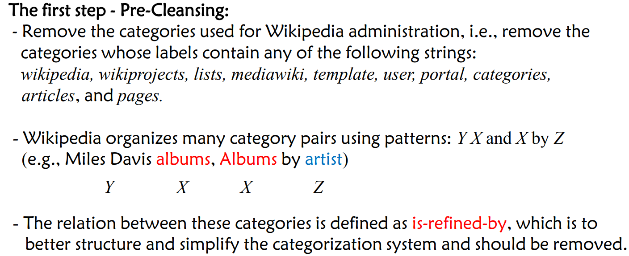 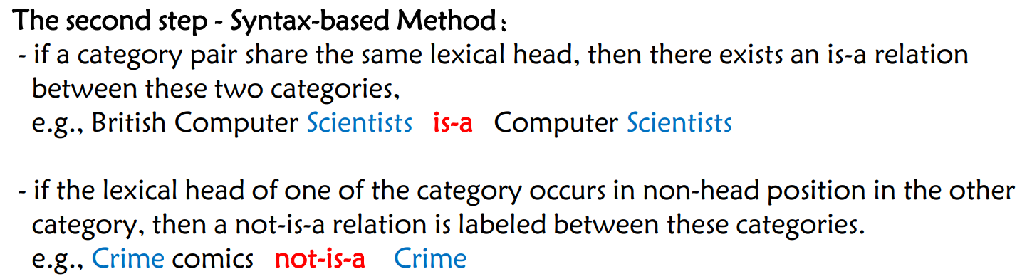 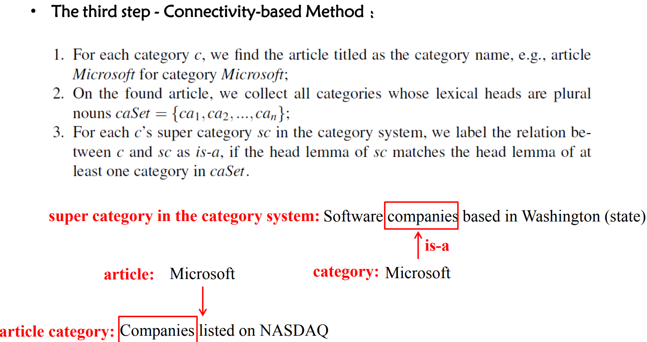 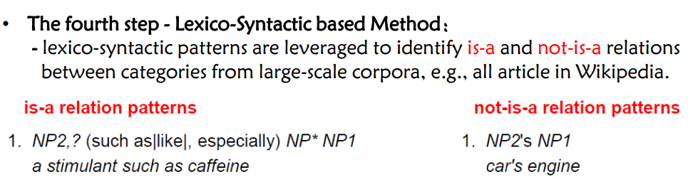 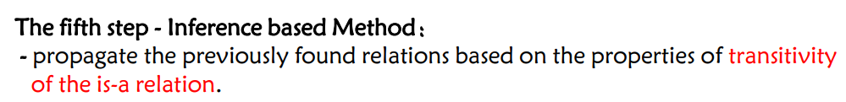 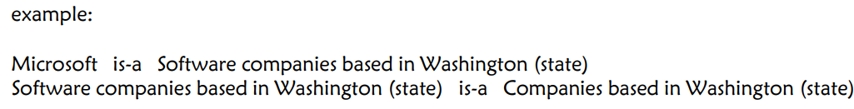 推出->

**Knowledge Graph Construction from Unstructured Data (Text)**

**Two Specific Tasks in Knowledge Engineering**: **General IS-A Relation** Extraction (benefit to build taxonomies) 、 **Terminology/ Term Extraction** (benefit to domain-specific knowledge graph construction)

**The general is-a relation**

The general **is-a relation** is the semantic relationship between a more specific word (i.e., hyponym) and the more general term (i.e., hypernym).

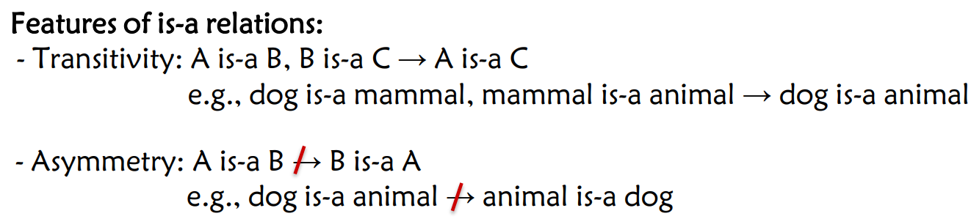!!考 输入输出：

**Triple generation**: **Input:** a large scale corpus **Output:** triples denoting is-a relations

**IS-A relation prediction:** **Input:** a pair of candidate hyponym and hypernym, and the corresponding vector representations **Output:** true or false e.g., Pair(dog, animal) → true Pair(dog, cat) → false

**Methods Classification:** - **Pattern-based Methods (task: triple generation)** - **Distributional Methods (task: is-a relation prediction)** * Unsupervised Distributional Methods * Supervised Distributional Methods

**Pattern-based Methods: Hearst Patterns**

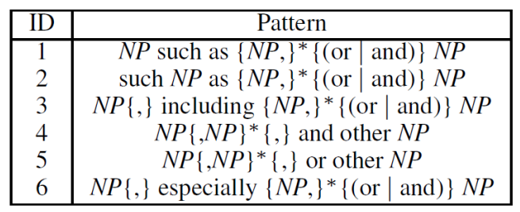 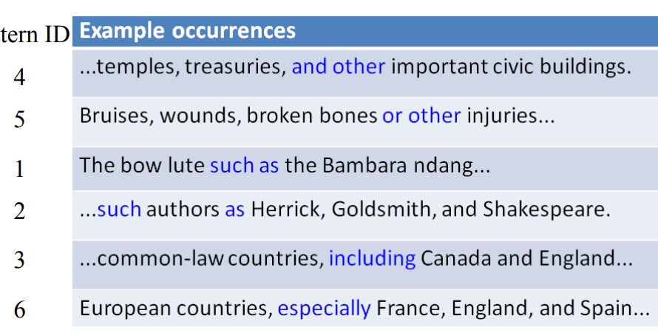

**EX:**  There are further opportunities on exporting UK red meat to **such** countries **as** China, Japan, Korea, **and** Southeast Asian countries, **including** Singapore or Vietnam.

**ANS:** China, Japan, Korea, and Southeast Asian countries is-a contries ; Singapore or Vietnam is-a Southeast Asian countries ; Singapore or Vietnam is-a countries.

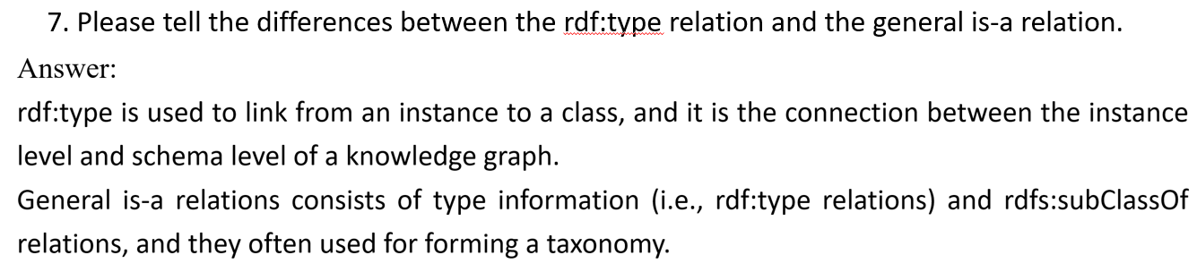

**Distributional Methods**

Why Introducing **Distributional Methods?**

• **Limitations of Pattern-based Methods:** - The coverage and generalization are uncertain: * The hyponym and hypernym must appear in a sentence at the same time.

• **Distributional Methods** aim to solve the problem of **co-occurrence sparsity** between the **hyponym(下义词) and hypernym（上义词）**

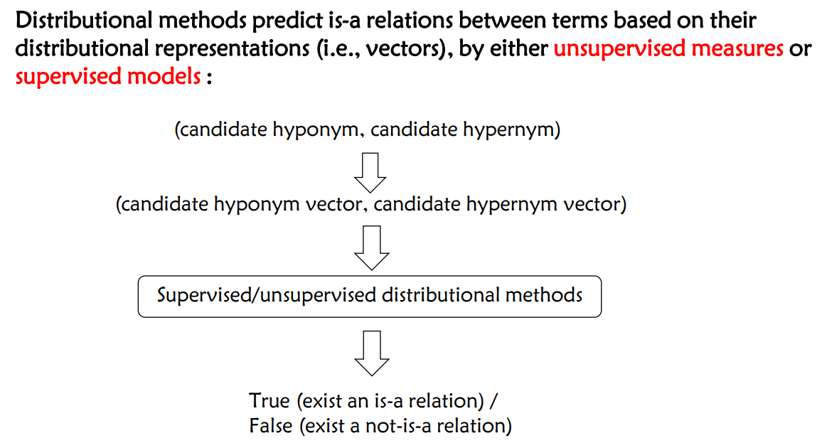

**How to Get Distributional Representations?**

• **Pre-trained Models** on a Corpus: - Word2vec, BERT, etc.

• **Traditional Methods** based on Term Co-Occurrence . Example: sliding window strategy

**Unsupervised Distributional Methods**

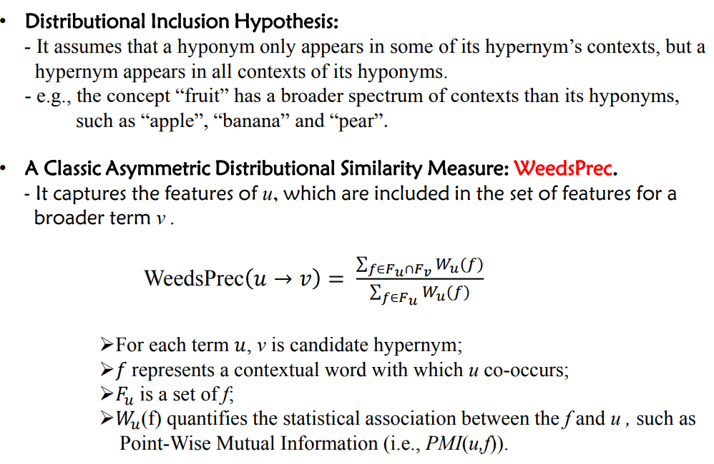

**Project learning** learns a function to measure how possible there is an is-a relation between two words. KeyPoint: **A projection tensor T** is used to project the hyponym vector into the hypernym vector.

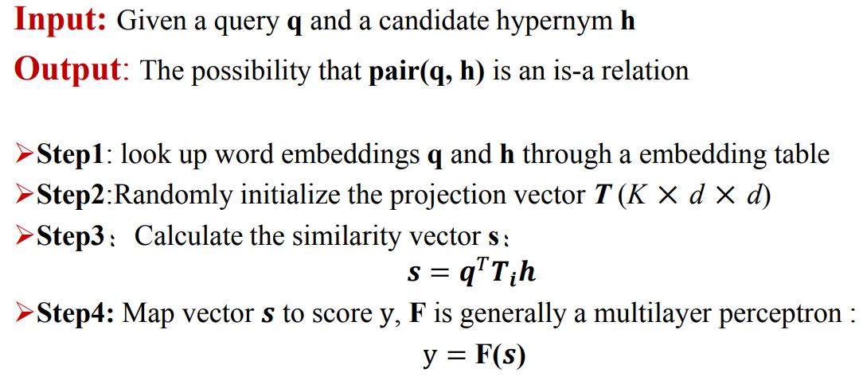

**Term Extraction**

**Terminology:** Linguistic units which characterise specialised domains domain-relevant

ο Terminology extraction is associated with some other tasks, such as NER,keyword extraction, etc. ο Different from other tasks, terminology extraction is highly related to the domain. ο Terminology extraction is th key issue of ontology construction, text summarization, knowledge graphs, etc.

**Approaches** ο **Linguistic-based approaches ο Statistical-based approaches ο Graph-based approaches**

**Linguistic-based approaches —Chunker** Toolkit NLTK RegexpParser: Convert regular expressions into syntax trees Step1: Define patterns of NPs

Step2: Find Candidate Terms using Chunker Step3: Candidate Terms Filtering

**Statistical-based approaches** Theory ： Candidate terminology with higher frequency is more likely to be a terminology

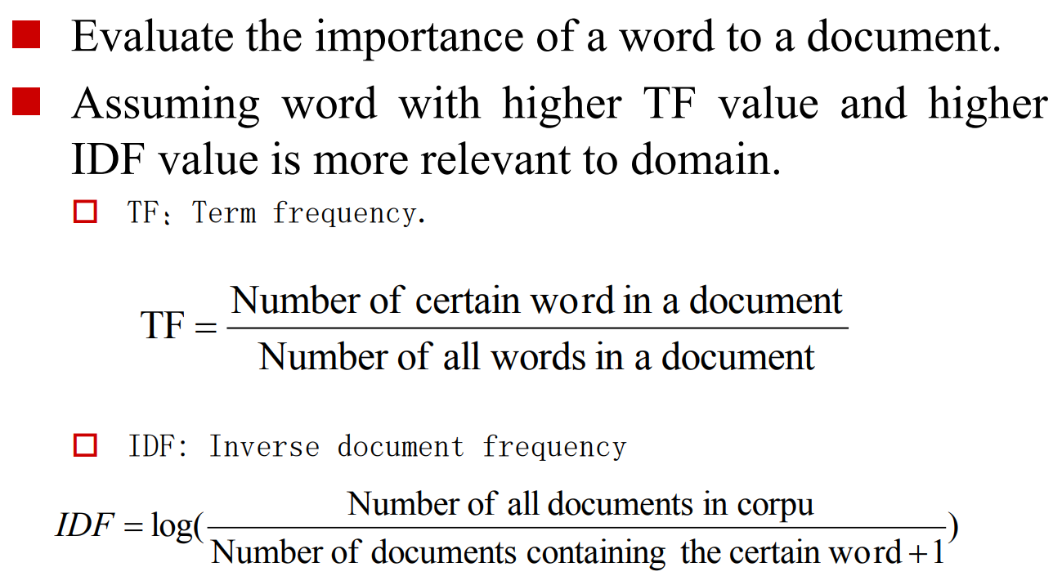

Compute the TF-IDF values of “knowledge”, “AI” and “Engineering” with the statistics in the following tables, and rank them (Computing IDF using lg).

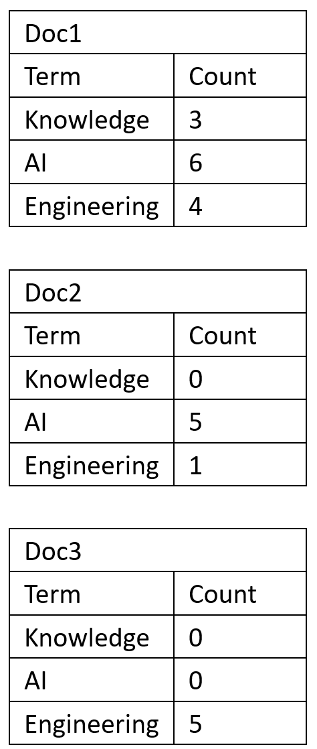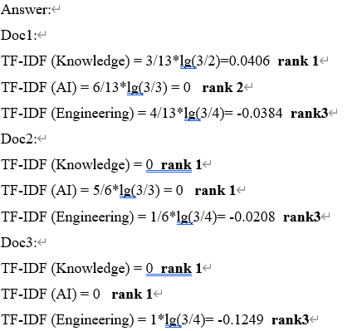

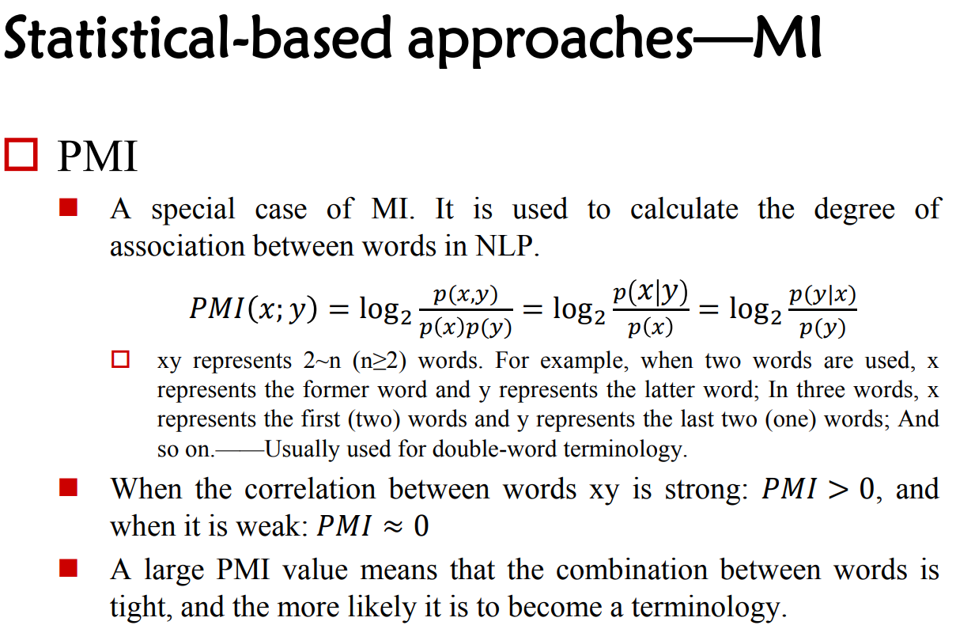

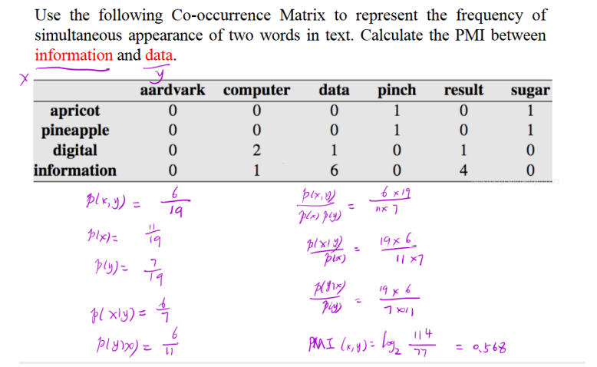

$$P\left(x,y\right)=\frac{6}{19}, P\left(x\right)=\frac{11}{19},P\left(y\right)=\frac{7}{19} , PMI=\log_{2}{\frac{P\left(x,y\right)}{P(x)P(y)}}$$

**Graph-based approaches** : construct graph based on the co-occurrence relationship between words. Assume that the co-occurrence of words represents semantic correlation between them.

**PageRank:** Calculate the importance of webpages based on the link between them.

**TextRank**: • Regard ‘word’ as ‘webpage’. • Calculate the importance of words based on the co-occurrence between them. • Turn the directed graph in PageRank into an undirected graph.

**Feature** TextRank can extract terminologies from a single document without relying on other corpora.

**PageRank's Theory** : • Regard the Internet as a directed graph, with webpages as nodes in the graph and links between webpages as edges in the graph.

• When a webpage is linked by many other webpages, it means that this webpage is more important, that is, the PR value (PageRank value) of this webpage will be higher.

• If a webpage with a high PR value links to another webpage, the PR value of the linked webpage will increase accordingly

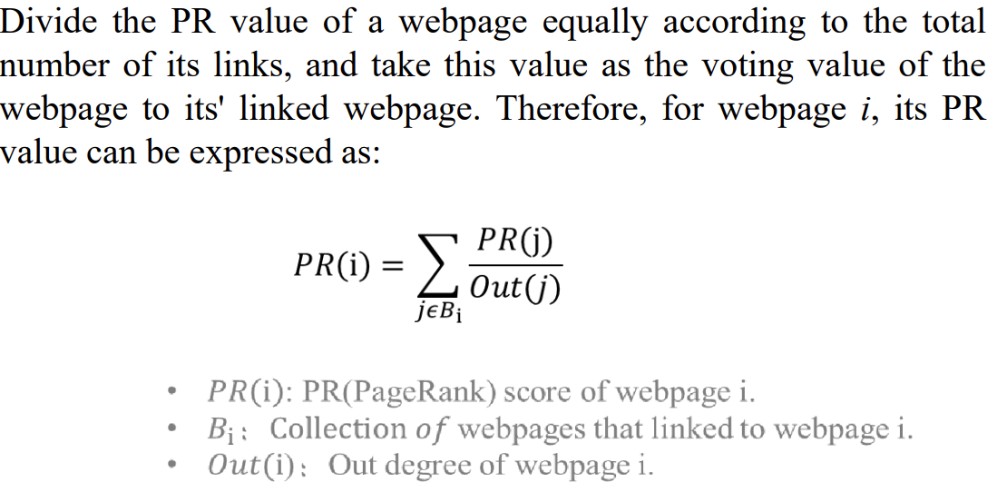

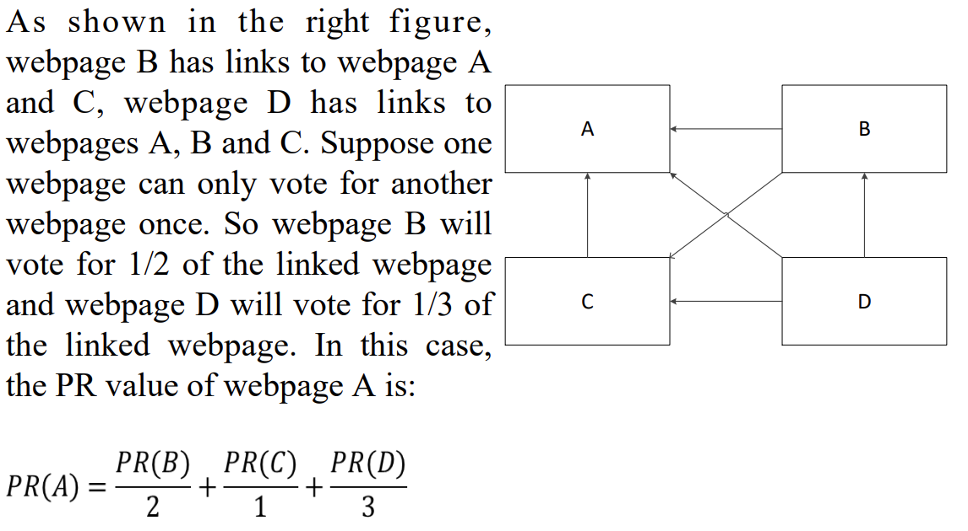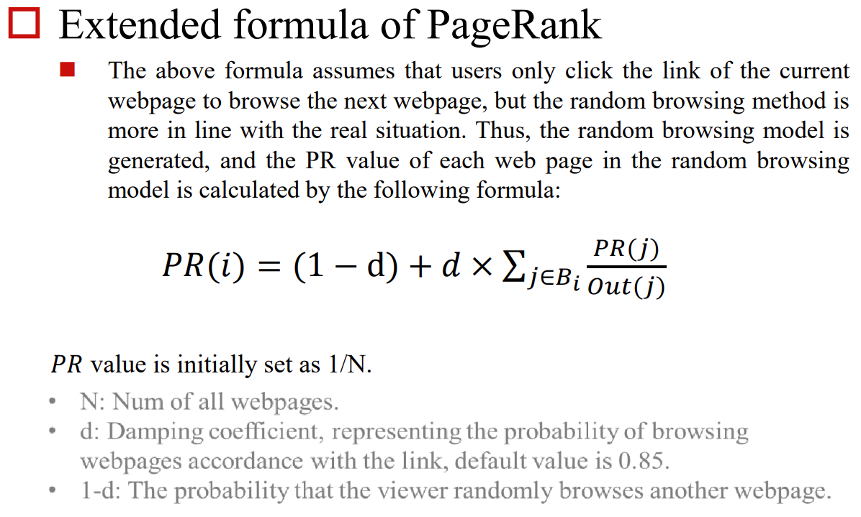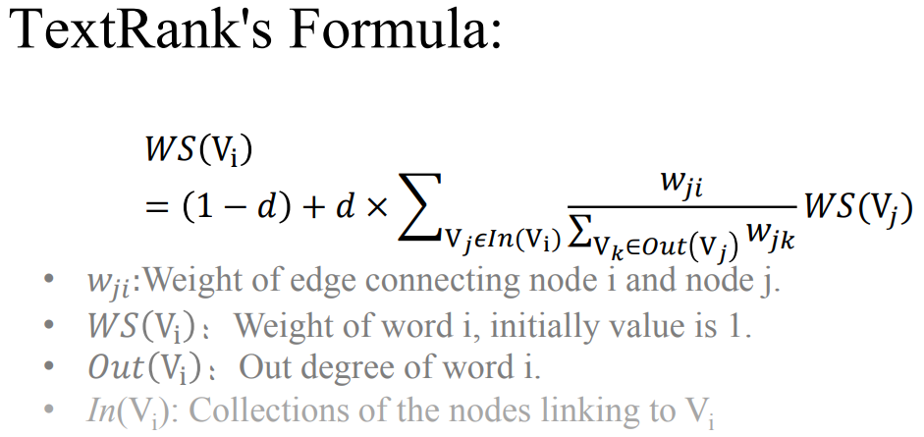

**Knowledge Graph Alignment**

Knowledge Graph Alignment **consists** of: - **ontology matching** (i.e., schema matching), - **instance matching**

**Ontology Matching (本体匹配)**：It is the process of finding correspondences (i.e., relationships) between classes (or properties) of different ontologies

**Benefits of Ontology Matching:** ● Creating global ontologies from local ontologies

● Reuse information between ontologies

● Dealing with heterogeneity

● Queries across multiple distributed resources

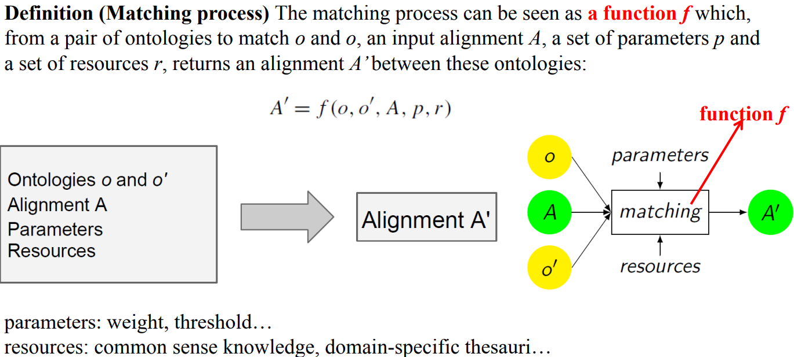

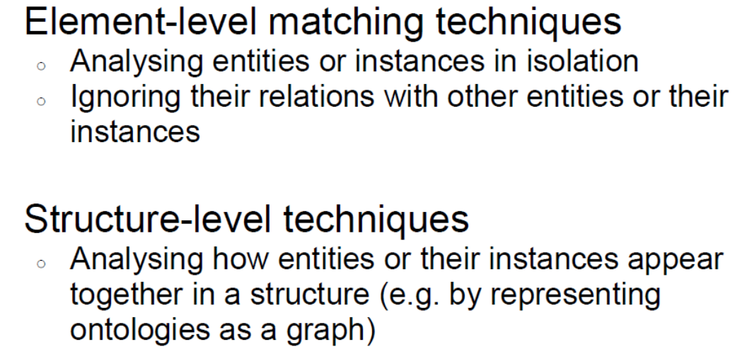

**Element-level Matching Techniques: String-based**

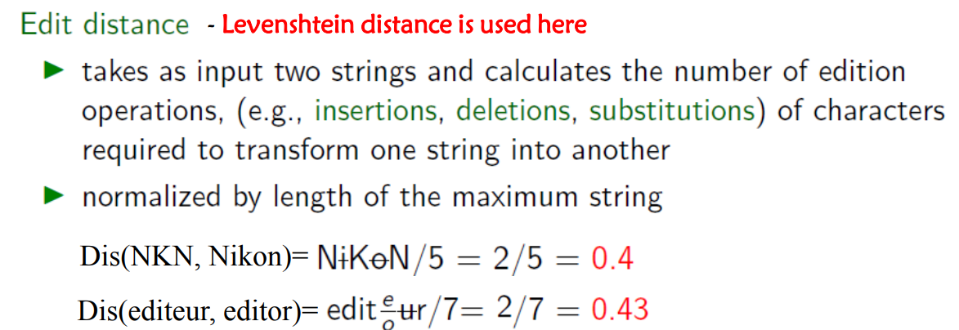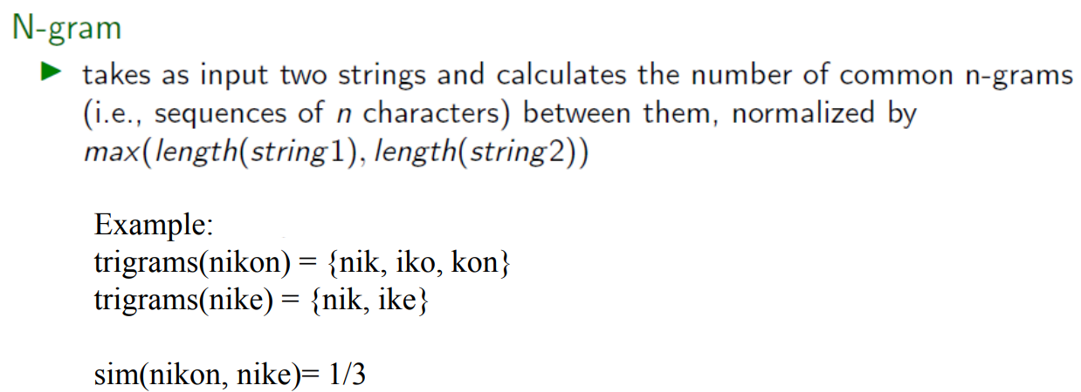

**Structure-level Matching Techniques**

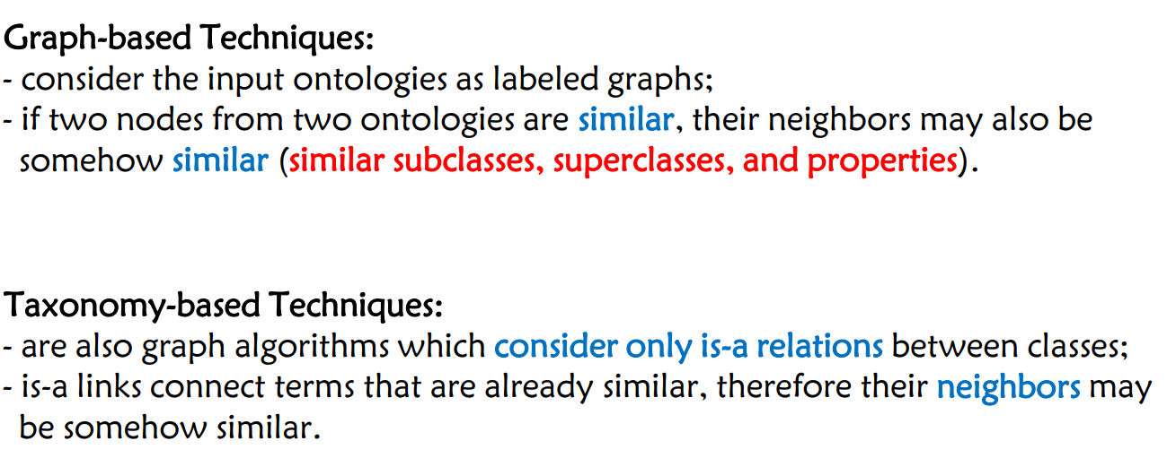

**为什么设计非对称相似度特征，因为本体间存在不对称性。**

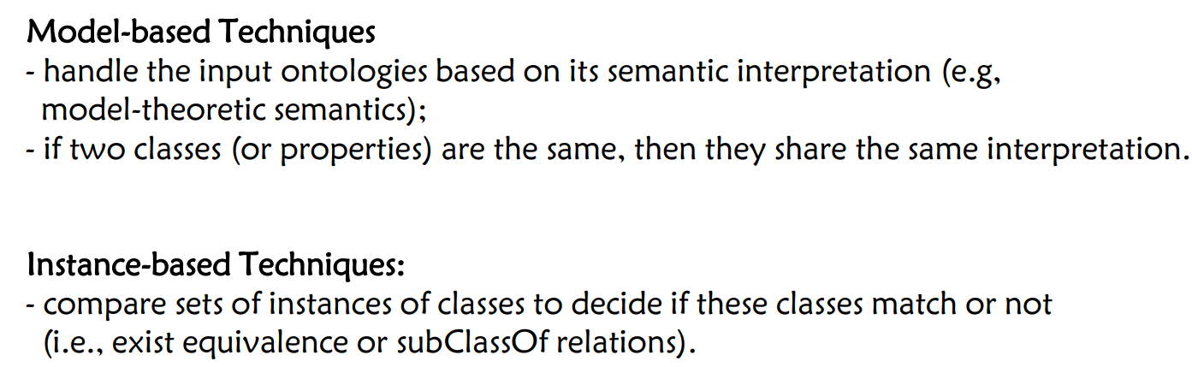

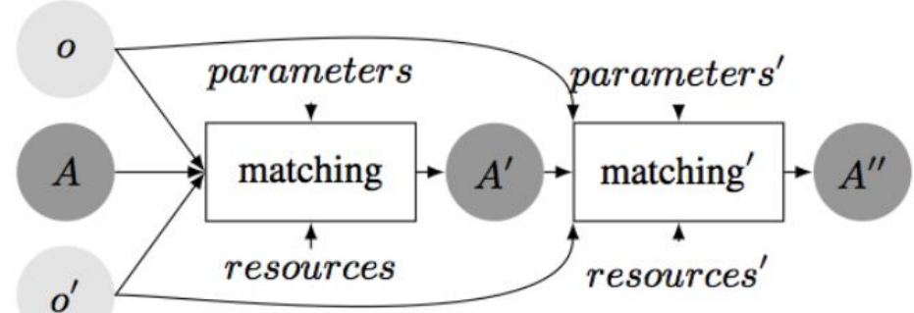

**Sequential composition of matches**：problem：error accumulation and low coverage

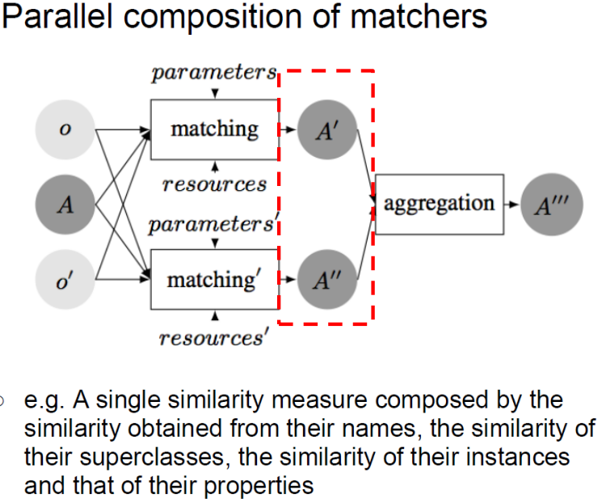

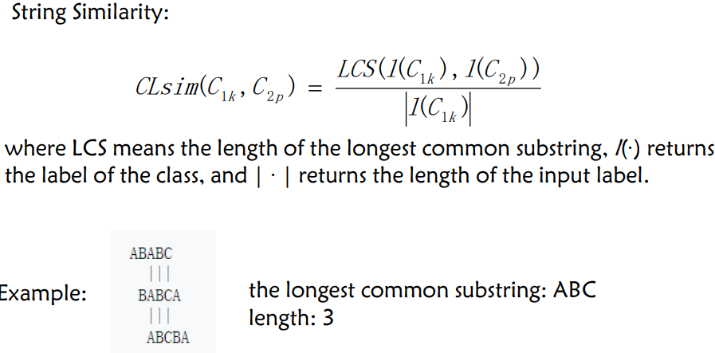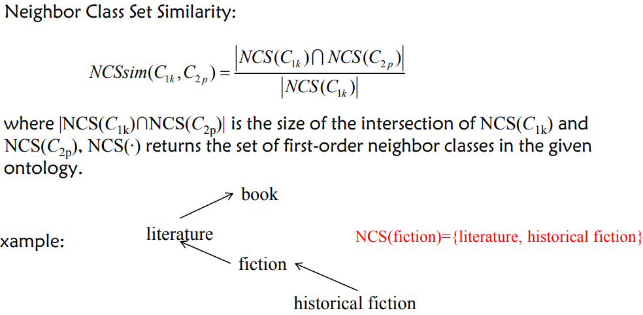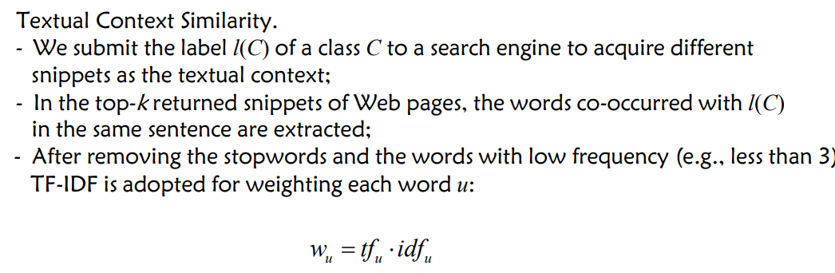

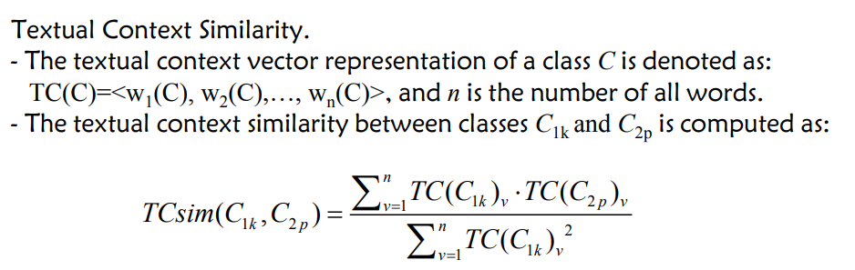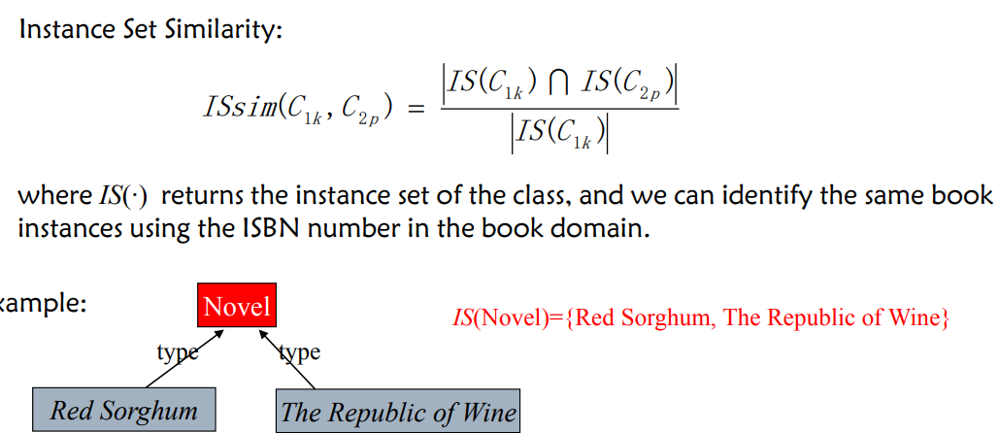

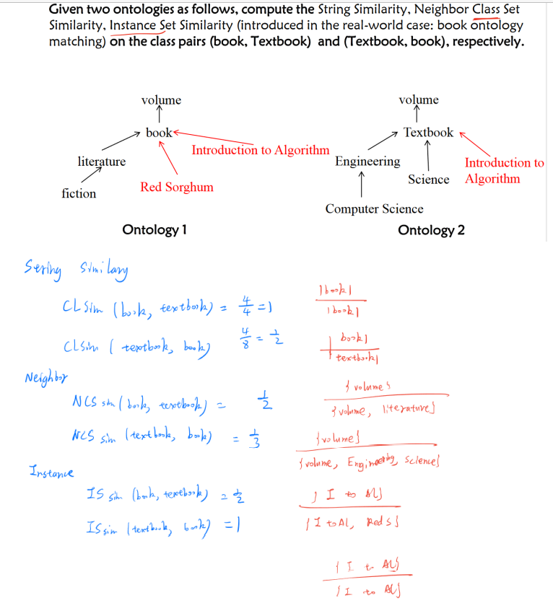

String Similarity:

$$CLsim\left(book,textbook\right)=\frac{\left|book\right|}{|book|}=\frac{4}{4}=1$$

$$CLsim\left(textbook,book\right)=\frac{\left|book\right|}{|textbook|}=\frac{4}{8}=\frac{1}{2}$$

Neighbor Class Set Similarity

$$NCSsim\left(book,textbook\right)=\frac{\left\{volumn\right\}}{\{volumn, literature\}}=\frac{1}{2}$$

$$NCSsim\left(textbook, book\right)=\frac{\left\{volumn\right\}}{\{volumn, Science, Engineering\}}=\frac{1}{3}$$

Instance Similarity

$$ISsim\left(book,textbook\right)=\frac{\left\{Intro to Alg\right\}}{\left\{Intro to Alg, Red Sorghum\right\}}=\frac{1}{2}$$

$$ISsim\left(textbook,book\right)=\frac{\left\{Intro to Alg\right\}}{\left\{Intro to Alg\right\}}=1$$

Aggregate these similarities by a semi-supervised learning strategy: self-training, for binary classification on subClassOf relations: - In each iteration, self-training accepts the labeled data as training data and learns a classifier. - Then the classifier is applied to the unlabeled data and adds class pairs of high confidence to the labeled data to train a new classifier for the next iteration. - The whole process will terminate if the difference between the predicted labels of the class pairs given by classifiers in the two consecutive iterations is smaller than a threshold or the maximal number of iterations is achieved. - The binary classifier can use SVM, Random Forest, Neural Networks, and etc. - In each iteration, rules are applied to filter out misclassified relations.

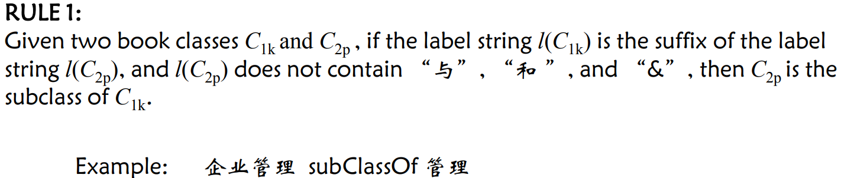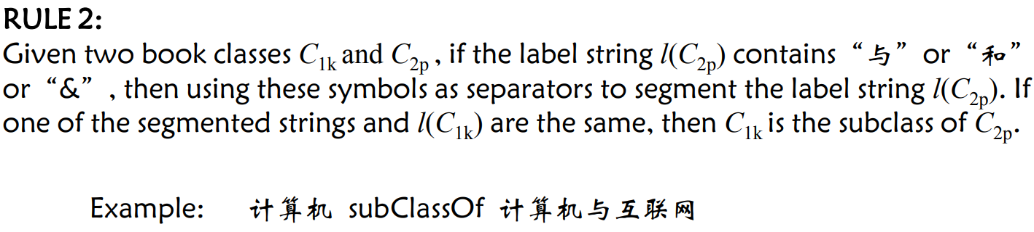

**Instance Matching (实例匹配)**：It is the process of finding different instances of the same real-world objects

**Embedding** maps discrete variables to continuous vector representations; • Embedding learning techniques has achieved great progress in CV, NLP, Speech Recognition, and etc.; • Knowledge Graph Embedding aims to map entities and relations to continuous vector representations.

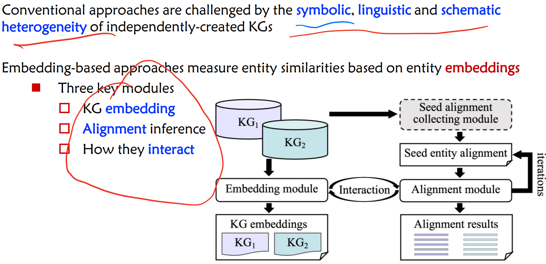

**What are the advantages and disadvantages of the embedding-based method and rule-based method for instance matching?**

**RDF Query Language: SPARQL**

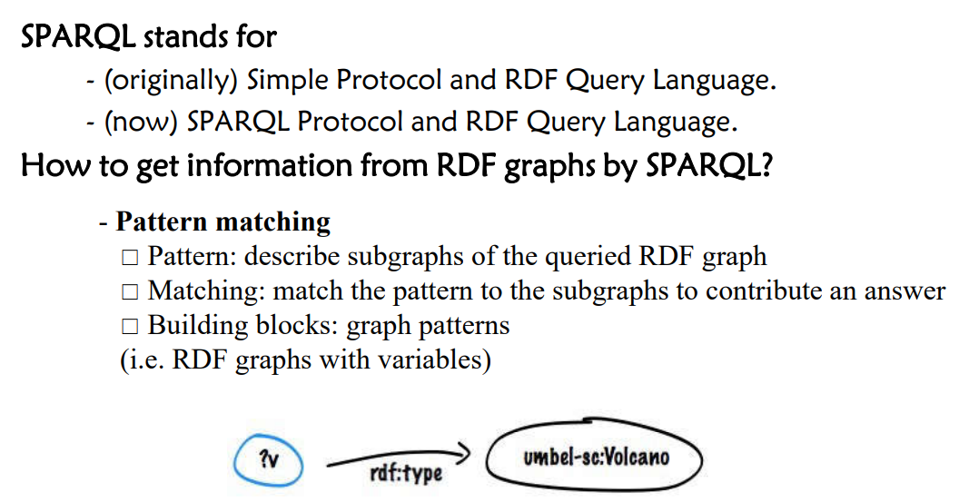

**Components** of SPARQL Queries：

**Prologue(1 2行)** – Prefix definitions for compact URIs; – Attention (difference w.r.t. Turtle): No period (“.”) character as separator.

**Query Form（3行）** – SELECT, DESCRIBE, CONSTRUCT or ASK **Dataset specification（4）** – Specify 一the RDF dataset to be querying • **Query pattern（567）** – WHERE clause specifies the graph pattern to be matched **;**

**Solution modifiers(8)** – Order: put the solutions in order; Projection: choose certain variables; Distinct: ensure solutions in the sequence are unique; Reduced: permit elimination of some non-unique solutions; Offset: control where the solutions start from in the overall sequence of solutions; Limit: restrict the number of solutions.

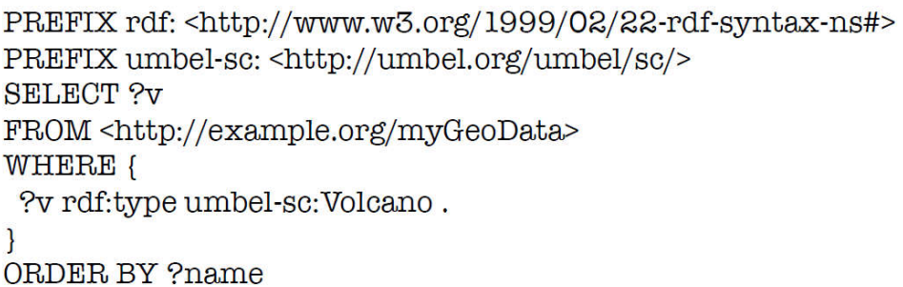

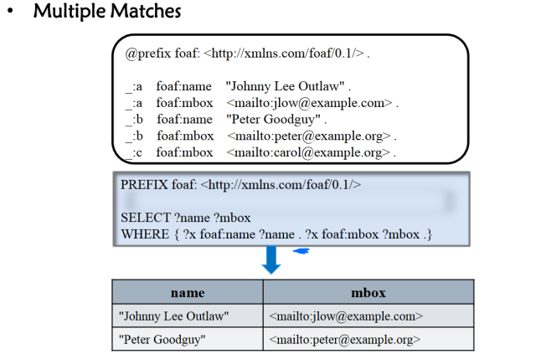

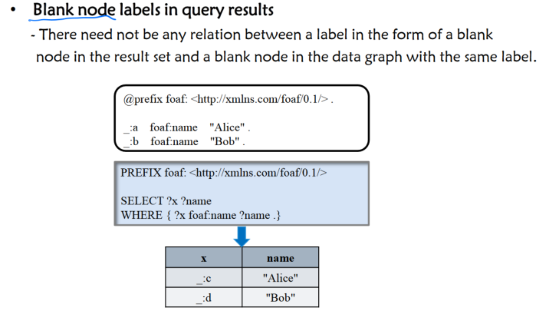

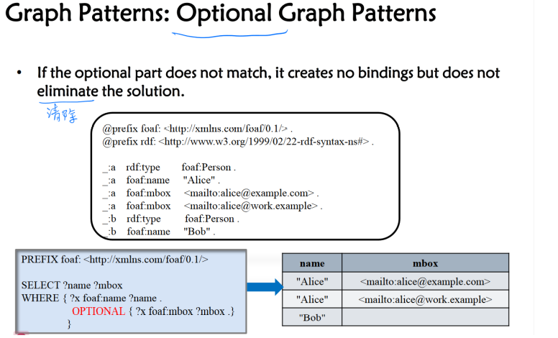

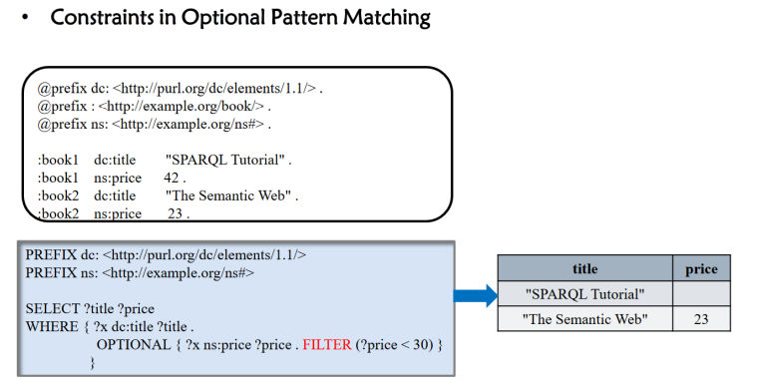

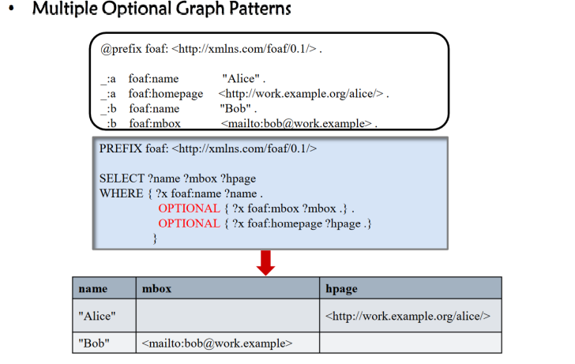

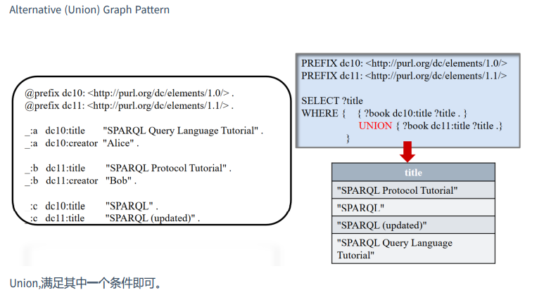

**Dataset specification •** SPARQL queries are executed over an RDF dataset: – One default graph and – Zero or more named graphs (identified by an **IRI**).

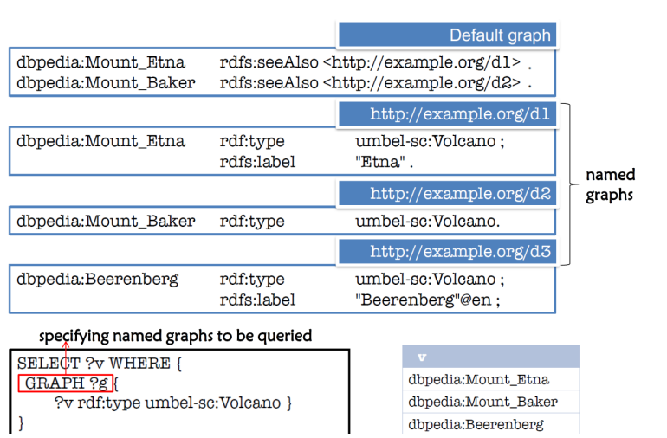

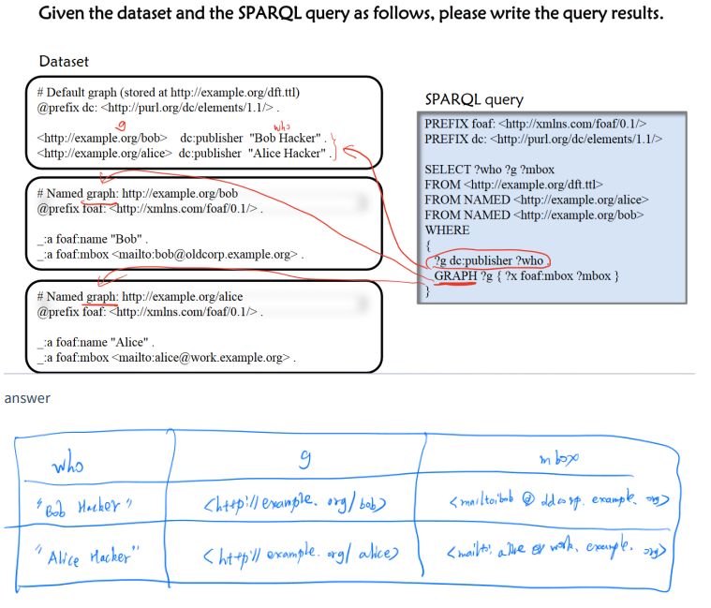

|  |  |  |
| --- | --- | --- |
| who | g | mbox |
| “Bob Hacker” | <http://example.org/bob> | <mailto:bobo@oldcorp....> |
| “Alice Hacker” | <http://example.org/alice> | <mailto:alice@oldcorp....> |

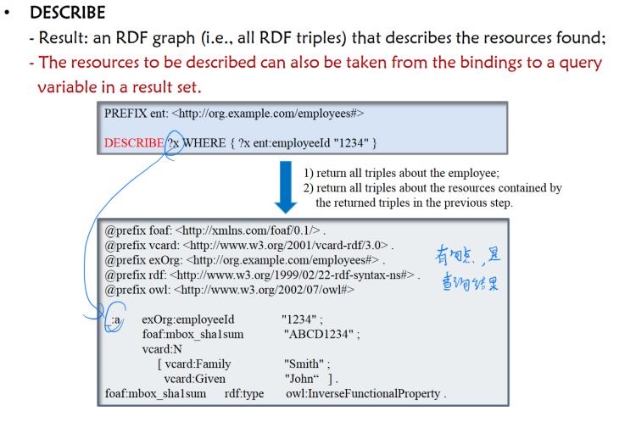

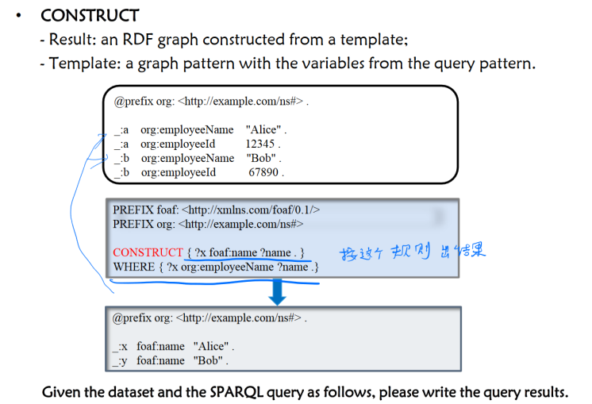

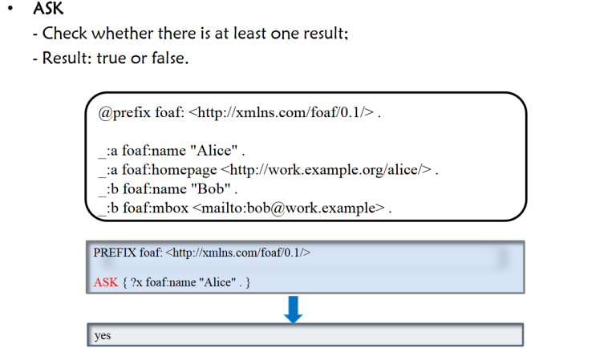

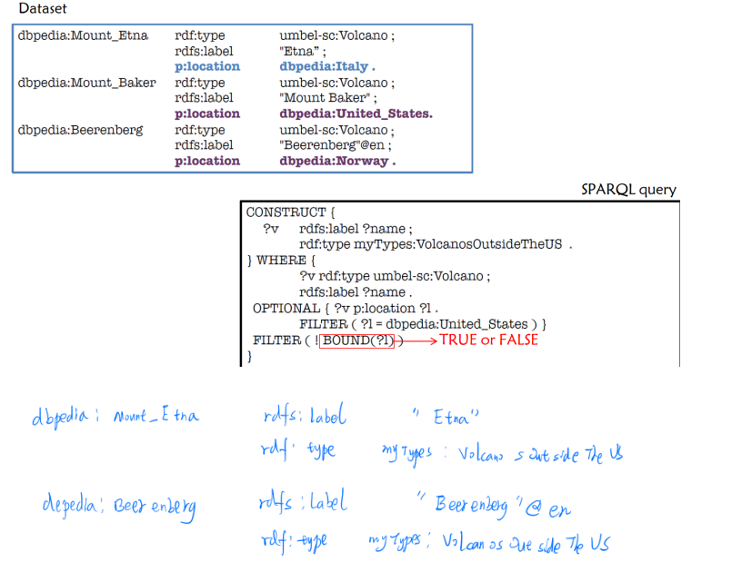

dbpedia:Mount_Etna rdfs:label “Etna” ;

rdf:type myTypes:VolcanoOutsideTheUS .

dbpedia:Beerenberg rdfs:label “Beerenberg”@en ;

rdf:type myTypes: VolcanoOutsideTheUS .

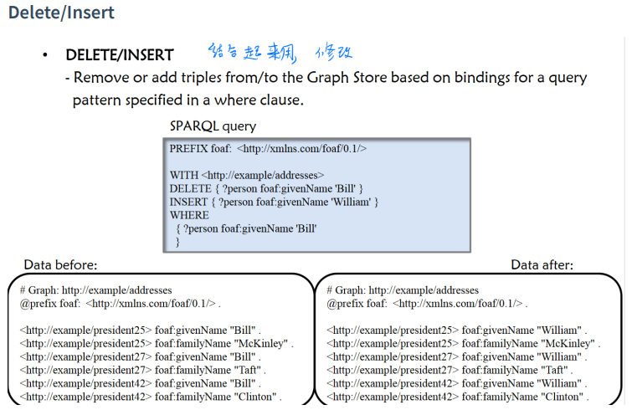

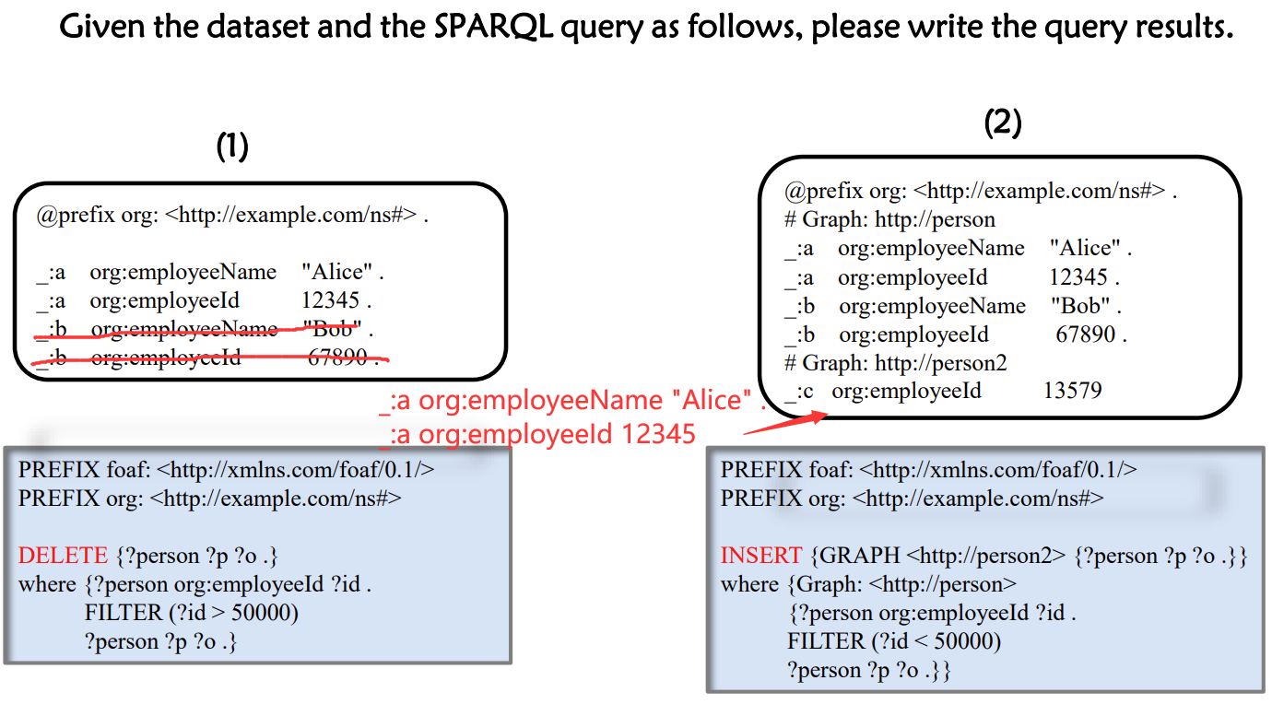

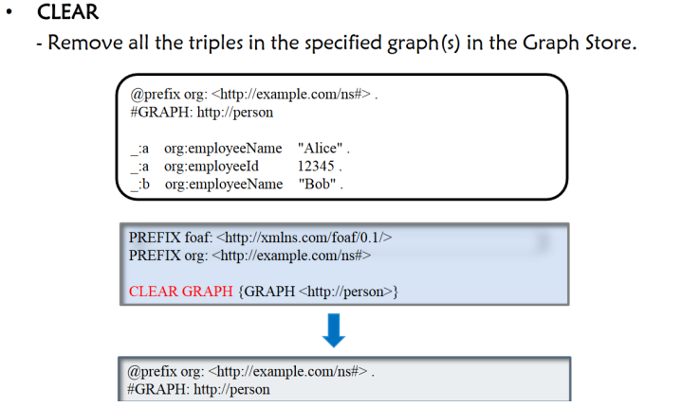

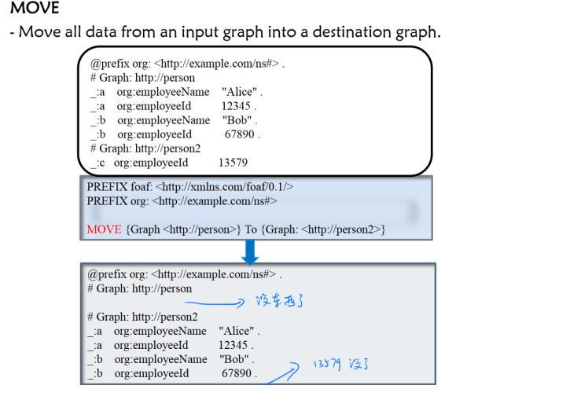

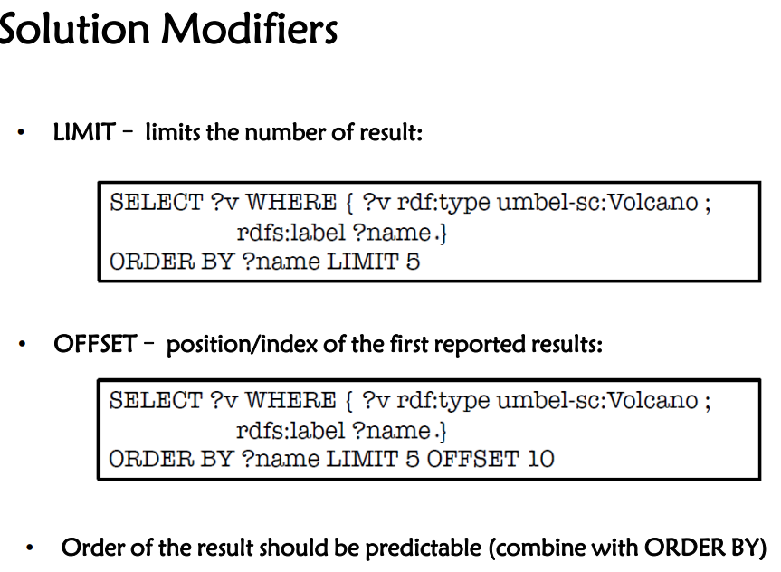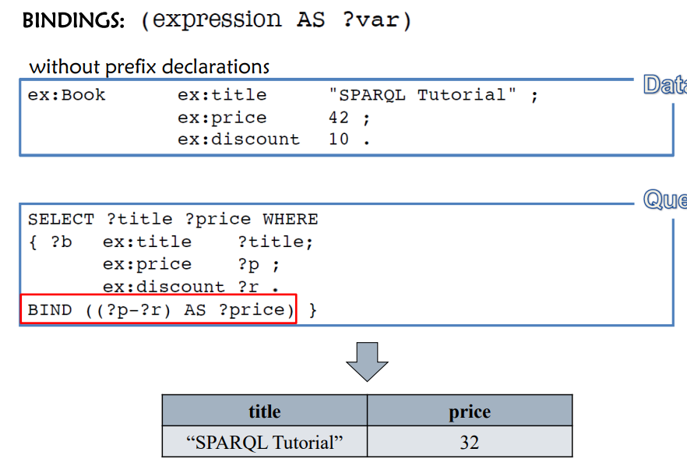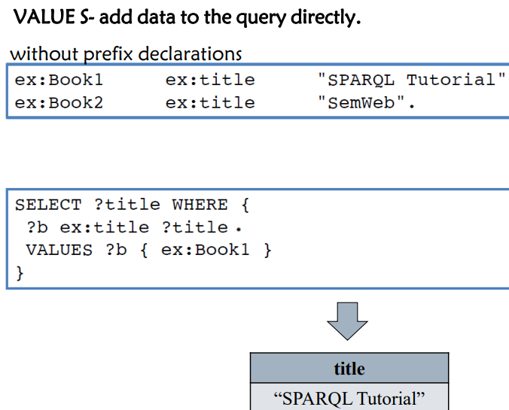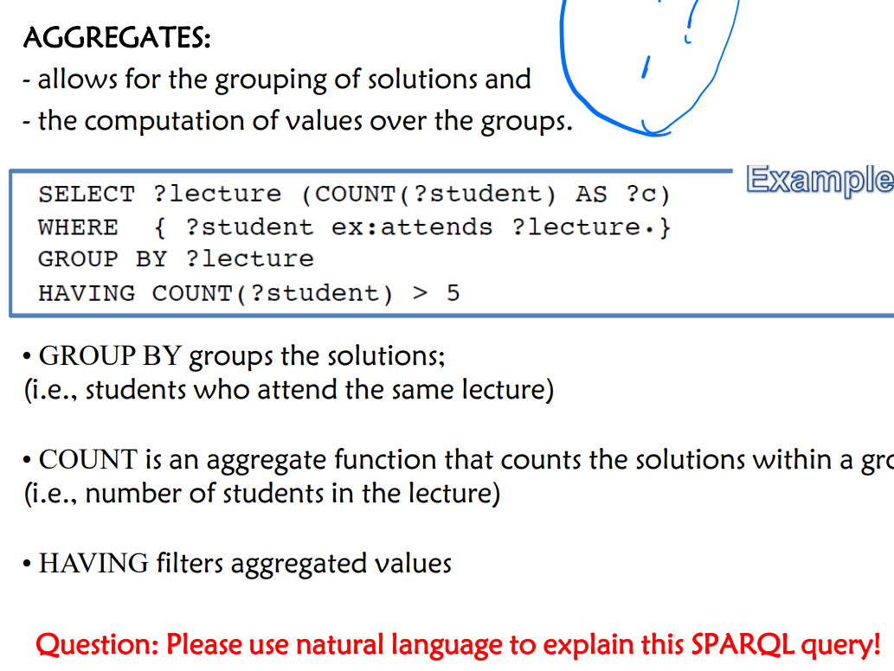

1. 在 **WHERE** 子句中，查询匹配了所有学生参加讲座的情况。
2. 使用 **GROUP BY ?lecture** 对结果按讲座进行分组，这样每个讲座的学生数量都会被分别计算。
3. **COUNT(?student) AS ?c** 计算每个讲座的学生人数，并将这个计数命名为变量 **?c**。
4. **HAVING COUNT(?student) > 5** 这个条件过滤掉那些学生人数不超过5人的讲座。

最终，这个查询返回的结果集会包括每个符合条件的讲座及其对应的学生人数。

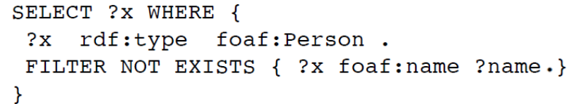

1. 首先，查询匹配了所有类型为 **foaf:Person** 的实体。
2. 然后，使用 **FILTER NOT EXISTS** 子句来过滤掉那些有 **foaf:name** 属性的实体。

最终，这个查询将返回所有被标记为人，但是在数据集中没有记录名字的实体。简单来说，就是查找那些未知名字的人的列表。

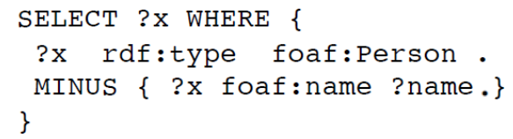

1. 查询先查找所有类型为 **foaf:Person** 的实体。
2. **MINUS** 子句用于排除那些有 **foaf:name** 属性的实体。

最终的查询结果将返回那些类型为人，但没有名字属性的所有实体。这与 **FILTER NOT EXISTS** 类似

EX:

What are all the countries and their capitals in Africa? (Given

<http://dbpedia.org/property/continent>,

<http://dbpedia.org/resource/Afirca>,

<http://dbpedia.org/ontology/Country>, http://dbpedia.org/ontology/capital)

ANS: PREFIX dbp:<http://dbpedia.org/>

PREFIX rdf:<http://www/w3/org/1999/02/22-rdf-syntax-ns#>

SELECT ?x ?y {

?x rdf:type dbp:ontology/Country .

?x dbp:property/contient dbp:resource/Africa .

?x dbp:ontology/capital ?y .

}

**Graph Database**

• Definition - A database for storing and querying data in a data structure like graphs

• Composition

- Node Specific entities, such as the movie "Harry Potter 2“, - Relation The connection between entities.

- Label Abstract concepts that group similar nodes together, such as movie characters.

- Property Specific information about the node or relationship, such as name, age, etc

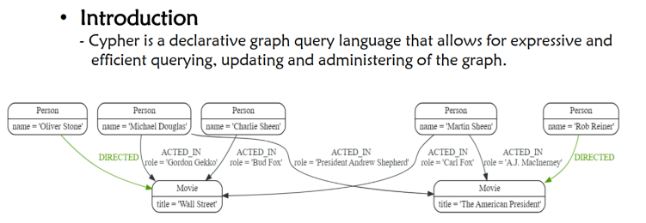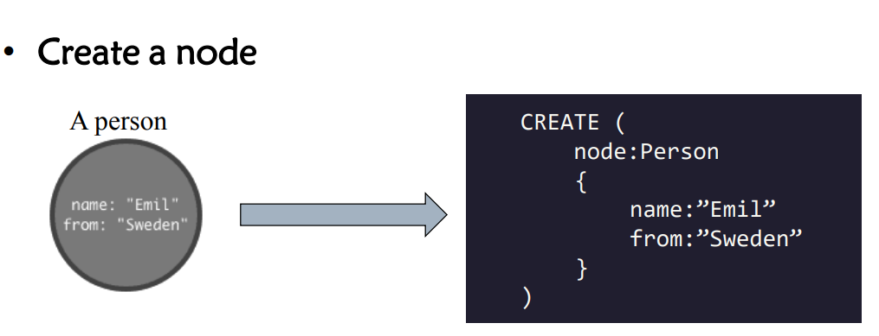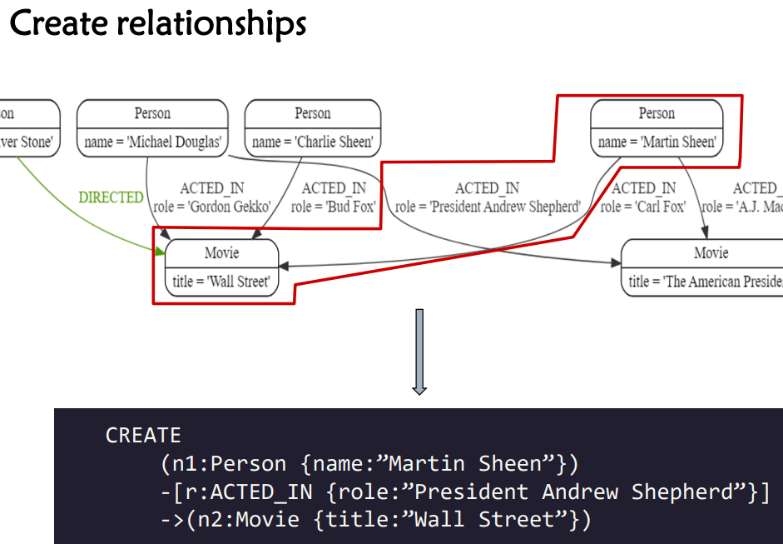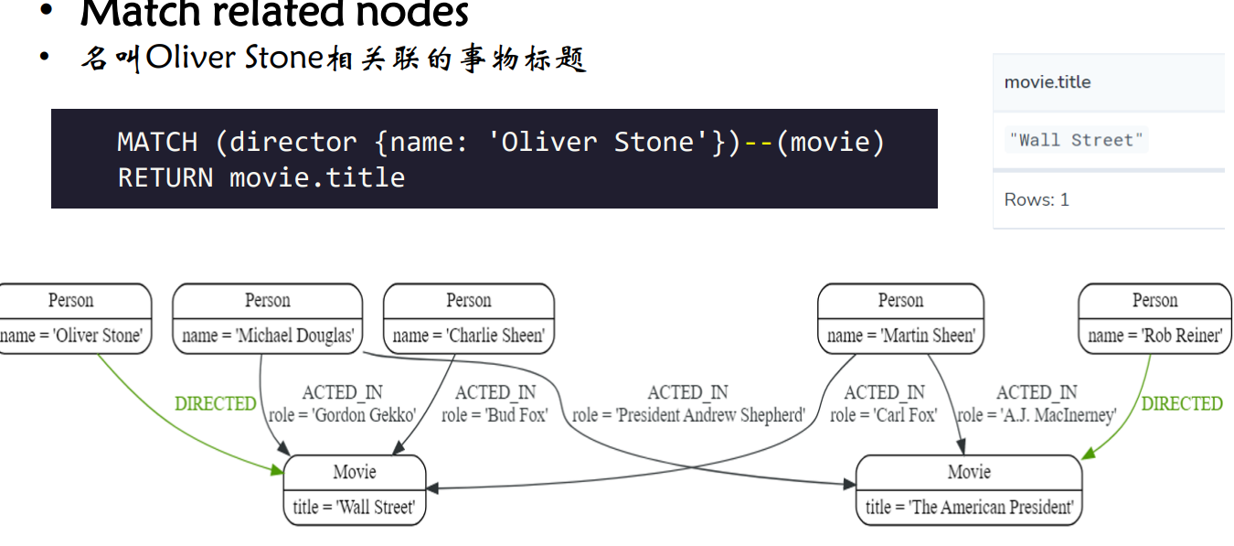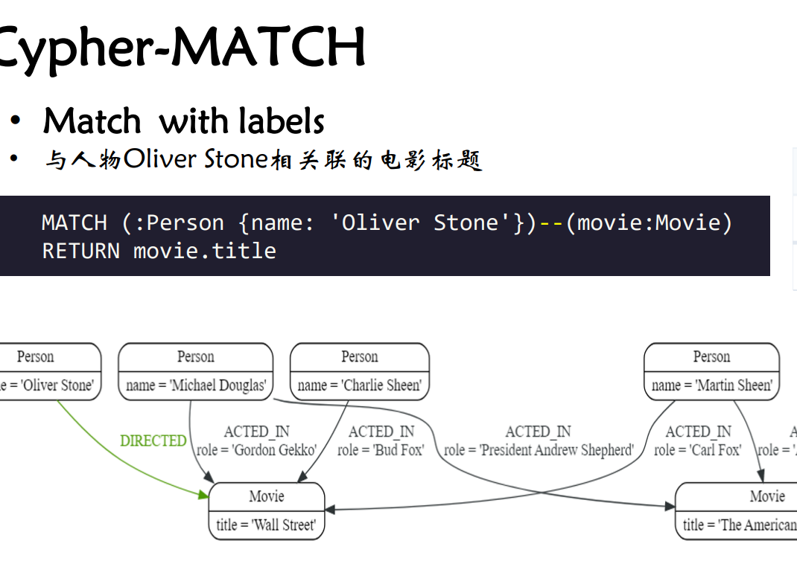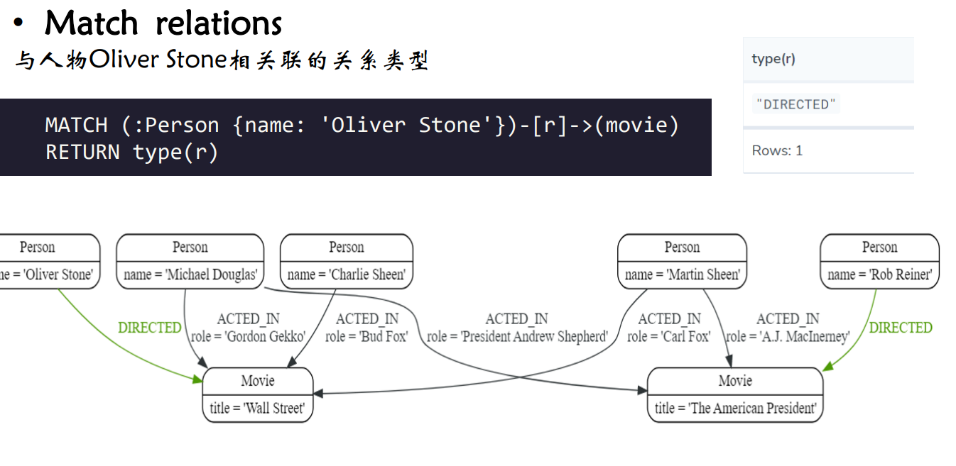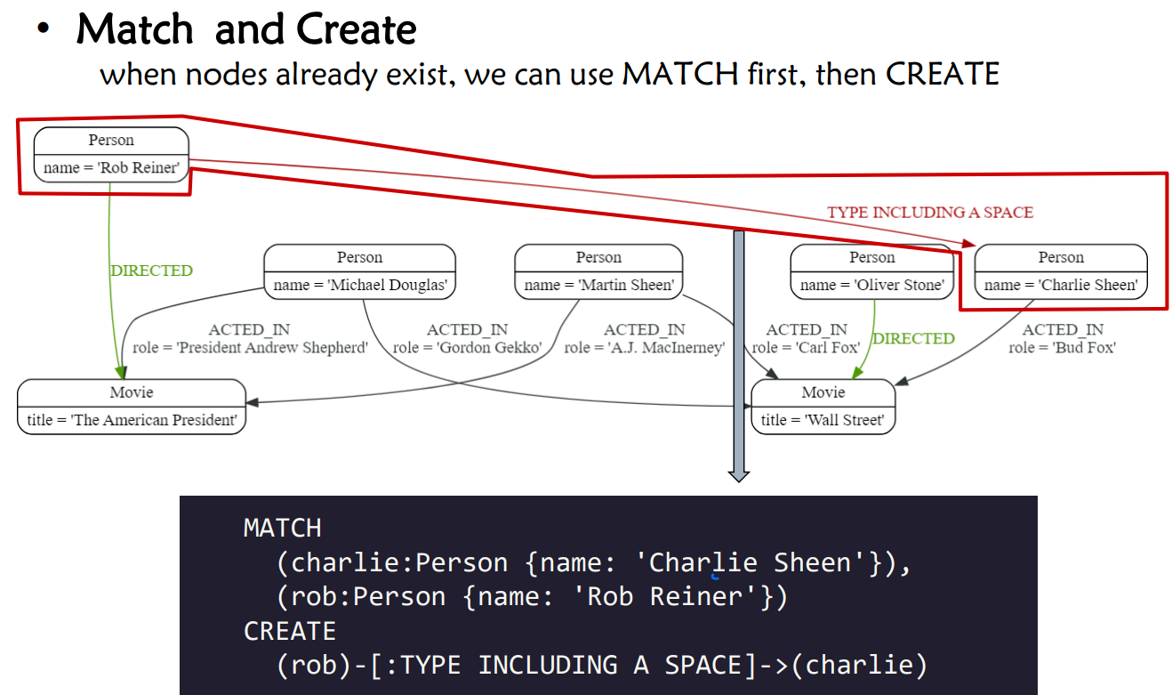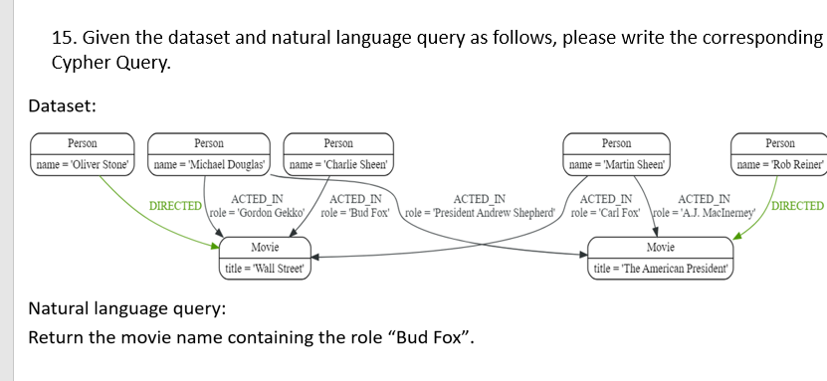

MATCH(actor)-[:ACTED_IN {role:’Bud Fox’}]->(movie:Movie)

RETURN movie.title

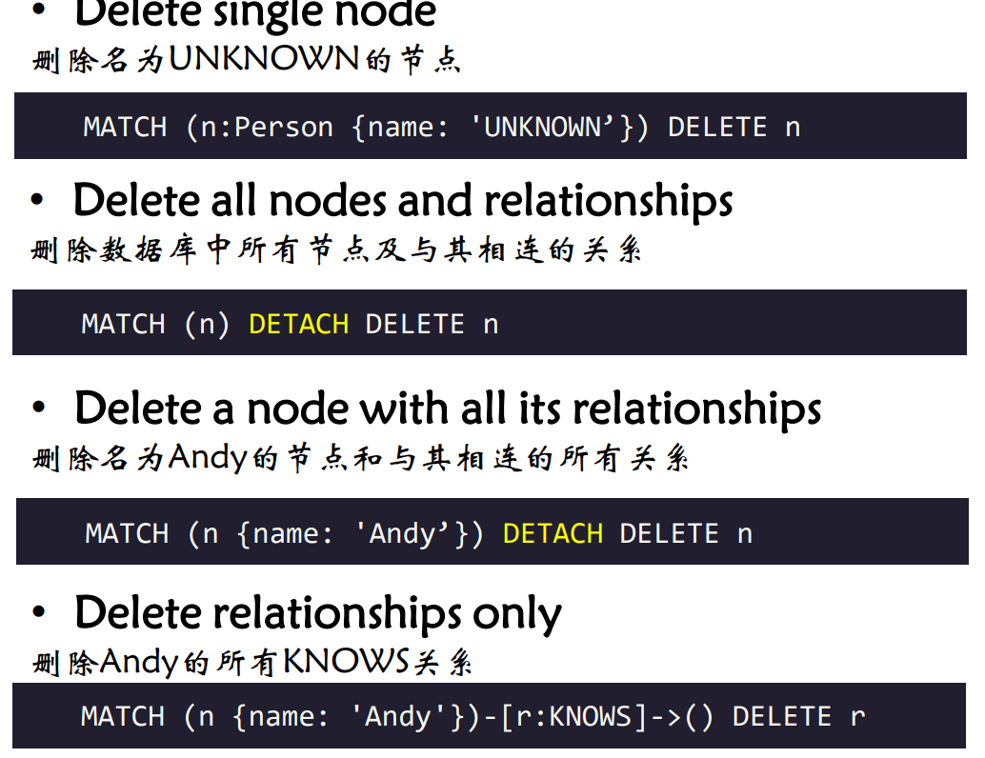

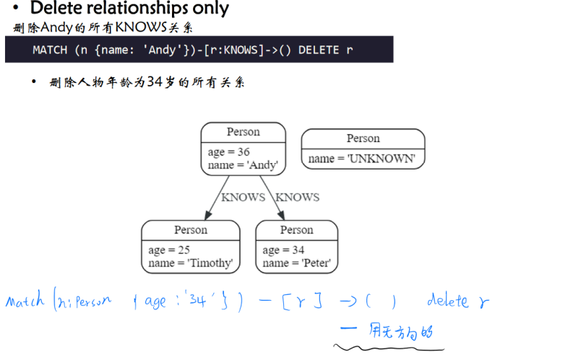

MATCH (:Person {age: 34})-[r]-()

DELETE r

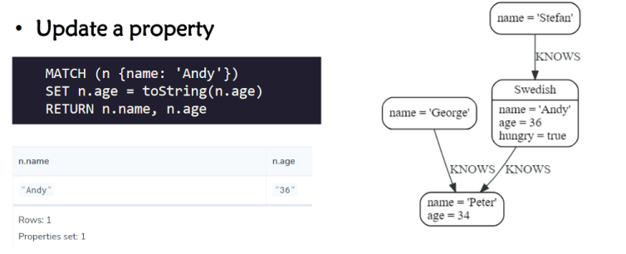

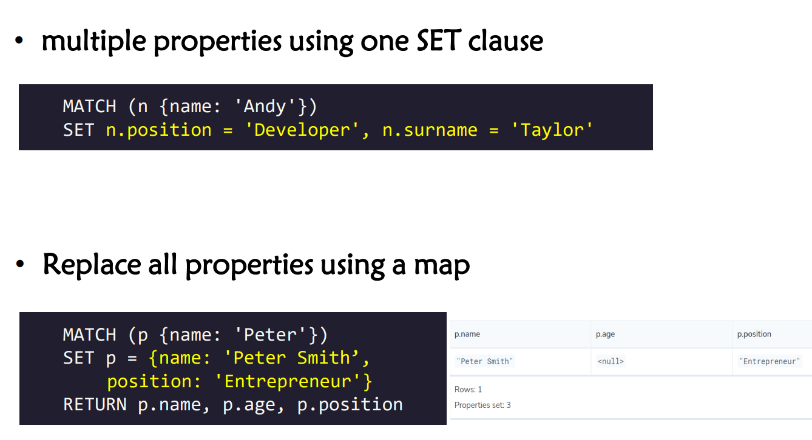

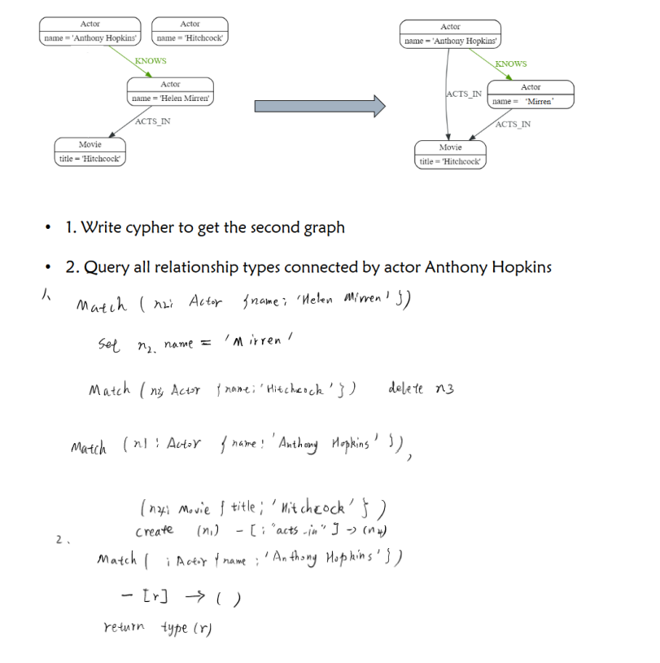

1.

MATCH (n1:Actor {name:‘Hitchcock’})

DELETE n1

MATCH (n2:Actor {name: ‘Helen Mirren’})

SET n2.name = Mirren

MATCH (n3:Actor {name: ‘Anthony Hopkins’}), (n4:Movie)

CREATE (n3)-[:ACTS_IN]->(n4)

2.

MATCH (:Actor {name: ‘Anthony Hopkins’})-[r]-()

RETURN type(r)